Snapshot Day 10/8/09 Data
(Salt Front RM 60.3)
RIVER MILE 76
Waryas Park, Poughkeepsie, Dutchess County
Brian Mohan, Clearwater
Jacob Lawrence, Arlington High School, 11-12th grade, 28 students
N 41 – W 73
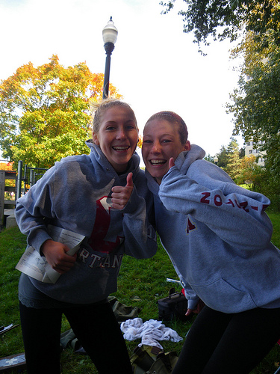 | 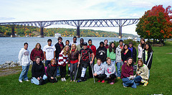

Location: Waryas Park, Poughkeepsie, New York.
Area: public park
Surrounding Land Use: 50 % urban/residential; 20% Industrial/commercial; 30% park
Sampling Site: grassy, pier, shoreline is riprap, banks altered
Plants in area: ~ 25% urban/residential, 50% forested, 25% industrial/commercial.
Tidal Shallows: Water celery 80%, Water Milfoil 10%
Water depth: 4 ft. for surface readings & 40 ft. for depth measures
River Bottom –muddy, rocky

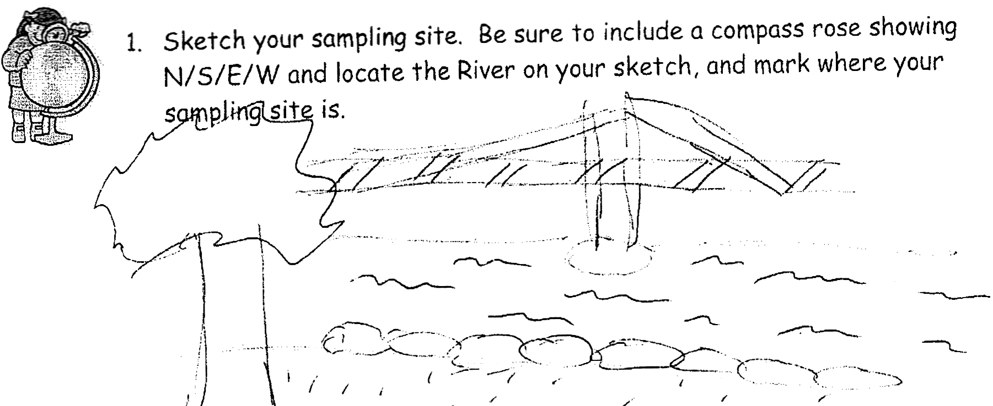

ITEM | Time |  | Reading 1 | Reading 2 | Comments
Physical
Air Temperature | 12:30 PM |  | 17°C
Wind Speed | 4 beaufort |  | NW | 13.5 mph  12.7 mph  14.9 mph  9 mph
Cloud Cover | Partly cloudy |  | No rain | Very Windy
Water | Very Choppy
Weather recently | The day before – Wed., 10/7/09, was extremely windy and rainy
Water Temperature | 10:17 AM | 11°C |  | Surface temp.
 | 10:17 AM | 14°C |  | Deep temp.
 | 10:51 AM | 13°C |  | Deep
 | 11:17 AM | 16°C |  | Surface temp.
 | 11:17 AM | 15°C |  | Deep temp.
 | 11:49 AM | 13°C |  | Surface temp
 | 11:49 AM | 14°C |  | Deep temp
Turbidity | 10:42AM | 13.5 inches  11 inches |  | 12.25 inches average |  | Very cloudy
 | 11:30 AM | 12 inches
 | 11:50 AM | 19 inches
Chlorophyll | 10:50 AM | 0.7 |  | 11:30 AM |  | 0.4
 | 11:43 | 0.5
Chemical
DO  (Test tabs) | 10:15 AM | 11°C |  | 8.4 ppm  9.0 ppm |  | 75%  80%
 | 10:57 AM | 13°C |  | 10 ppm |  | 95%
 | 11:20 AM | 16°C |  | 8.6 ppm  9.0 |  | 93%  100%
 | 11:54 AM | 16°C |  | 9 ppm  8.8 ppm |  | 90%  89%
pH – indicator solution | 10:20 AM | 7.6  8.0 |  | Surface and deep |  | Average 7.8
 | 10:57 AM | 6.0  7.6 |  | surface  deep
 | 11:26 AM | 7.75  7.2 |  | Surface sample |  | Average 7.5
 | 11:26 AM | 7.6  8.0 |  | Deep sample |  | Average 7.8
 | 11:59 AM | 7.5 & 7.2  8.0 & 7.5 |  | Surface  Deep
Salinity - Quantab testtabs- low chloride | 10:20AM | 1.0 or 28 ppm Cl
 | 10:51 AM | 33 ppm Cl
 | 11:15 AM | - surface  - 1.2 depth |  | 28 ppm  33 ppm
Fish Catch | Number Caught | Species |  | Largest
1st pull -  10:27 AM | 1 | Tessellated darter |  | 3 inch |  | Total 2
 | 1 | Blue clawed crab |  | 1 inch
2nd pull –  10:34 AM | 2 | Bluegill |  | 4 inch |  | Total 3
 | 1 | Killifish |  | 4 inch
Tides | 10:15 AM | 8.9 cm
 | 10:48 AM | 22.9 cm |  | Rising
 | 11:15 AM | 36.8 cm |  | Rising
 | 11:47 AM | 53.3 cm |  | rising
Currents | 10:25 AM | 3600 cm/60 secs |  | 60 cm/sec |  | ebb
 | 10:55 AM | 5000 cm/60 secs |  | 83.33 cm/sec |  | flood
 | 11:20 AM | 6900 cm/60 secs |  | 115 cm/sec |  | flood
 | 11:47 AM | 5000 cm/60 secs |  | 83.33 cm/sec |  | flood
Core | Rock on top of sediment | Bottom of core is all mud
Shipping | 10:59 AM | Tug – Grey |  | Southbound |  | Empty stone
 | 12:30 PM | Caribbean Cruise ship |  | Southbound
Others | There are lots of people biking and enjoying the sights. I saw a groundhog on the rocks. I heard birds more towards the industrial side of the river.

