Snapshot Day 10/8/09 Data
(Salt Front RM 60.3)
RIVER MILE 78
Quiet Cove, Poughkeepsie
Skip Hoover, Cornell Cooperative Extension, Duchess County
Robert Adams & Scott Jameson, DEC Fisheries Dept.
G. W. Krieger Elementary School 4th & 5th students &
Tracy Zeoli, Gayhead School – 76 students total
9-11th grade helpers (8)
41.44°N and 73.56°W

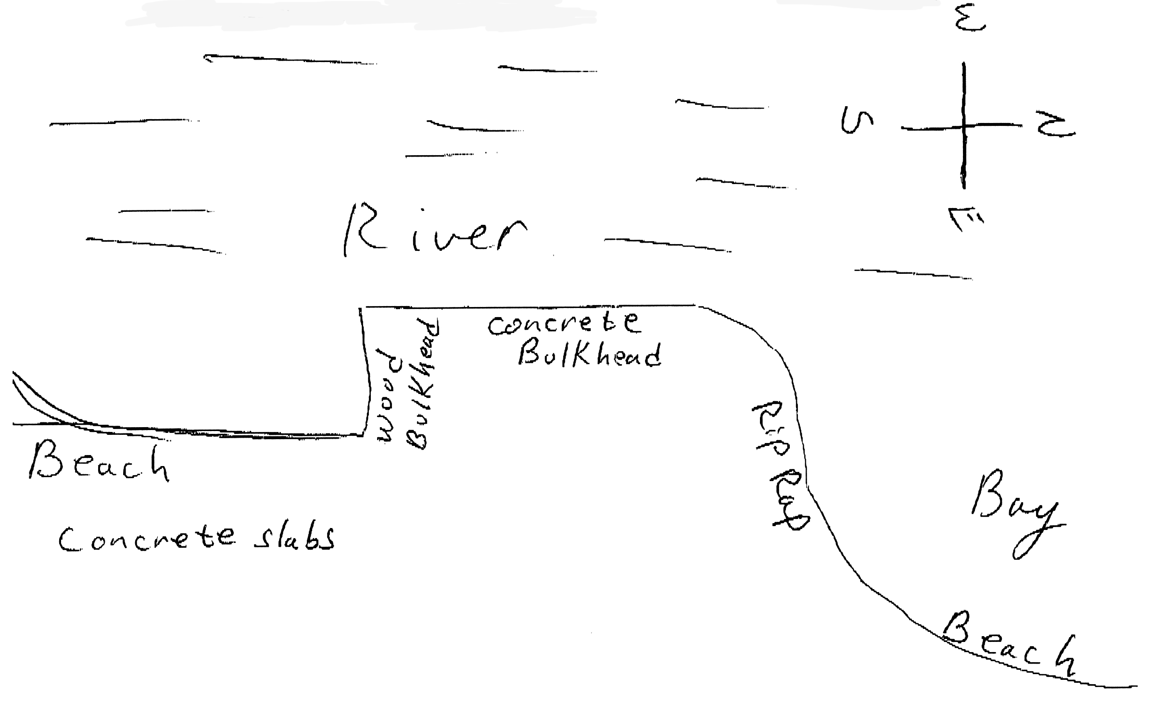
Location: Quiet Cove, Poughkeepsie, Dutchess County
Area: Grassy area with parking lot, beach like waterfront
Surrounding Land Use: Picnics, boating – 60% is beach with rip rap banks, 40% previous industrial site
Sampling Site: An old industrial area that has been turned into a park. Used by people for picnics, fishing. Shoreline rocky, banks altered with rip rap and wooden bulkhead, boat launch for kayaks and canoes
Plants in area: yes – 5% or area is water celery
Debris in area: remnants of industrial site and some papers in the water
Water depth: 160 cm in the area with concrete embankments
River Bottom – muddy in beach area
ITEM | Time |  | Reading 1 |  | Reading 2 | Comments
Physical
Air Temperature | 10:06 AM |  | 15°C
 | 12:40 PM |  | 20°C
Wind Speed | 10:39 AM |  | Beaufort #17-20 |  |  | North
Cloud Cover | Partly cloudy
Weather today | No rain
Weather recently | Monday sunny, Tuesday rainy, Wednesday very windy but sunny
Water Description | VERY choppy
Water Temperature | 9:45 AM | 15.5°C  60°F
 | 10:27 AM | 12.77°C  55°F
 | 11:10 AM | 15°C  59°F
 | 12:50 PM | 16.1°C  61°F
Turbidity | 11:00 AM | 37 cm  37 cm  27 cm  25 c |  | 31.5 cm average |  | Long site tube
Chlorophyll | 11:30 AM | 0.4
Chemical
DO (LaMotte elementary kit tablets) | Very poor readings with kit | <3.0 ppm |  | 15°C
pH  (LaMotte color match kit) | 11:11 AM | 8  7.5  8 |  |  |  | 7.8 average
Nitrates  Using LaMotte Elementary test kits | 11:11 Am | <5 ppm
Phosphates | 11:11 AM | <1 ppm
Salinity | Not tested
Fish Catch- 25 ft. | Number Caught | Species |  | Macroinvert |  | Seine
3 seines total | 10 | Spottail Shiners |  | 1 Crayfish |  | 9:45 AM
 | 6 | Banded killifish
 | 1 | Pumpkinseed
 | 1 | Male Bluecrab |  |  |  | TOTAL 18 fish  1 macro
 | 2 | Spottail Shiners |  |  |  | 12:30 PM
 | 2 | Banded killifish
 | 6 | Pumpkinseed
 | 2 | Male Bluecrab
 | 2 | Bay Anchovies |  |  |  | TOTAL 14
Tides | 9:47 AM | 120 cm
 | 10:14 AM | 122 cm |  | Falling |  | *measuring down to water level
 | 10:27 AM | 1100 cm |  | Rising
 | 10:55 AM | 98 cm |  | Rising
 | 11:11 AM | 93 cm |  | Rising
 | 11:34 AM | 75 cm |  | Rising
 | 12:29 PM | 50 cm |  | Rising
 | 12:55 PM | 35 cm |  | Rising
Currents | 9:47 AM | South |  | Ebb
 | 10:27 AM |  |  | Still
 | 11:11 AM | North |  | Flood
 | 12:29 PM | North |  | Flood |  | 15 ft/22 secs = .68 ft/sec.
 |  | NOTE |  | 30 ft/32 secs |  | < 1 ft. per sec.
Traffic
Sediment Core | 11 inches length | Gray silky smooth much |  | Not much distinction in layers |  | Some roots present
Other Items

