Snapshot Day 10/8/09 Data
(Salt Front RM 60.3)
RIVER MILE -11
Breezy Point, Queens
Geri Kobryn-Blatter, National Parks Service Rangers
Greg Grambo/Tony Yaskowski –Louis Armstrong Middle School – IS227Q
GPS latitude N40.33.442 W 073.55.997
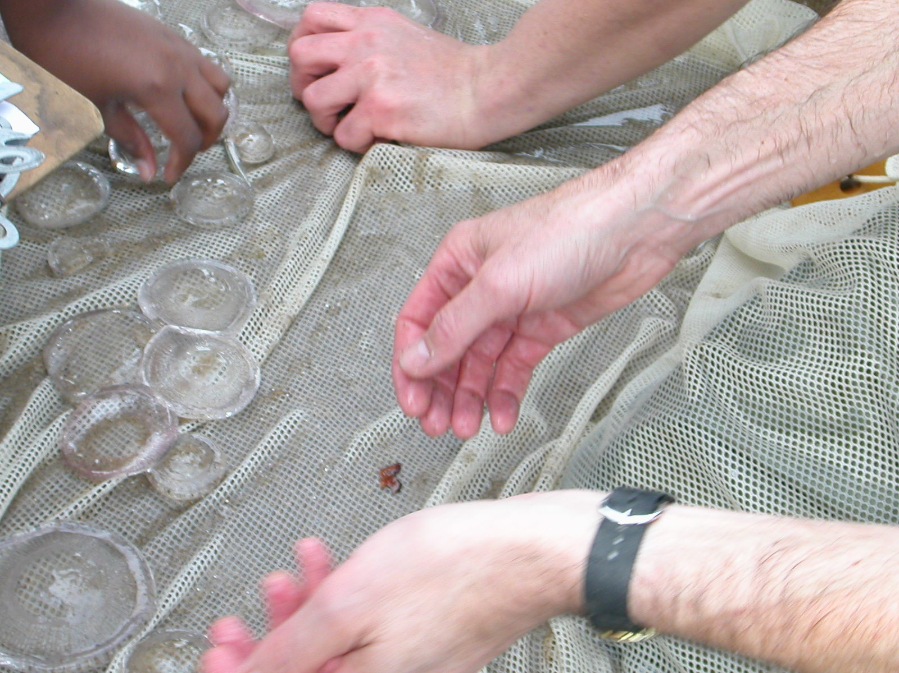 | 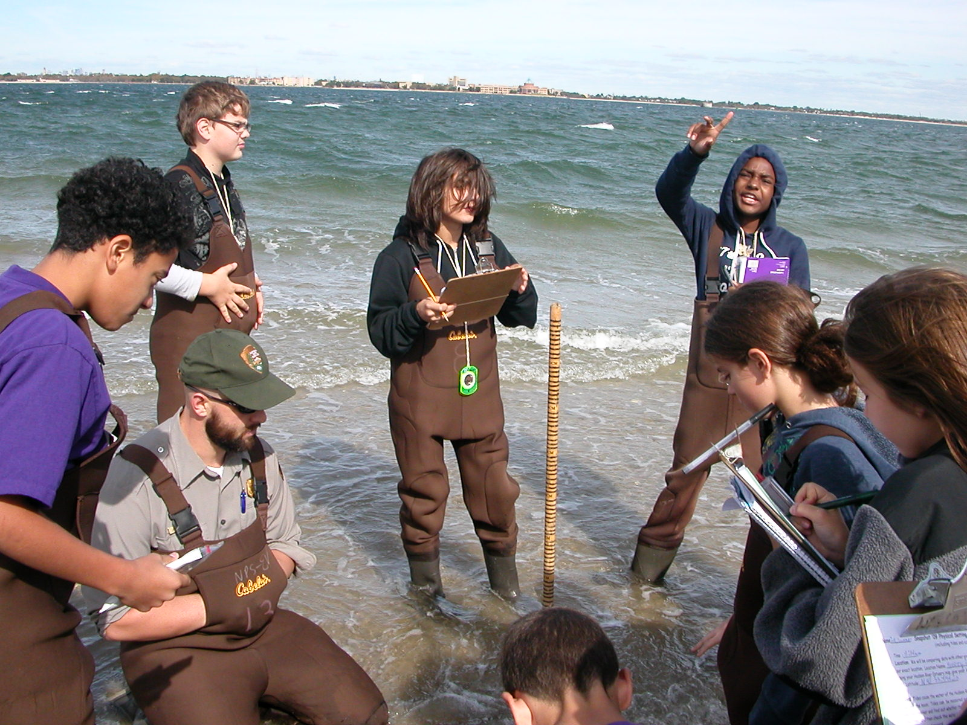
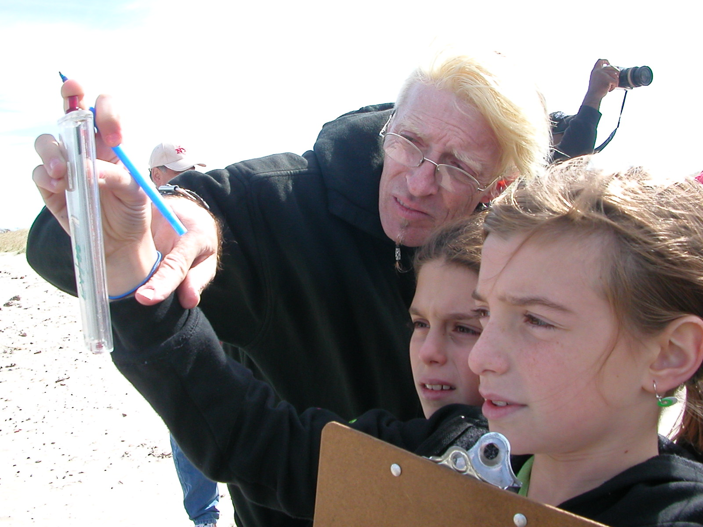 | 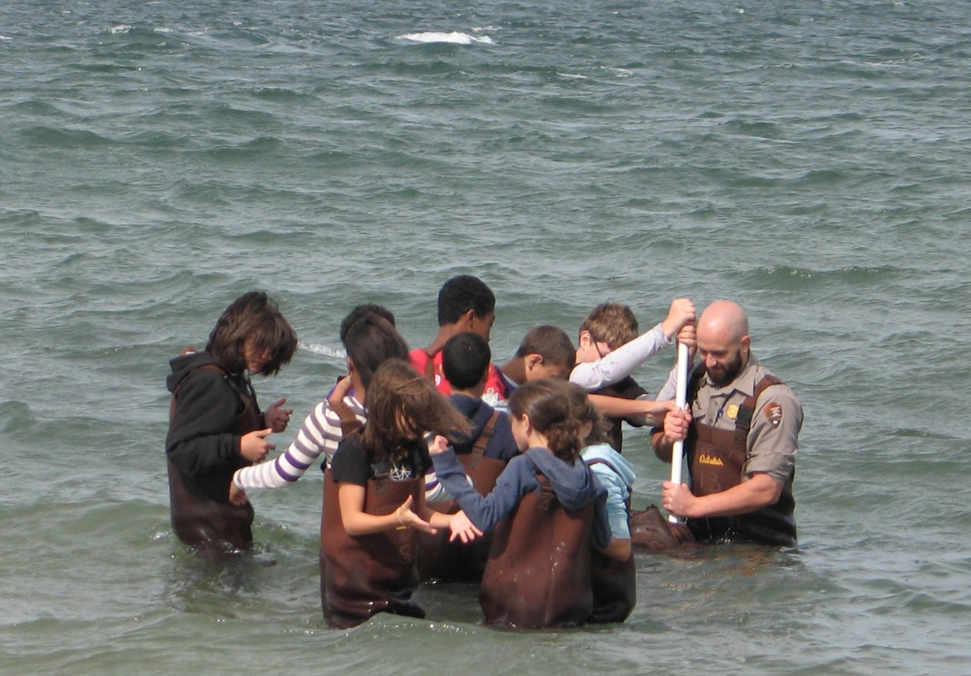

Location: Beach on bay side of Breezy Point, Queens, Jamaica Bay
Sampling site: Fishing beach area, dune system behind beach, used for recreational boating, commercial traffic, kite sailing
Surrounding Uses: 100% beach
Area: All beach, grassy dunes
River Bottom: sandy, gravel
Plants in area: Not in the water but in the area - Ammophila breviligulata (Beach grass) 50%, Seaside goldenrod 10%, Russian Thistle 20%, Eastern Cottonwood 10%
Water Depth: 4 ft.
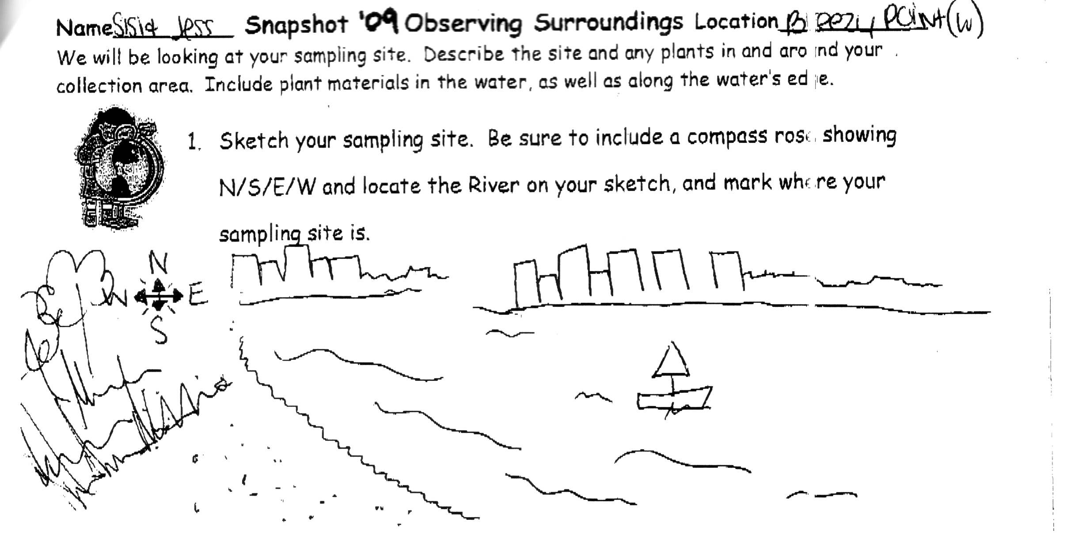
ITEM | Time |  | Reading 1 | Reading 2 | Comments
Physical
Air Temperature | 11:37 AM |  | 48 ° F  10° C
Wind Speed | 19.8 mph |  | 24 kts | NW
Cloud Cover | Partly cloudy |  | Cirrus, high thin cirrostratus | Freezing windy  Sunny  cold
Weather yesterday | Sunny windy cooler temperatures
Water Surface | White Caps
Water Temperature | 12:33 AM | 17° C  64 ° F |  | 18° C  67 ° F | Avg: 16.67° C  63.67° F
15° C
60 ° F
Turbidity | 12:10 AM | 76 cm  84.75cm  90.2 cm |  |  | Avg:  83.65
 |  | 79 cm  84.75 cm  102.28 cm |  |  | Ave: 88.67
Chlorophyll |  | 0.1
Chemical
DO  LaMotte | 12:32 PM | 4.0 mg/L |  | Temp. 17° C | 40% saturated
pH – tabs | 12:16 PM | 7  7  7 |  |  | 7
Salinity -  hydrometer | 12:22 AM | 32.6 ppt
Fish Catch –  10 ft. X 12 ft. seine/1 pull | Number Caught | Species |  | Total Catch ~150 | Seine net
 | 150 | Atlantic Silversides |  | 4 inches
 | 30-50 | Moon Jellies |  | 6 inches
 | 3 | *Baby Blue fish |  | 1.5 – 2.0 inches
*Bluefish have distinct spring and summer spawning cohorts, spring spawners dominate in the estuary and summer spawners dominate along the coast. These small blue fish must have been summer spawners from their small size.
 | 75 | Jellyfish |  | 3 inches
Tides | 11:19 AM | 5 cm |  | Falling
 | 11:34AM | 4 cm |  | Falling
 | 11:55 AM | 2 cm |  | Falling
 | 12:14 PM | 0 |  | Falling
 | 12:20 PM | -255cm |  | Falling
Currents | CM/60 sec | Cm/Sec |  | North/South | Ebb/Fllod/Still
11:20 AM | 1460 | 26.35 |  | N | Ebb
 | 2600 | 46.92 |  | N | Ebb
Core-  Noon  Water depth 4 ft, | 16 cm total length | 6 cm top |  | Dark anoxic layer, some shells | Light on the bottom
Shipping | 10:30 AM | Cargo ship – |  | Wade D | Northbound
 | 11:54 AM | Tug Boat - light blue |  | Brian Nicholson | Southbound
 | 11:55AM | Fishing Boat |  | Yellow Black
 | 12:00 PM | Sailboat |  | White
Journal | We had the privilege of watching 3 sharp shined hawks hunting above the dunes while kite surfers appeared to fly above the choppy weather.

