Snapshot Day 10/8/09 Data
(Salt Front RM 60.3)
RIVER MILE -7 Ft. Wadsworth
Carol Williams, John Warren National Parks Service, NPNH Education Center
Mrs. Bridgman - I.S. 27 – 8th grade, 31 students
GPS latitude N40.60537 W 074.05367
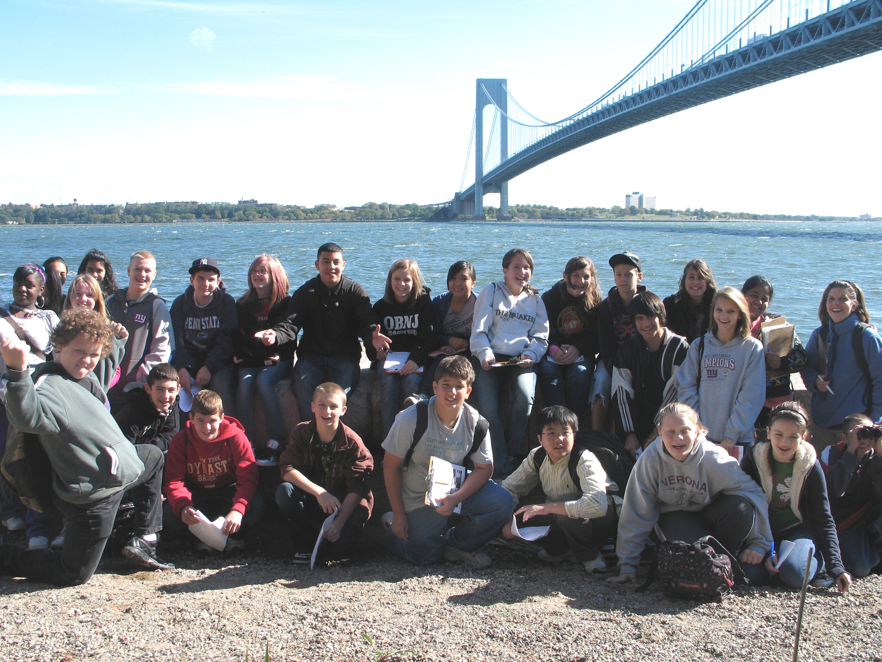
Location: Battery Weed, just north of the Verrazano Bridge, Staten Island
Area: Shoreline is rocky, banks are stone walls next to fort, collected wood/debris in the area
Surrounding Area: 25% forested - historic fort next to the Verrazano Bridge
River Bottom: Rocky
Water Depth:
Plants in water: no
Tidal Shallows:
ITEM | Time |  | Reading 1 | Reading 2 | Comments
Physical
Air Temperature | 11:53 AM |  | 63° F  17.2° C
Wind Speed | Beaufort 4 |  | East
Cloud Cover | Partly cloudy
Weather | Nice,
Weather yesterday | Windy low 60s
Water Surface | WATER CHOPPY
Water Temperature
Turbidity | 10:57 AM | 113 cm  100 cm  104 cm |  |  | Average 105.6 cm
Chlorophyll | 11:30 AM | 0.3
Chemical
DO
pH
Alkalinity
Salinity

Fish Catch | Number Caught | Species
 | 1 | Atlantic Silverside |  | 4 inches
Other Items | 2 peregrines, two dozen brant, and the ship carrying the Dutch sloops home from the Quad celebrations on the river

