Snapshot Day 10/8/09 Data
(Salt Front RM 60.3)
RIVER MILE 11.5 – Fort Washington Park
Carolina Behe & Ingrid Garcia-Solera – PS 125
11-13 yr. olds – 13 students
SCA Jessica Perez and Fen Huang
Latitude 40.89° N - Longitude 73.94°W

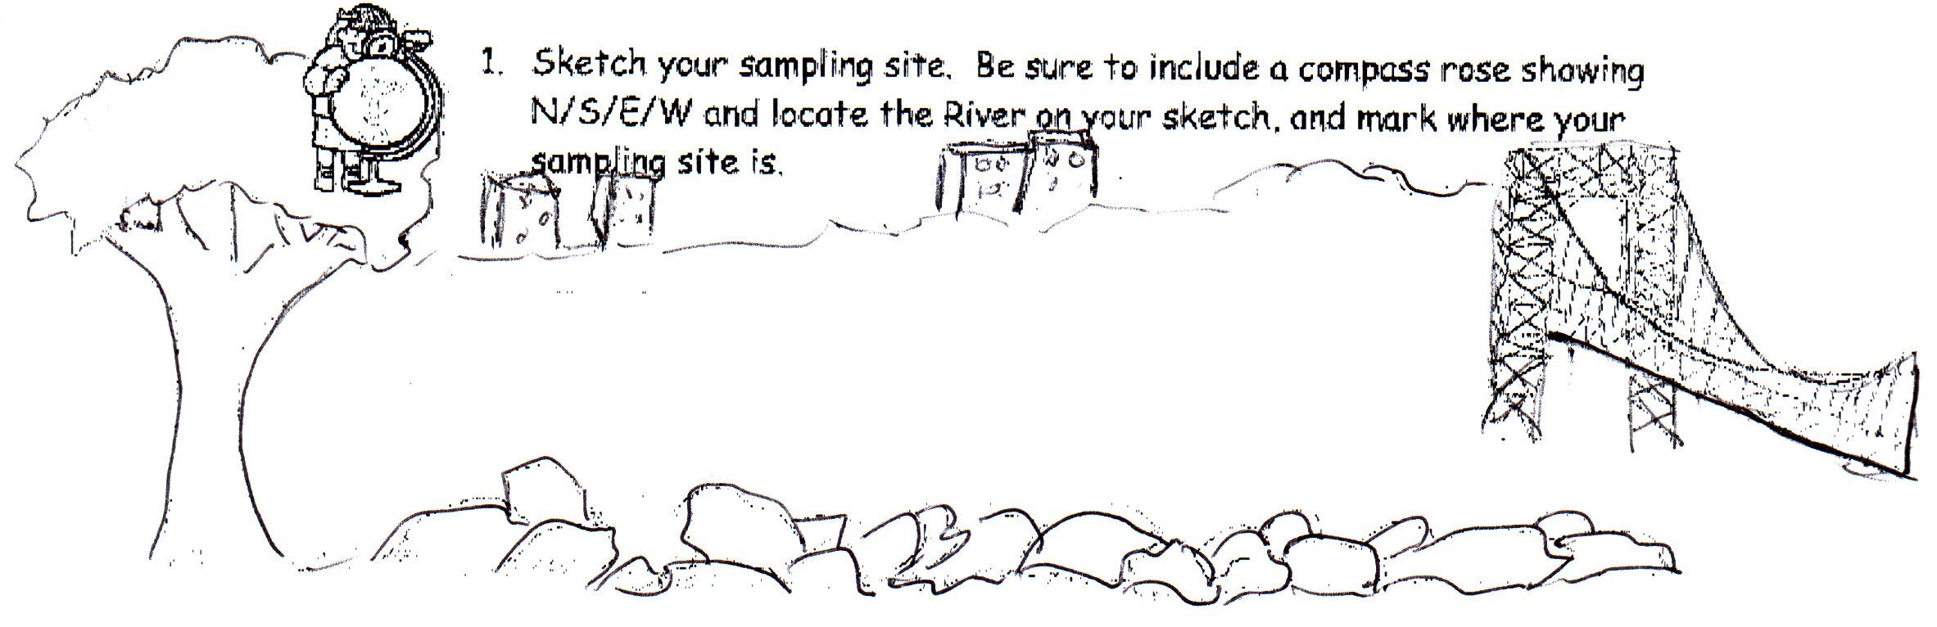

Location: Fort Washington Park just South of the George Washington Bridge
Area: Park/Boat launch, sandy beach area on the point
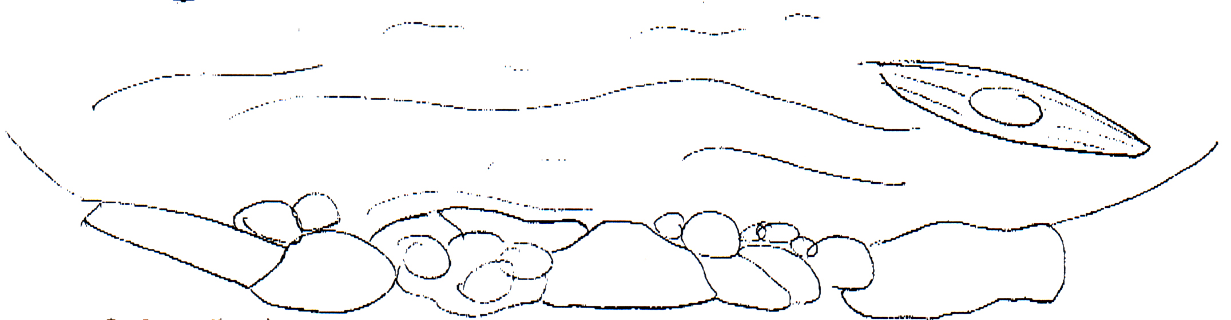
Surrounding Land Use: urban residential
Sampling Site: Park with a lot of trees, rocks bulkhead, covered with vegetation, riprap shore, collected wood debris.
Plants in water: <10% - a grass of some sort
Plants in area: Oak trees, maple trees, Common plantain, grass
Water depth: 14 inches
River Bottom –sandy

ITEM | Time | Reading 1 | Reading 2 | Comments
Physical
Air Temperature | 1:52 PM
Wind Speed | 2-3 Beaufort
Cloud Cover | Overcast but sunny
Weather today | No rain –
Weather last 3 days
Water
Water Temperature
Turbidity | 2:00 PM | 10 NTU |  | Long site tube
Chlorophyll | 2:30 PM | 3.0
Chemical
DO  Drop count | 2:00 PM | 6.0 |  | 49% saturation
pH | 2:40 PM | 6.5 pH
Phosphate
Nitrates | 2:40 PM | 5.0 ppm
Salinity
hydrometer
Fish Catch | Number Caught | Species
Tides | 1:50 PM | 14 in
 | 2:09 PM | 10.5 in | Falling
 | 2:22 PM | 8.5 in | Falling
 | 2:57 PM | *11.5 in | *Rising – doubt this was rising see note | *Probably due to a wave
 | 3:20 PM | 3 in | Falling
Currents | Time | Ebb/Flood |  | cm per sec
 | 1:50 PM | Ebb | 414 inches/14 secs. | 75.11 cm/sec.
 | 2:01 PM | Ebb
 | 3:20 PM | Ebb
Turbidity
Core Description | Total Length | Top Layer | Second Layer | Describe
 | Fine grain | No plant material
Commercial Traffic
Other | Kayaking | Sailing | Fishing | biking

