Snapshot Day 10/8/09 Data
(Salt Front RM 60.3)
RIVER MILE 127 – Stuyvesant Landing
Chelsea Benson, Columbia County Soil & Water Conservation District
Cammy Salazar, The Alternative Learning Center (TALC) – 10-13 yrs. – 12 students & 11 adults
Latitude 47 N Longitude 73W (topo map)
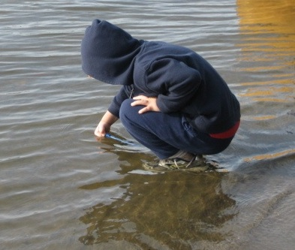 | 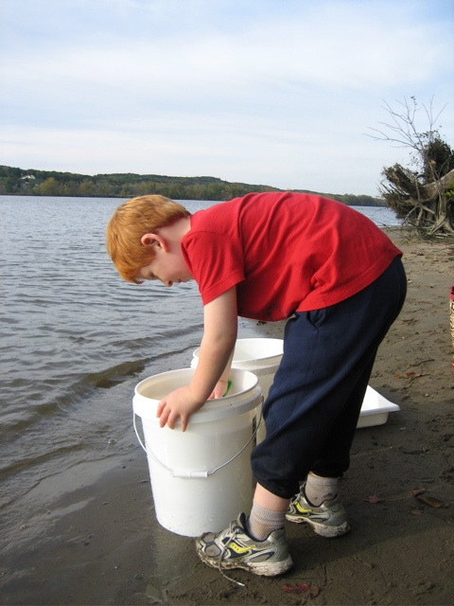 | 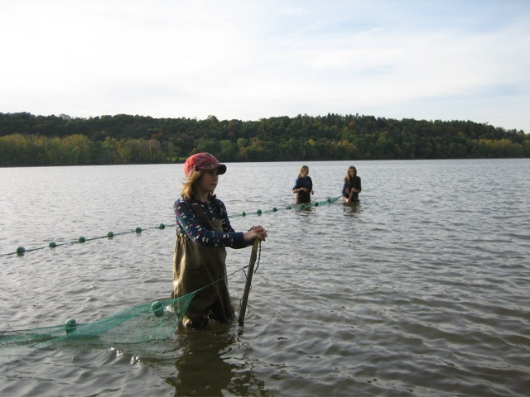

Location: Sandy point of Stuyvesant Landing, Columbia County. The sandy point is just south of the parking lot.
Area: forested area used for picnics & camping Park/Boat launch, sandy beach area on the point
Surrounding Land Use: 95% forested, 5% beach – used for picnics, swimming, campfires, sandy beach and dense woods behind
Sampling Site: Beach, fallen trees,
water area is sandy with little mud further out – gently sloped beach, shallow quite a distance and then shipping channel
Plants in area: yes – about 1% of sampling area has water chestnut in it.
Water depth: waded in approx. 2 ft.
River Bottom –gradual slope, sandy

ITEM | Time |  | Reading 1 | Reading 2 | Comments
Physical
Air Temperature | 3:40 PM |  | 65°F  18°C
Wind Speed | 1.5 knots |  | Anemometer | NW
Cloud Cover | clear |  |  | Water few waves
Weather today | Mostly cloudy
Weather last 3 days | Rain, high speed wind gusts on 10/7/09
Water Temperature | 3:45 PM | 64°F  18°C
 | 4:00 PM | 64°F  18°C
Turbidity – short site tube | 4:00 PM | 60 JTU |  |  | 60 JTU average
Chlorophyll | 4:15 PM | 0.5
Chemical
DO  Drop count | 3:45 PM | 9.5 mg/L |  | 18 ° C | 100%
pH  pen | 3:30 PM | 7.6  8.0  7.8 |  |  | Average 7.8
Nitrates | 3:56 PM | 0.29 ppm
Phosphates | 3:53 PM | 0.08 ppm
Alkalinity | 3:45 PM | 100 ppm  94 ppm  100 ppm |  | 98 ppm
Salinity  Test strip | 3:540PM | 28 ppm X 3 |  | Chloride
Fish Catch – 4:30 PM | Number Caught | Species |  | Size of largest | 2 seine with fish catch
Seine 40 ft. X 3 ft.  Mesh 0.25 inch | 1 | Herring y-o-y |  | 8 cm
3 minute pull | 4 | Spottail shiner |  | 7 cm
Tides | 3:30 PM |  |  | 23 cm
 | 4:00 PM | Rising |  | 34 cm | .36 cm/min
 | 4:15 PM | Rising |  | 42 cm | .53 cm/min
Currents | 3:40 PM | south |  | ebb
Other Items
Core Description | Total Length | Top Layer |  | Second Layer | Describe
 | 8 inches | No distinct layers |  | All sand
Shipping | 3:45 PM | Double decker |  | Fun boat | Southbound
Traffic | 4:15 PM | Barge |  | Eva Leigh Cutler | Southbound

