Snapshot Day 10/8/09 Data
(Salt Front RM 60.3)
RIVER MILE 13
Bloomers Beach @ Engelwood Boat Basin
Kirk Weber – Meadowlands Environmental Center
Judi Bettencourt – West New York Middle School – 7th – 31 students
N40.881297 -W73.943948

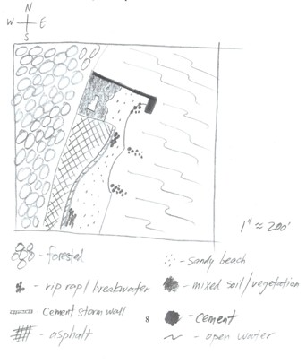
Location: Bloomers Beach – north end
Area: sandy beach, banks altered, pier with rip rap sections, wood bulkhead, collected wood/debris in area, piping approx. 30” located at sampling site, 2 stone breakwaters as well as on shoreline, + cement storm wall
Surrounding Land Use: 20% urban/residential; 40% forested; 20% beach; 20% Industrial/commercial
Bottom: sandy & muddy
Plants in area: none in the water
Water Depth:170 cm at high tide, or 5 ft. 7 inches

ITEM | Time |  | Reading 1 | Reading 2 | Comments
Physical
Air Temperature | 9:45 AM |  | 60°F
Wind Speed | 95 mph |  |  | S
Cloud Cover | clear
Weather today | No precipitation
Weather recently | Above average winds yesterday., rain overnight
Water | Choppy
Water Temperature | 9:50 AM | 15.6 °C  15.6 °C  16.1°C |  | 60°F  60°F  61 °F | 15.7°C  60.3°F
 | 10:50 AM | 21 °C  15.6°C  21°C |  | 70.°F  60 °F  70°F | 19.4°C  67°F
 | 11:30 AM | 18.3°C  17.2°C  16.7 °C |  | 65 °F  63 °F  62 °F | 17.4°C  63.3°F
Turbidity - secchi | 10:43 AM | 16 cm  14 cm  11 cm |  |  | 14 cm
Chemical
Chlorophyll | 10:00 PM | 0.5
DO – ampules | 11:40 AM | 7 mg/L |  | 17.5° C | 70% saturated
pH – indicator sol. | 11:00 AM | 8.0  7.5  8.0 |  |  | 7.8 avg.
Salinity (hydrometer) | 10:45AM | 10 ppt  14 ppt  12 ppt |  |  | 12 ppt average
Fish Catch | Count | Fish |  | Size of largest | Macros
14 ft. X 3 ft seine – pulled 20 ft. | 75 | Atlantic Silverside |  | 4 inches | Blue Crab
3/16 inch mesh |  |  |  | 1 | Mud Crab
 |  |  |  | 2 | Moon Jellies
 |  |  |  | 2 | Sand Shrimp
Seine #1 | 11:30 AM | 12 fish |  | 20 ft pull | .14
Seine #2 | 11:45 AM | 15 fish |  | 20 ft pull | .18
Seine #3 | 12:00 PM | 16 fish |  | 20 ft pull | .19
NOTE | Local fisherman | Caught 2 large stripers ~ 40 inches |  | Caught 1 large blue fish~18-24 inches
Tides | 9:45 | rising |  | 125cm
 | 10:20 | rising |  | 140cm | .43 cm/min
 | 10:50 | rising |  | 150cm
 | 11:20 | rising |  | 165cm | .5 cm/min
 | 11:35 | rising |  | 165cm
 | 12:05 | rising |  | 170cm | .17 cm/min
Currents | • due to local conditions an accurate measurement of the current & not be obtained. |  |  | Flood | North
Core – | 20 cm total | Top layer 6 cm – dark blackish, pudding like |  | Second layer 14 cm – nearly black - clayey
Boats | None
Other Observations

