Snapshot Day 10/8/09 Data
(Salt Front RM 60.3)
RIVER MILE 182
Riverside Park, Schuylerville , Hudson River
Nancy Robertson, Cornell Cooperative Extension
4 H Homeschool Group, The Adirondack School
43°06.59.60 N, 73°34.35.29’W
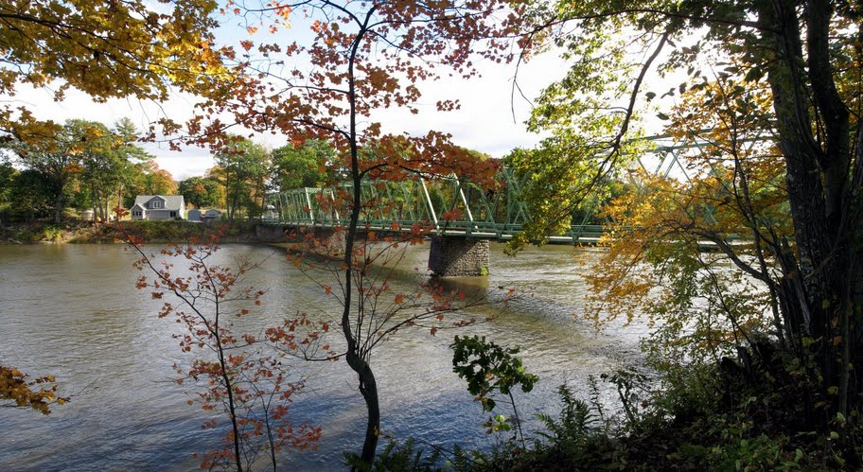
Photo taken of the site on the upper Hudson River.
The Dix Bridge in Hudson Crossing Park
Location: Upper Hudson Lock 5 in Schylerville, NY
Area: Dix Bridge
Surrounding Land Use: urban/residential- 25 %, forested- 75 lightly %, commercial- 0% but evidence of commercial industry in the past- old mills, railroad structures)–The site is the exact spot where General Burgoyne crossed the Hudson during the Rev. War. He picked that site because the river is narrow there and the banks are not as steep. He built a bridge out of boats.
Sampling Site: Rocky and steep, forested, covered with vegetation; Plants in area: Grasses, ferns, moss, wildflowers, mushrooms, golden rod
Trees- red oak, beech, sugar maple, red maple
Water depth: muddy and rocky
Altitude: 86' above sea level
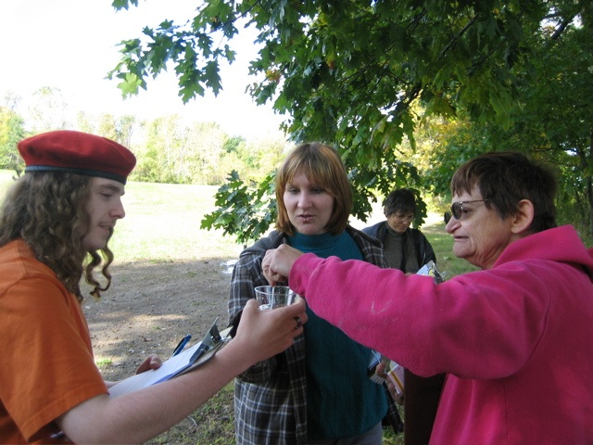 | 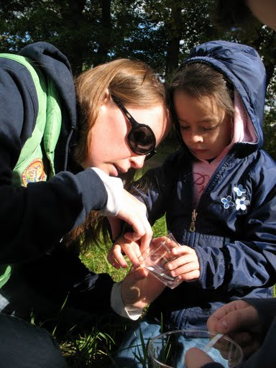 | 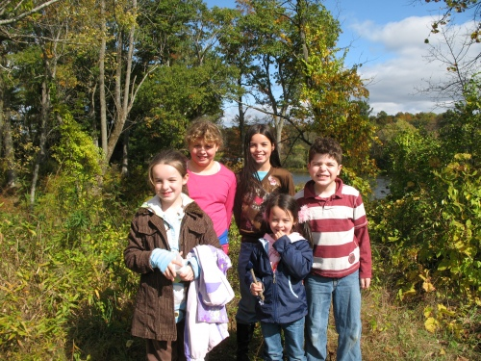

ITEM | Time |  | Reading 1 | Reading 2 | Comments
Physical
Air Temperature | 10:45 AM |  | 16° C
Wind Speed | 10:45 AM |  | gusty | Beaufort #2 | NW
Cloud Cover | Partly cloudy
Weather yesterday | Tues. nice and in the 60s no rain in day but rain during night. Wed. heavy rain in AM and extremely windy in PM, several fast moving fronts blew through over the day.
Water Temperature | 11:00 AM | 12° C
Water surface | Water calm but movement is swift over many rocks
Turbidity

Chemical
PurTest kit
pH | 11:00 AM | 5.5 litmus paper.
Chlorine |  | 1 ppm
Copper |  | 0 ppm
Nitrate |  | 0 ppm
Alkalinity |  | 80 ppm
Iron |  | .3 ppm
Lead |  | Negative
Pest. |  | Positive
Fish Catch | Number Caught | Species |  |  | Minnow traps
Currents | 10:40 AM | 70 cm/sec. |  | South
Other | Canada Geese Flock up, 2 or 3 ducks on the river, songbirds in the trees, evidence of pilated woodpecker nest

