Snapshot Day 10/8/09 Data
(Salt Front RM 60.3)
RIVER MILE East River 1 West
Tara LaPorte, Lower East Side Ecology Center
Jaclyn Hoahing, University Neighborhood High School
11th -12th grade, 24 students
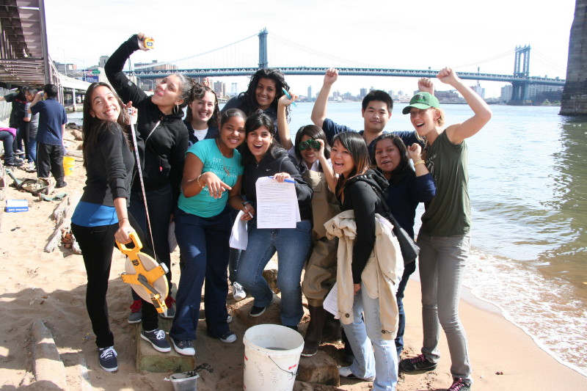
Location: Beach under the Brooklyn Bridge, 125 ft. North of Dover St., Manhattan side
Area: Pier and path for recreational walking, jogging, bike riding and fishing. The surrounding land is sandy with water – beach like. Water best used for fishing & boating. Lots of rocks and sand. Beach is opened to the public but no swimming. Also near a parking lot.
Surrounding Land Use: Urban/residential 50%; Industrial/Commercial 40%; Beach 10%
Sampling Site: Sandy, Beach, covered in vegetation, banks altered, bulkhead with timbers, RipRap. Piping entering river
Plants in area: 5-10% of area – list below
Water depth: 3.5 ft.
River Bottom –weedy
Plants: Vesiculosus (bladder wrack); Sea Lettuce; Lace red weed; bushy red weed; Filiformis; Twig weed.

ITEM | Time |  | Reading 1 | Reading 2 | Comments
Physical
Air Temperature | 10:52 AM |  | 72°F  22°C
Wind Speed | Beaufort #3 |  |  |  | South
Cloud Cover | Partly cloudy |  | No rain
Weather last 3 days | Rainy and windy yesterday
Water surface | choppy
Water Temperature -  Depth 2 ft. | 11:25 AM | 70°F  20°C |  | 65°F  18°C | Avg  67°F  19°C
 | 11:45 AM | 68°F  19°C |  | 66°F  19°C | Avg  67°F  19°C
Turbidity
Long site tube
Chlorophyll | 11:15 AM | .5-.7 |  | 11:25 AM | .3
Chemical
DO - drop count kit | 10:50 Am | 18°C |  | 4 ppm | 40%
 |  | 19 °C |  | 8 ppm | 85%
pH | 10:45 AM | 7.9  7.7 |  |  | Avg, 7.8
 | 11:55 AM | 7.7
 | 11:51 AM | 8.0  7.7  7.8 |  |  | Avg. 7.8
Salinity  (Hydrometer) | 11:25 AM | 25 ppt  27  23 |  |  | Avg. 25 ppt
 | 11:46 AM | 22 ppt  23  26 |  |  | Avg. 24 ppt
Fish Catch | Number Caught | Species
Other organisms
Tides
 | 10:45 AM | 20 ft.
 | 11:33 AM | 21 ft. |  | rising
Currents
Evidence of pollution | garbage | pollution
Shipping | 10:06 AM | DEP white |  | Northbound | Full
 | 10:07 AM | Police blue |  | Southbound | Empty
 | 10:40 AM | Coastguard white, orange, black |  | Northbound | Empty
 | 11:15 AM | Zephyr, white & blue
Other Items | FOUND A RED-EARED SLIDER TURTLE ON THE BEACH (didn’t look so well). There are people fishing, exercising, birds flying on water and on land. Lot of garbage in the water and on the beach.

