Snapshot Day 10/8/09 Data
(Salt Front RM 60.3)
RIVER MILE 30.5 – Summit School Beach
Diana Cutt, U. S. EPA
Czarnetzki, G. Rameshar, E. Bobo, Upper Nyack Elementary School
60 - 3rd graders
41°06’11.39”N - 73°54’53.38” W
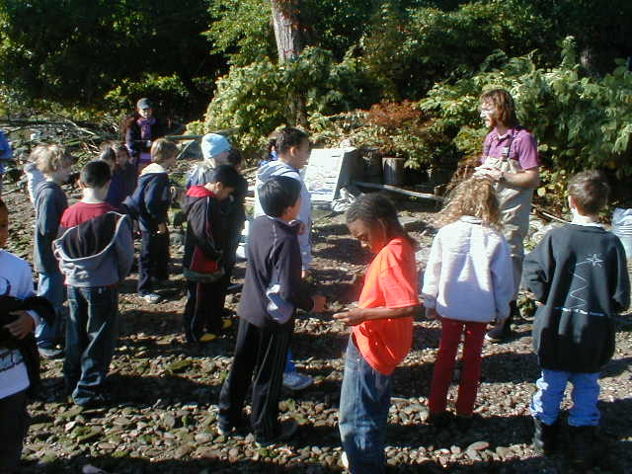 | 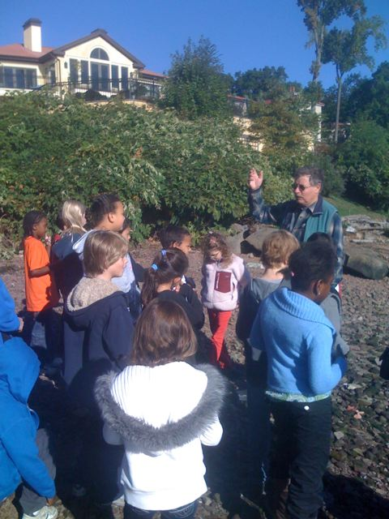 | 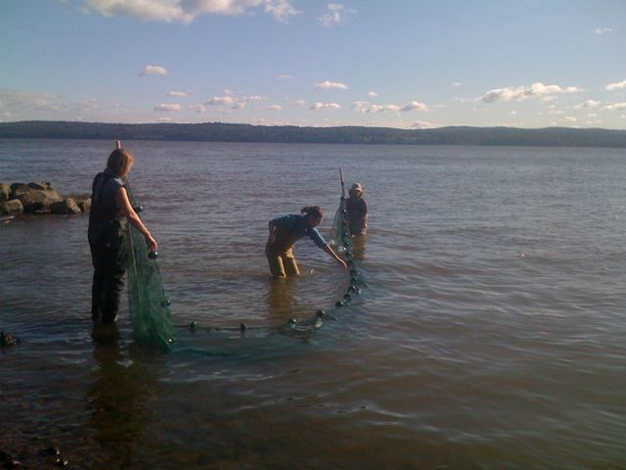

Location: Summit School Beach across from Upper Nyack El. School on N. Broadway
Area: Park/Boat launch, sandy beach area on the point
Surrounding Land Use: 75% residential, 10% forested, 5% beach, 10% school
Sampling Site: Beach – with a lot of vegetation, sandy and rocky at edges, collected wood debris in area, rocky
Plants in water: no
Water depth: 2-4 feet
River Bottom – muddy, rocky

ITEM | Time |  | Reading 1 | Reading 2 |  | Comments
Physical
Air Temperature | 9:30 AM |  | 25.55°C | 78°F
 | 10:30 AM |  | 27.7°C | 82°F
Wind Speed | Beaufort 2 |  | 9:50 AM | NE |  | 1-2 mph Anenometer
Gusty wind | Beaufort 1 |  | 10:05 AM | SW
Cloud Cover | Partly cloudy
Weather today | No rain – windy
Weather last 3 days | Periods of rain, overcast, high winds
Water | Calm
Water Temperature | 9:37 AM | 18.3°C  18.3  17.8  18.3  18.3 |  |  |  | 18.3°C
Turbidity  Long site tube | 9:50 AM | 64.2 cm  27  46.2  21 |  |  |  | 39.6 cm average
Chlorophyll | 10:48 AM | 0.1 each
Chemical
DO  Drop count | 11:02 AM | 5 mg/L |  | 18 ° C |  | 50%
pH  Litmus paper | 10:00 AM | 6.5  6.5  6.5 |  |  |  | Average 6.5
Phosphate
Nitrates
Salinity  hydrometer | 10:10 AM | 0 ppt  4 ppt  6 ppt |  |  |  | Average  3.33 ppt
Fish Catch | Number Caught | Species
Seine 30 ft. X 4ft.  Mesh 0.25 inch | 4 | Atlantic Silverside |  | 8 cm |  | SEINE #1
9:20-9:50 AM | 1 | Striped Bass |  | 16 cm |  | SEINE #2
3 seines – catches 4/2/4 | 1 | Male blue crab |  | 14.5 cm
 | 1 | Banded killifish |  | 4.5 cm |  | SEINE #3
 | 3 | Atlantic Silversides |  | 8 cm
Tides | 8:00 AM | 35.5 cm
 | 9:37 AM | 71 cm |  | rising
 | 10:19 AM | 91.5 cm |  | rising
Currents | North/South
9:44 AM | South | Discussed with kids why orange moved S when we knew tide was coming in - Not in main channel – river is wide here
10:20 AM | South

