Snapshot Day 10/8/09 Data
(Salt Front RM 60.3)
RIVER MILE 31 – Hook Mountain State Park
Laurie Seeman & Joanne Dickey– Strawtown Art & Garden Studio
Lorraine Marden Komar & Meredith Kates -Blue Rock School –
6^{th,} 7th & 8th – 22 students
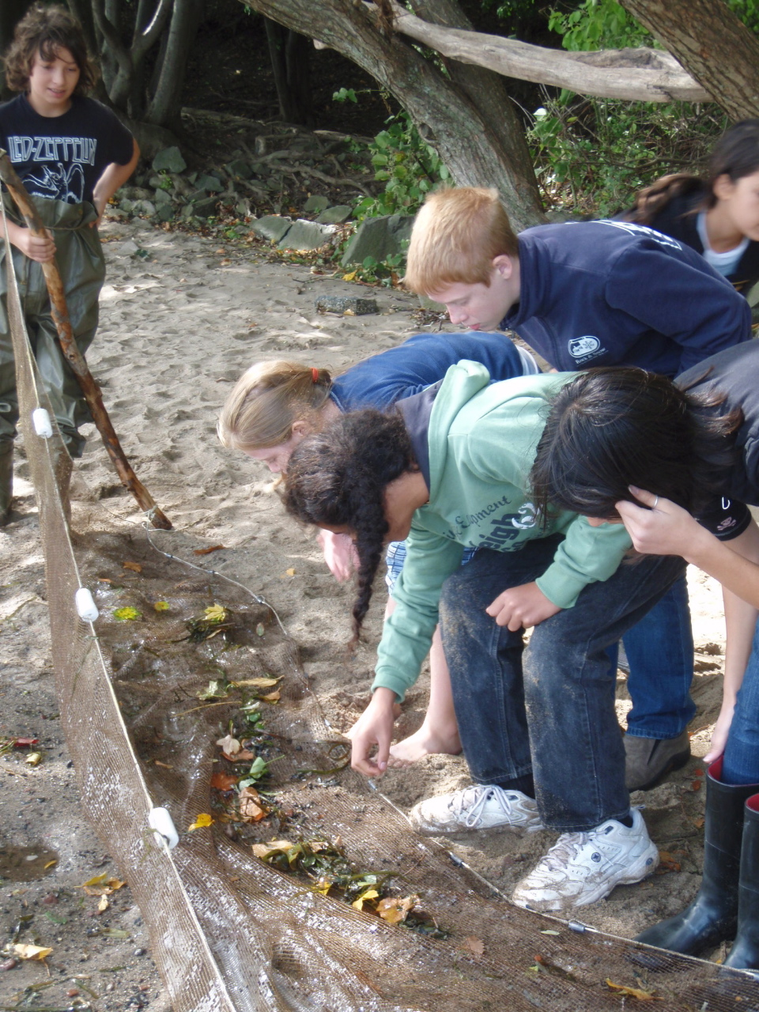 | 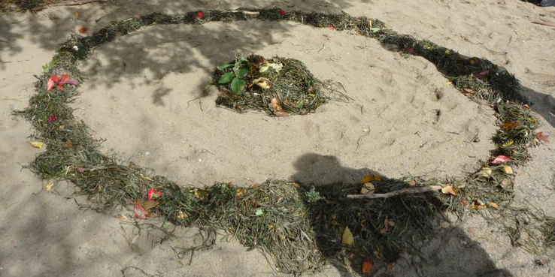  Center image: A water celery Earth Art Medicine Wheel of the Hudson River  Laurie Seeman & Joanne Dickey  & students | 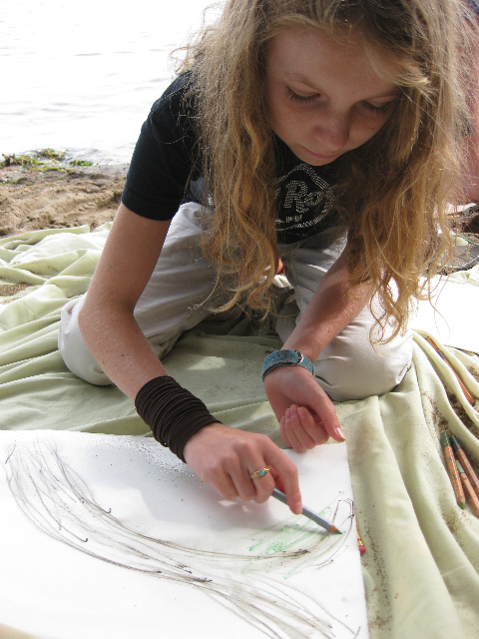

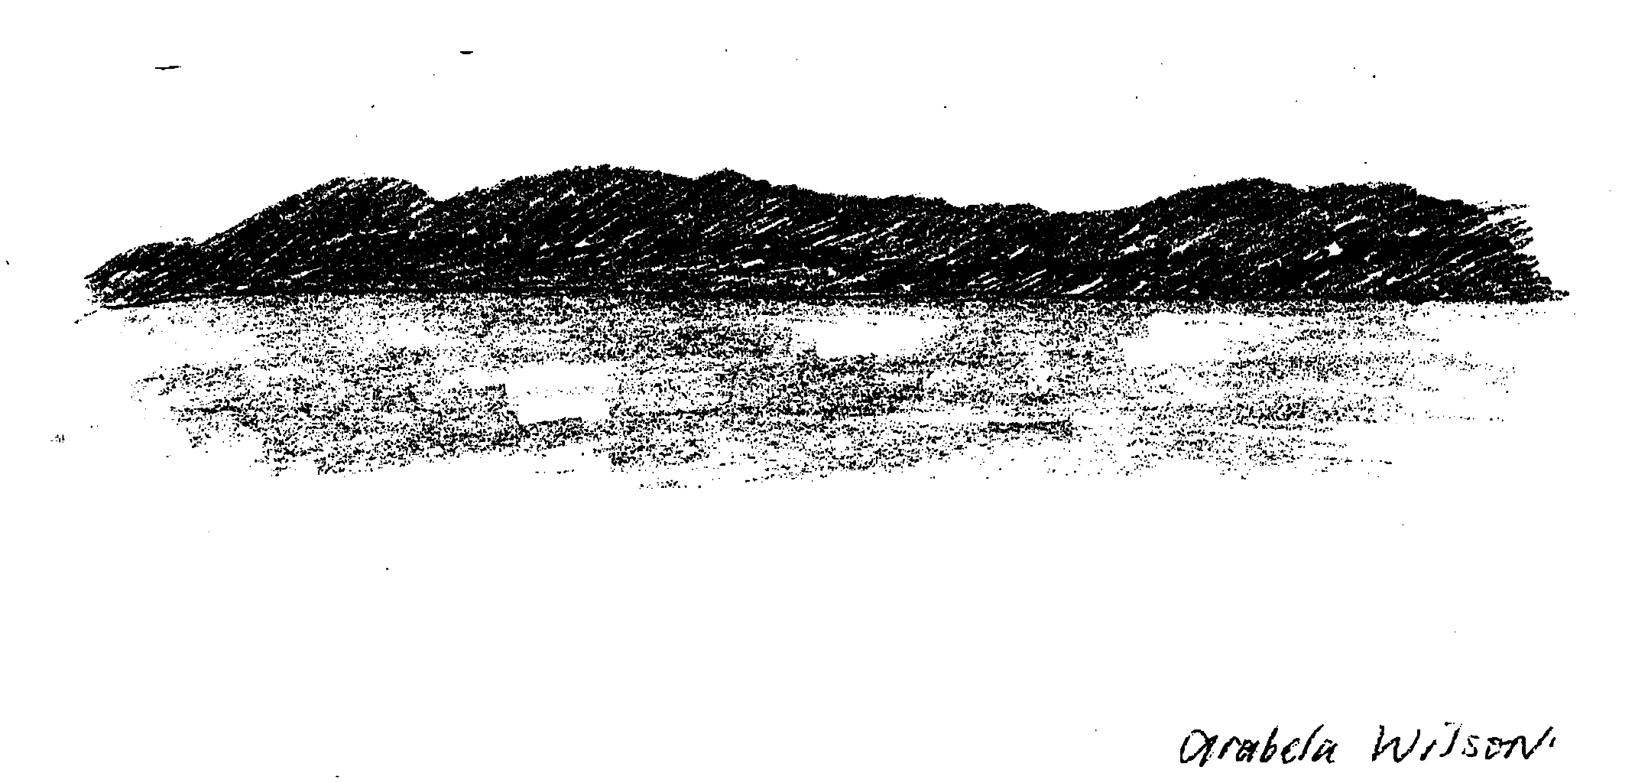
Location: Nyack Beach near Hook Mountain Sandy Beach right side of riverfront area
Area: Park/Boat launch, sandy beach area on the point
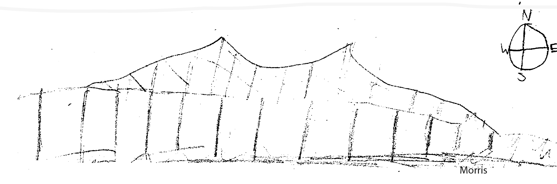
Surrounding Land Use: 50% forested, 20% beach, 30% used for recreation & picnics and parking lot
Sampling Site: Beach – with a lot of trees, picnic tables, sandy and rocky at edges, covered with vegetation beyond the beach, stone wall, riprap shore, collected wood debris –not many houses.
Piping coming into river south of sampling site
Plants in water: 1% water celery
Plants in area: Japanese Knotweed 50%; Sumac
Water depth: 18 inches
River Bottom –sandy, muddy, rocky

ITEM | Time |  | Reading 1 | Reading 2 | Comments
Physical
Air Temperature | 11:02 AM |  | 18°C  18  17 | 66°F  66  65 | 17.6°C  65.66°F
 | 11:34 AM |  | 18°C  18 | 66°F  66 | 18°C  66°F
Wind Speed | Beaufort 3 |  |  | NE
 |  |  |  |  | Water Calm
Cloud Cover | clear
Weather today | No rain – windy
Weather last 3 days | Very windy, rainy
Water Temperature | 11:10 AM | 20°C |  | 20°C | 20°C
 | 1:04 PM | 21°C |  | 21°C | 21.5°C
 | 1:44 PM | 21°C |  | 21°C | 21°C
Turbidity | 1:04 PM | 5 JTU  10 JTU  5 JTU |  |  | 6.7 JTU average
Chlorophyll | 10:48 AM | 0.1 each
Chemical
DO  Drop count | 11:02 AM | 5 mg/L |  | 18 ° C | 50%
pH  Indicator solution | 11:45 AM | 8.0  8.0  7.0 |  |  | Average 7.6
Phosphate | 10:25 AM | 1 ppm |  | 1 ppm | Average 1 ppm
Nitrates | 10:45 AM | 5 ppm |  | 5 ppm | Average 5 ppm
Salinity  Test strip/ | 10:45 AM | 3300 ppm  3594 ppm  3594 ppm |  | 3.3 ppt  3.6 ppt  3.6 ppt
Fish Catch | Number Caught | Species
Seine 12 ft. X 6ft.  Mesh 0.25 inch | 2 | Atlantic Silverside |  | 1.5 inch | SEINE #1
8 feet of pull | 10 | Atlantic Silverside (?) |  | 3.5 inch | SEINE #2
3 seines | 1 | Killifish |  | 1.25 inch
 | 1 | Mini crab |  | .75 inch
Tides | 11:35 AM | 24 cm
 | 11:55 AM | 28 cm |  | rising
 | 12:53 PM | 38 cm |  | rising
 | 1:13 PM | 44 cm |  | rising
Currents | CM/60 secs | Cm/Sec |  | North/South Ebb/Flood/Still | Knots
11:43 AM | 168 cm | 2.8 |  | South (Ebb) | 0.05 kts
12:56 PM | 258 cm | 4.1 |  | South (Ebb) | 0.088 kts
Turbidity  Short site tube | 10:45 Am | 40 JTU |  | 40 JTU | Average 40 JTU
Core Description | Total Length | Top Layer |  | Second Layer | Describe
Commercial Traffic |  | Grey Speedboat |  |  | Northbound – ½ full
Other | ducks swimming, cormorants diving  Some litter and footprints

