Snapshot Day 10/8/09 Data
(Salt Front RM 60.3)
RIVER MILE 31 – Nyack Beach Hook Mountain State Park
Kim Kastens & Dale Chayes, Lamot-Doherty Earth Observatory
Cathy Van Saun –Nyack Middle School – 8th grade – 31 students
41°07.5”N 73°54.5”W
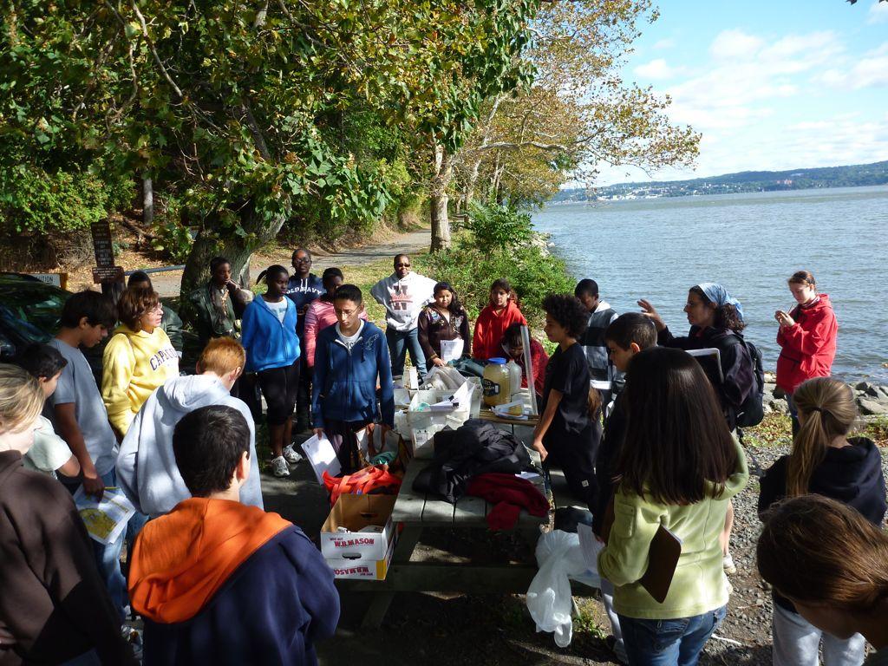 | 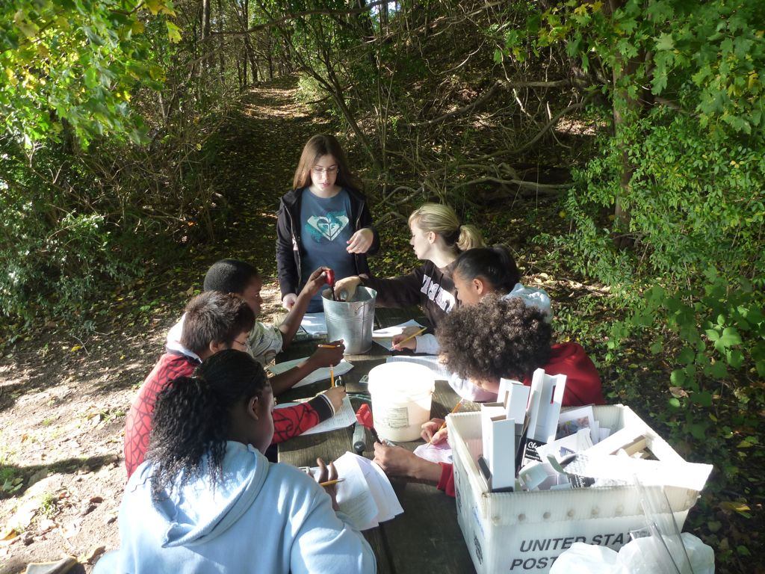

Location: Nyack Beach, Upper Nyack, Rockland County NY
Area: Park/Boat launch, near Hook Mountain Sandy Beach by the large sitting stairs, Surrounding Land Use: 70% forested, 5% urban/residential, 20% beach – used for recreation & picnics
Sampling Site: Beach – sandy and rocky at edges, covered with vegetation beyond the beach, stone wall, riprap shore, collected wood debris –
Piping coming into river south of sampling site
Plants in area:
Water depth:
River Bottom –sandy

ITEM | Time |  | Reading 1 | Reading 2 | Comments
Physical |  |  |  | Beaufort Scale
Air Temperature | 9:19 AM |  | 52°F  17°C | #2
 | 9:26 AM |  | 60°F  20°C | #3
 | 9:55 AM |  | 62°F  16.67°C | #6 | Wind increasing
 | 10:04 AM |  | 60°F  20°C | #4
Wind Speed | 20 kts |  |  | NE
 |  |  |  |  | Water Choppy
Cloud Cover | clear
Weather today | No rain – windy
Weather last 3 days | Very windy, a bit chilly, rainy.
Water Temperature | 9:18 AM | 61°F |  | 16°C | 4 cm depth
 | 9:36 AM | 62.6°F |  | 17°C | 4 cm
 | 9:58 AM | 62.9°F |  | 17.17°C | 3 cm
 | 10:33 AM | 62.6°F |  | 17°C | 3cm
 | 10:35 AM | 62.5°F |  | 16.94°C | 2cm
Turbidity | 9:05 AM | 16 cm  17.75 cm  19 cm |  |  | 17.6cm average
Chlorophyll
Chemical
DO  Drop count | 11:10 AM | 8 mg/L |  | 20 ° C | 90%
pH  Colormetric kit | 9:15 AM-10:35 AM twelve readings | 8.70  8.63  8.61  8.65  8.64  8.57 |  | 8.42  8.43  8.42  8.44  8.27  8.39 | Average 8.51
Salinity  meter/ | 9:36AM | 9.13 uS |  | 5.13 ppt | • converted from conductivity
 | 10:25 AM | 9.24 uS |  | 5.17 ppt
 | 10:26 AM | 9.39 uS |  | 5.26 ppt
 | 10:29 AM | 9.36 uS |  | 5.24 ppt
 | 10:32 AM | 9.48 uS |  | 5.31 ppt
Fish Catch | Number Caught | Species |  | Macroinvert.
Seine 12 ft. X 6ft.  Mesh 0.25 inch | 1 | American Eel |  | 16 | Blue Crabs
 | 2 | Banded Killifish |  | 150 | Amphipods
 | 2 | Common Blenny
 | 4 | Atlantic Silverside
Tides | 9:00 AM | 26 cm
 | 9:15 AM | 36 cm |  | rising
 | 9:34 AM | 45 cm |  | rising
 | 9:45 AM | 57cm |  | rising
 | 10:10 AM | 63 cm |  | rising
Currents | CM/60 secs | Cm/Sec |  | North/South Ebb/Flood/Still | Knots
9:15 AM | 60 cm | 1 cm/sec |  | flood
10:25 AM | 200 cm | 3.3 cm/sec |  | flood

