Snapshot Day 10/8/09 Data
(Salt Front RM 60.3)
RIVER MILE 96.5
Ulster Landing State Park, Town of Ulster, Ulster Co.
Latitude 42°N, Longitude 73°56’W
Lia Harris, Cary Institute of Ecosystem Studies
Dixon Onderdonk, Kingston High School 11/12th graders – 12 students

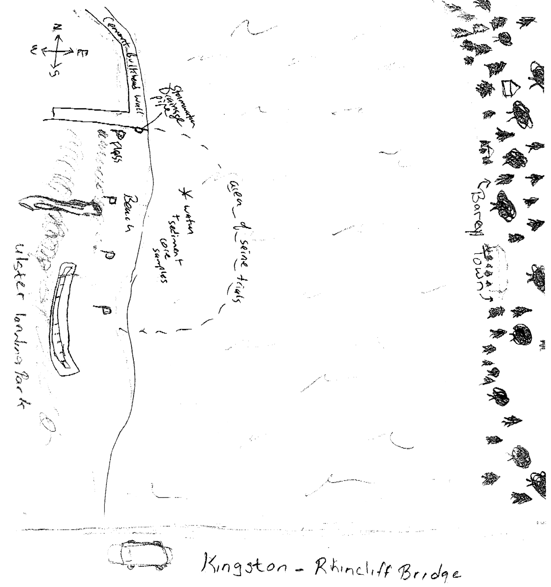
Location: Swimming beach, Ulster Landing Park, Town of Ulster, Ulster County
Area: fishing, swimming beach, has a building with restrooms
Surrounding Land Use: Beach 40%; Forested area 45%, Industrial/Commercial 15%
Sampling Site: beach, altered bank with concrete bulkhead, wood debris driftwood, drainage from bulkhead north of site immediately
Plants in area: yes
Water depth: 3 ft.
River Bottom : sandy, muddy bottom
Plants: Tidal flats – 49% water chestnut; 49% water celery; 2% water milfoil

ITEM | Time |  |  |  | Reading 1 | Reading 2 | Comments
Physical
Air Temperature | 9:45 AM |  |  |  | 10.56°C  51 °F
Wind Speed | 2 Beaufort |  |  |  | 4 kts. | East
Cloud Cover | partly cloudy |  |  |  | No rain
Weather today
Weather recently | Few showers and wind
Water Temperature | 9:05AM |  |  | 15°C  15  15 |  | 59°F  59  61 | 15°C  59°F
 | 10:10 AM |  |  | 16°C  17  16 |  | 63°F  61  63 | 17°C  69°F
 | 11:40 AM |  |  | 19°C  19  19 |  | 66°F  66  66 | 15°C  66°F
Water Surface | calm
Turbidity  turbidimeter | 10:35 AM |  |  | 61 NTU  60.2  60.5 |  |  | 60.6 NTU
Chlorophyll | 10:17 AM |  |  | 1.0
Chemical
DO - meter | 10:09AM |  |  | 8.6 mg/L |  | 16°C | 85% saturated
(Hach DR-890) | 10:09 AM |  |  | 9 mg/L |  | 16°C
pH | 10:20 AM |  |  | 7  8  6.5 |  | 7.17 | Indicator sol.
 | 10:00 AM |  |  | 8.01  7.94  8.0 |  | 8.0 | meter
Phosphate | 10:30AM |  |  | 2.75 ppm  2.75 ppm  2.75 ppm |  |  | 2.75 ppm
Nitrate - | 10:18 AM |  |  | 0.5 ppm |  |  | 0.17 ppm
Alkalinity | 10:18 AM |  |  | 164 mg/L  116mg/L  88 mg/L |  |  | 122.7 mg/L
Salinity – drop count test kit | 12:00 PM |  |  | 40 ppm  48 ppm  41 ppm |  |  | 43 ppm
 | 12:00 PM |  |  | 39 ppm  28 ppm  32 ppm |  | 33 ppm Cl | 41.25 ppm salinity
Fish Catch  27.5’seine X 1/18 inch mesh | Number Caught per seine |  |  | Species |  | Length of largest | Seine
7 seines | 3 | 2 |  | Pumpkinseed |  | 11 cm
Pull 50 ft. | 30 | 19 | 20 | Spottail Shiner |  | 11.5 cm
 | 15 | 11 | 14 | Bluegill
 | 13 | 8 | 4 | Banded Killifish |  | 10 cm
 | 2 | 3 | 25 | White Perch |  | 14 cm
 | 1 |  |  | Herring
 | 8 | 5 | 10 | Yellow Perch
 | 3 | 3 | 3 | Striped Bass
 |  | 2 |  | Four spine stickleback
 | 8 | 2 |  | Blue Crab
 | 3 | 1 | 7 | Crayfish
Pull | Time |  |  | Catch |  | CPUE | PULL
Seine #1 | 12:00 PM |  |  | 87 fish |  | 0.21 | 50 ft. pull
Seine #2 | 12:30 PM |  |  | 56 fish |  | 0.13 | 50 ft. pull
Seine #3 | 1:00 PM |  |  | 83 fish |  | 0.19 | 50 ft. pull
Tides | 9:00 AM |  |  | Falling |  | 9 cm
 | 9:15 AM |  |  | Falling |  | 7 cm
 | 9:30 Am |  |  | Falling |  | 6.5 cm
 | 9:45 Am |  |  | Falling |  | 2 cm
 | 10:00 AM |  |  | Falling |  | -5 (away from tide stick
 | 10:15 AM |  |  | Falling |  | -15
 | 10:30 Am |  |  | Falling |  | -40
 | 10:45 AM |  |  | Falling |  | -50
Currents  8:45 AM | 125 cm/60 secs |  |  | 2:08 cm/sec. |  | 0.04 knots | South  Ebb
9:15 Am | 130 cm/60 secs |  |  | 2:16 cm/sec |  | 0.042 knots | South  Ebb
9:45 Am | 140 cm/60 secs |  |  | 2:30 cm/sec |  | 0.044 knots | South  Ebb
10:15 AM | 133 cm/60 secs |  |  | 2:22 cm/sec |  | 0.043 knots | South  Ebb
10:45 AM | 128 cm/60 secs |  |  | 2:13 cm/sec |  | 0.041 knots | South  Ebb
Traffic | 8:35 AM |  |  | Barge/ |  | Eastern Dawn | South
 | 10:17 Am |  |  | US Coast guard |  |  | North
 | 11:25 AM |  |  | Barge |  |  | South
Other Items | Lots of wrack
Core | Length |  |  | Top |  | Bottom
 | 11 inches |  |  | 4 inch top |  | 7 inch bottom

