Snapshot Day 10/8/09 Data
(Salt Front RM 60.3)
HARLEM RIVER MILE 13
Sherman Cove/Swindler’s Cove Park on the Harlem River
Obed Fulcar, George Washington HS, MS 319 – 7-12th graders – 6 students

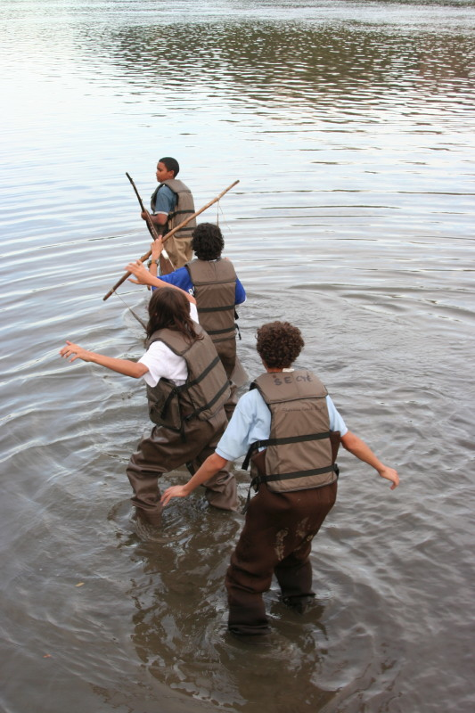
Location: Beach at Sherman Cove Park, adjacent to Swindler Cove next to the north end of Harlem River Drive, Manhattan
Surrounding Land Use: 50% urban/residential, 20% forested, 5% beach, 15% Industrial/commercial, 10% other
Sampling Site: Beach area, covered with vegetation Rip Rap used on beach, shoreline is sandy and rocky,
Plants in area: 50% of site is Phragmites
Water depth: 0.5 ft.
River Bottom: sandy & rocky bottom
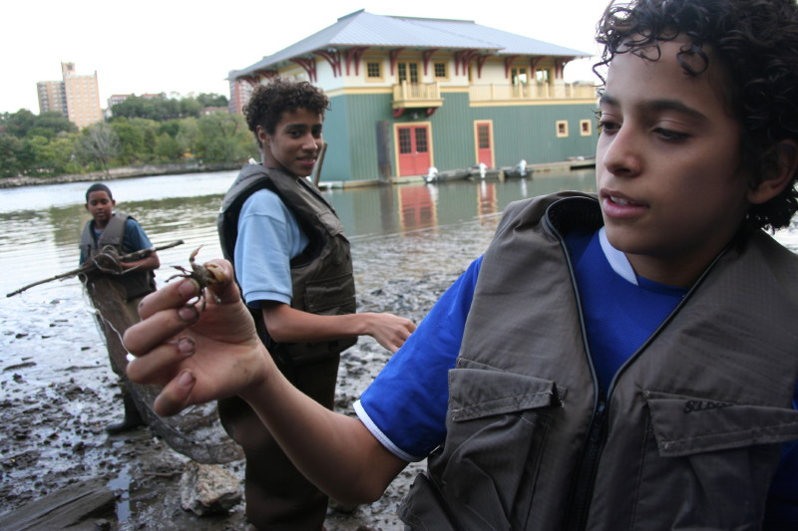
ITEM | Time |  | Reading 1 |  | Reading 2 | Comments
Physical
Air Temperature
Wind Speed
Cloud Cover | Partly cloudy
Weather today | No rain
Weather recently | Windy and rain
Water Temperature | 5:20PM | 17°C |  |  |  | Shady- 0.5 ft. water
Turbidity | 5:20 PM | 40 JTU |  | short sight tube
Chlorophyll
Chemical
DO  (LaMotte Green force kit) | 5:20 PM | 6.0 ppm |  | 17°C |  | 63% saturated
pH – LaMotte
Salinity - hydrometer | 5:20 PM | 11 ppt
Fish Catch | Number Caught | Species |  | CPUE |  | Size
 | 12 | Mummichogs
 | 12 | silversides
 | 6 | Juvenile blue crabs
 | 3 | mud crabs
 | 3 | Fiddler crab
 | 1 | Juvenile American Eel
E Coli | Positive Results
Core Sample Sediments | Whole core | Top layer |  | Bottom layer |  | description

