Piermont Phragmites & Macros Study
10/8/09

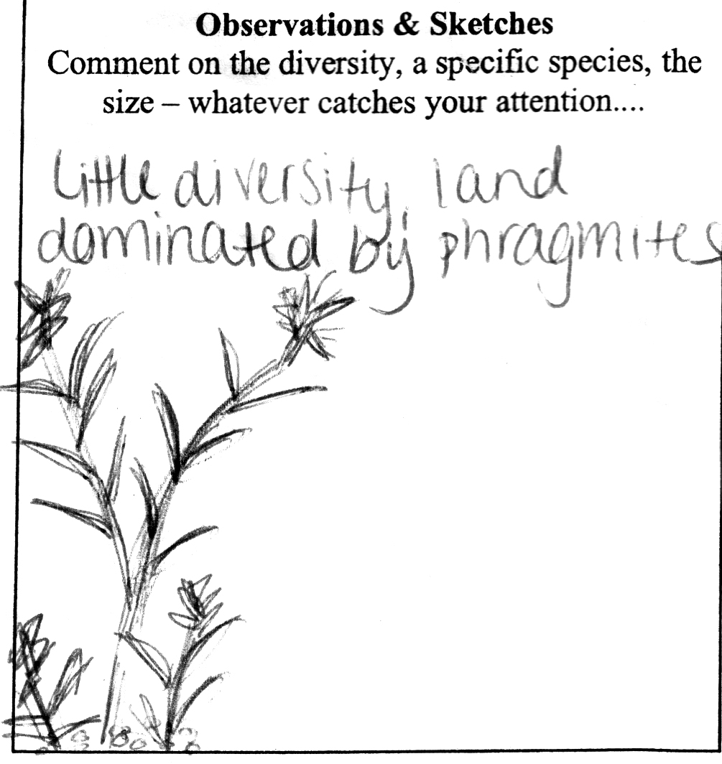

Names in team: Black/Purple (only 1 group) Time:___9:40 AM_____
Kelly Mulligan, Neal Franco

Rotation# (example 1a): 1a Transect #__1____

Latitude: 45.44N Longitude: 18.594E

Accuracy Reported on GPS:_________N/A_______________

Record the number of stems in a 30 X 30 cm square for phragmites & ‘other’ species. If you can identify the other species please do so.

PLANT  SPECIES | Distance along the transect line (m)
PLANT  SPECIES | 0 | 2 | 4 | 6 | 8 | 10
Phragmites | 18 | 20 | 25 | 2 | 0 | 2
Others | 0 | 0 | 3 | 1 | 0 | 2
Comments | Mainly land | Mainly land | Mainly land | Half water half land | All underwater | Not a lot of vegetation in water

Observations: Piermont Phragmites & Macros Study
10/8/09

Names in team: Red Team 1 Time:__10:40 AM______
Shannon, Rebecca, Steven, Luke, Grace, Jackie, Laura

Rotation# (example 1a): 2a Transect #__2____

Latitude: 45.44061N Longitude:18.592465E

Accuracy Reported on GPS:___________N/A_____________

Record the number of stems in a 30 X 30 cm square for phragmites & ‘other’ species. If you can identify the other species please do so.

PLANT  SPECIES | Distance along the transect line (m)
PLANT  SPECIES | 0 | 2 | 4 | 6 | 8 | 10
Phragmites | 45 | 25 | 31 | 12 | 28 | 24
Others | 0 | 0 | 0 | 0 | 0 | 0
Comments

Observations: Lots of phragmites. Mud is uniformly covered with a type of aquatic plant (moss/algae).

Bird & Animal Usage: None.

************************************************************************
Identify Macros located in area – include identification sketch & measurements – Please feel free to use the back for this work.

Mostly phragmites, little other vegetation.

Piermont Phragmites & Macros Study
10/8/09

Names in team: Red Team 2 Time:__11:00 AM______
Aditi, Amanda, Sharon, Kevin, Nick, Sam, Dimitry, Yuvian

Rotation# (example 1a): 2b Transect #__2____

Latitude: 45.44061N Longitude:18.592465E

Accuracy Reported on GPS:___________N/A_____________

Record the number of stems in a 30 X 30 cm square for phragmites & ‘other’ species. If you can identify the other species please do so.

PLANT  SPECIES | Distance along the transect line (m)
PLANT  SPECIES | 0 | 2 | 4 | 6 | 8 | 10
Phragmites | 47 | 23 | 26 | 13 | 35 | 18
Others | 0 | 0 | 0 | 0 | 0 | 0
Comments

Observations:

Bird & Animal Usage: None.

************************************************************************
Identify Macros located in area – include identification sketch & measurements – Please feel free to use the back for this work.
Piermont Phragmites & Macros Study
10/8/09

Names in team: Orange Team 1 Time:__11:13 AM______
Harry, Megan, Julianne, Deven, Doug, Will

Rotation# (example 1a): 3a Transect #__2____

Latitude: 45.44061N Longitude:18.592465E

Accuracy Reported on GPS:___________N/A_____________

Record the number of stems in a 30 X 30 cm square for phragmites & ‘other’ species. If you can identify the other species please do so.

PLANT  SPECIES | Distance along the transect line (m)
PLANT  SPECIES | 0 | 2 | 4 | 6 | 8 | 10
Phragmites | 57 | 19 | 36 | 18 | 39 | 17
Others | 0 | 0 | 0 | 0 | 0 | 0
Comments

Observations:

Bird & Animal Usage: None.

************************************************************************
Identify Macros located in area – include identification sketch & measurements – Please feel free to use the back for this work.
Piermont Phragmites & Macros Study
10/8/09

Names in team: Orange Team 2 Time:__11:30 AM______
Ryan, Katy, Emily, Robert, Joscelyn, Sammie

Rotation# (example 1a): 3b Transect #__2____

Latitude: 45.44061N Longitude:18.592465E

Accuracy Reported on GPS:___________N/A_____________

Record the number of stems in a 30 X 30 cm square for phragmites & ‘other’ species. If you can identify the other species please do so.

PLANT  SPECIES | Distance along the transect line (m)
PLANT  SPECIES | 0 | 2 | 4 | 6 | 8 | 10
Phragmites | 23 | 17 | 24 | 11 | 24 | 32
Others | 0 | 0 | 0 | 0 | 0 | 0
Comments |  |  |  |  |  | Counted more phragmites than there appeared to be

Observations: It seems like there would be more phragmites in more moist and lower leveled areas, but the numbers seem to vary sporadically.

Bird & Animal Usage: Several shells

************************************************************************
Identify Macros located in area – include identification sketch & measurements – Please feel free to use the back for this work.

Piermont Phragmites & Macros Study
10/8/09

Names in team: Blue Team (1 group only) Time:__12:30PM__
Kimberly, Danny, Kelly, Ciara, Pamela, Tim, Aaron, Steven, Nick

Rotation# (example 1a): 4a Transect #___3___

Latitude: 45.44065N Longitude: 18.592458E

Accuracy Reported on GPS:____________N/A____________

Record the number of stems in a 30 X 30 cm square for phragmites & ‘other’ species. If you can identify the other species please do so.

PLANT  SPECIES | Distance along the transect line (m)
PLANT  SPECIES | 0 | 2 | 4 | 6 | 8 | 10
Phragmites | 38 | 39 | 34 | 35 | 17 | 37
Others | 0 | 0 | 0 | 0 | 0 | 0
Comments

Observations: The phragmites are an invasive species that have driven out the cat tails and other organisms.

Bird & Animal Usage:

************************************************************************
Identify Macros located in area – include identification sketch & measurements – Please feel free to use the back for this work.
Piermont Phragmites & Macros Study
10/8/09

Names in team: Green Team (only 1 group) Time:__1:00PM__
?

Rotation# (example 1a): 5a Transect #___3___

Latitude: 45.44065N Longitude: 18.592458E

Accuracy Reported on GPS:____________N/A____________

Record the number of stems in a 30 X 30 cm square for phragmites & ‘other’ species. If you can identify the other species please do so.

PLANT  SPECIES | Distance along the transect line (m)
PLANT  SPECIES | 0 | 2 | 4 | 6 | 8 | 10
Phragmites | 39 | 6 | 18 | 38 | 19 | 32
Others | 0 | 0 | 0 | 0 | 0 | 0
Comments

Observations:

Bird & Animal Usage:

************************************************************************
Identify Macros located in area – include identification sketch & measurements – Please feel free to use the back for this work.

