Snapshot Day 10/14/10 Data
(Salt Front RM 36)
Brighton Beach, Brooklyn NY
Carol Ma – International HS @ Lafayette, K337
160 students, 9th & 10th graders
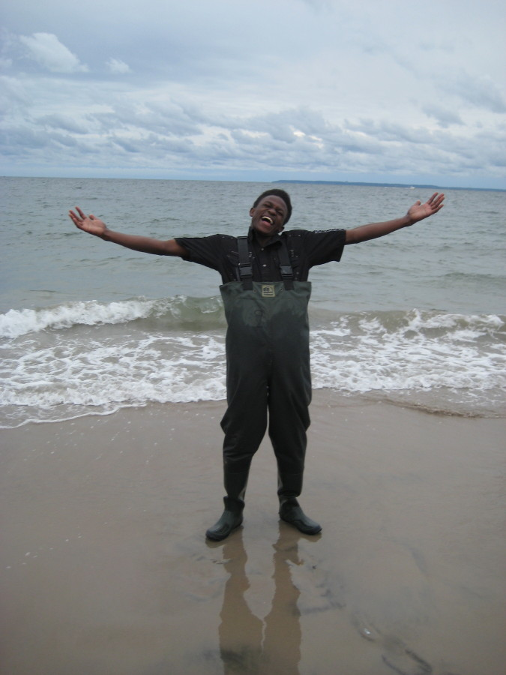
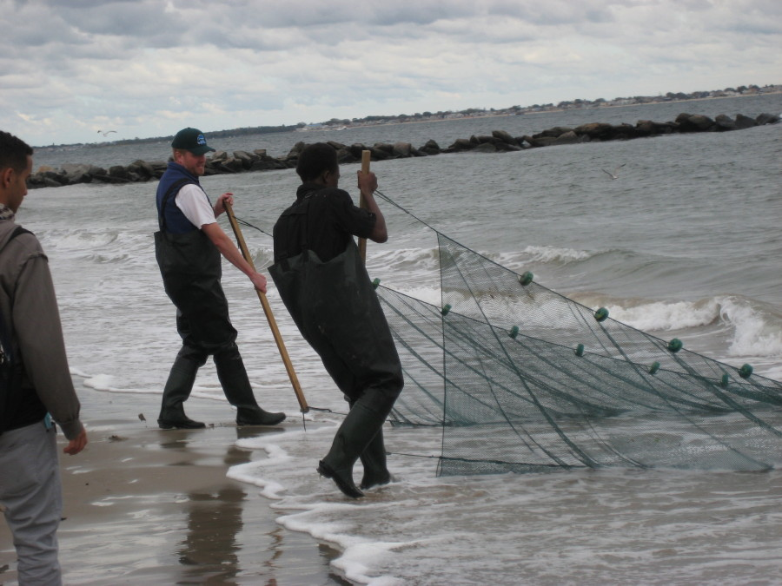

Location: Brighton Beach, Brooklyn
Area: Beach mainly
Surrounding Land Use: 65% residential; 10% forested; 5% recreational; 20% commercial
Sampling Site: Beach,
Depth:
Plants in area: No plants in the water

ITEM | Time |  | Reading 1 | Reading 2 | Comments
Physical
Air Temperature | 12:04 PM |  | 21°C  70°F
 | 1:04 PM |  | 20°C  68°F
Wind Speed
Cloud Cover | Partly cloudy
Weather today | No rain
Water Condition | Calm at noon but choppy by 1PM
Water Temperature | 12:32 PM | 28°C  18 °C  18 °C |  |  | Average  21.33°C
 | Because the water is cool and cool water has more oxygen than hot water I expect to find a lot of oxygen in the water.
Turbidity  secchi | Water looks clean
Chlorophyll | 1:00 PM | 0 |  | Color is light means little chlorophyll
Chemical
DO  (drop count kit) | 12:02 PM | 4 mg/L |  | 21.33°C | Oxygen level very low – 40% saturated
pH meter | 12:04PM | 8.0 |  |  | pH is healthy
Salinity
Fish Catch | Total | Fish
 | ~30 | Atlantic Silverside
 | 1 | Northern Kingfish |  |  | 3 cm long
Tides
Currents

Core – | Length | Common |  | Rare | Comment
1:37 PM | 5.5 inches | Clay, mud, stones |  | sand | No H2S smell or oxidized top
Pollution | There are no garbage cans on the sand but there are on the boardwalk. I have seen garbage in the water today. If there are more people they will throw more things in the water and this will make pollution increase.
Biotic Organisms I saw & observations | Plants, Animals, Birds, People. I saw birds and fishes. People can do fishing and sell them and earn money. People can eat fish.
Abiotic things I saw | Sand, water, rocks, metal. I saw broken glass, papers, plastic bags and bottles on the beach, and cigarette butts.

