Snapshot Day 10/14/10 Data
(Salt Front RM 36)
URBAN DIVERS ESTUARY CONSERVANCY
HARLEM RIVER URBAN ECOLOGY CENTER RM 12 (HARLEM)
ROBERTO CLEMENTE PARK, HARLEM
Urban Diver Educators Ludgar K. Balan
Interns - 6 young people
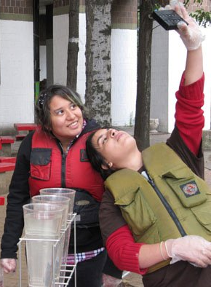 | 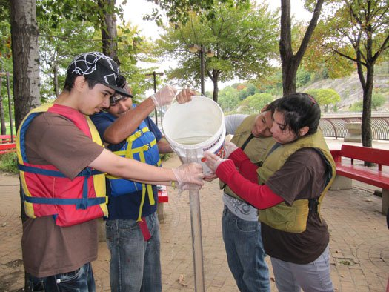

Location: Harlem River @ the Urban Ecology Center, Roberto Clemente Park
Area: Urban towers at the Southern end of park area
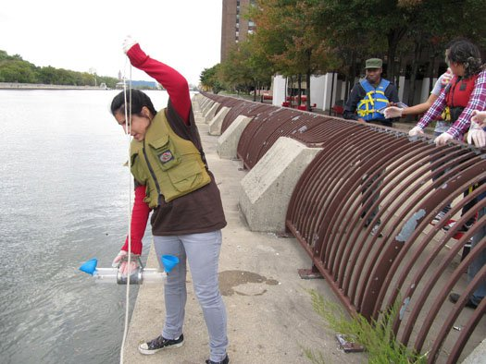
Surrounding Land Use: Residential high rise tower, park area
Sampling Site: See photo
Plants in area:
Water depth: ~ 19 ft.
River Bottom –
ITEM | Time |  | Reading 1 | Reading 2 | Comments
Physical
Air Temperature | 11:43 AM |  | 65°F  18.3°C
Wind Speed
Cloud Cover | Partly cloudy
Weather today | Warm and sunny
Weather recently | Clear and warm
Water Temperature |  |  |  |  | Average
 | 11:43 AM | 62°F  16.67°C
Turbidity  (Site tube)_ | 11:43 AM | 80.20 cm |  |  | Depth ~19 ft. at sample site
 | 1:31 PM | 50.3 cm |  |  | Depth ~21 ft. at sample site
Chlorophyll | 11:43 AM | 0.5 |  | 1:31 PM | 0.0
Chemical
DO  (drop count kit) | 11:43 AM | 5.5 mg/L |  | 62°F | % saturation
 | 1:31 PM | 9 ppm |  | None taken
pH | 11:43 AM | 7.5
 | 1:31 PM | 7.5
Salinity | 11:43 AM | 12 ppt
 | 1:31 PM | 16 ppt
Tides | 11:43 AM | Slack tide
 | 1:31 PM | Flood tide

