Snapshot Day 10/14/10 Data
(Salt Front RM 36)
RIVER MILE 115
Cohotate Preserve, Athens, Greene Co.
Liz LoGuidice, Cornell Cooperative Extension of Greene County
Fran Martino, River Haggie Outdoors Educator
Tony Loughran, Coxsackie Athens High School & Rachel AndersonGreenville HS,
33 students, 11-12th
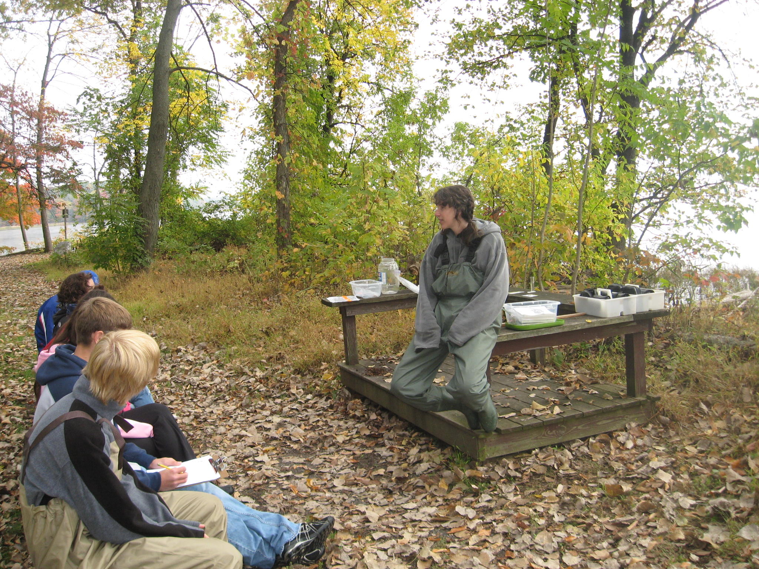
Location: Cohotate preserve – Ice house site –
Area: The ice house is a flat, grassy are on the river with several cotton wood trees. It is situated at the bottom of a forested hill. Large waterfront vegetated. The artificial shoreline of the bulkhead dominates the eastern shore. Shoreline is characterized by tidal mudflats. Area is used recreationally for picnicking, hiking and fishing. Ice house is approximately ½ miles walk from the parking area.
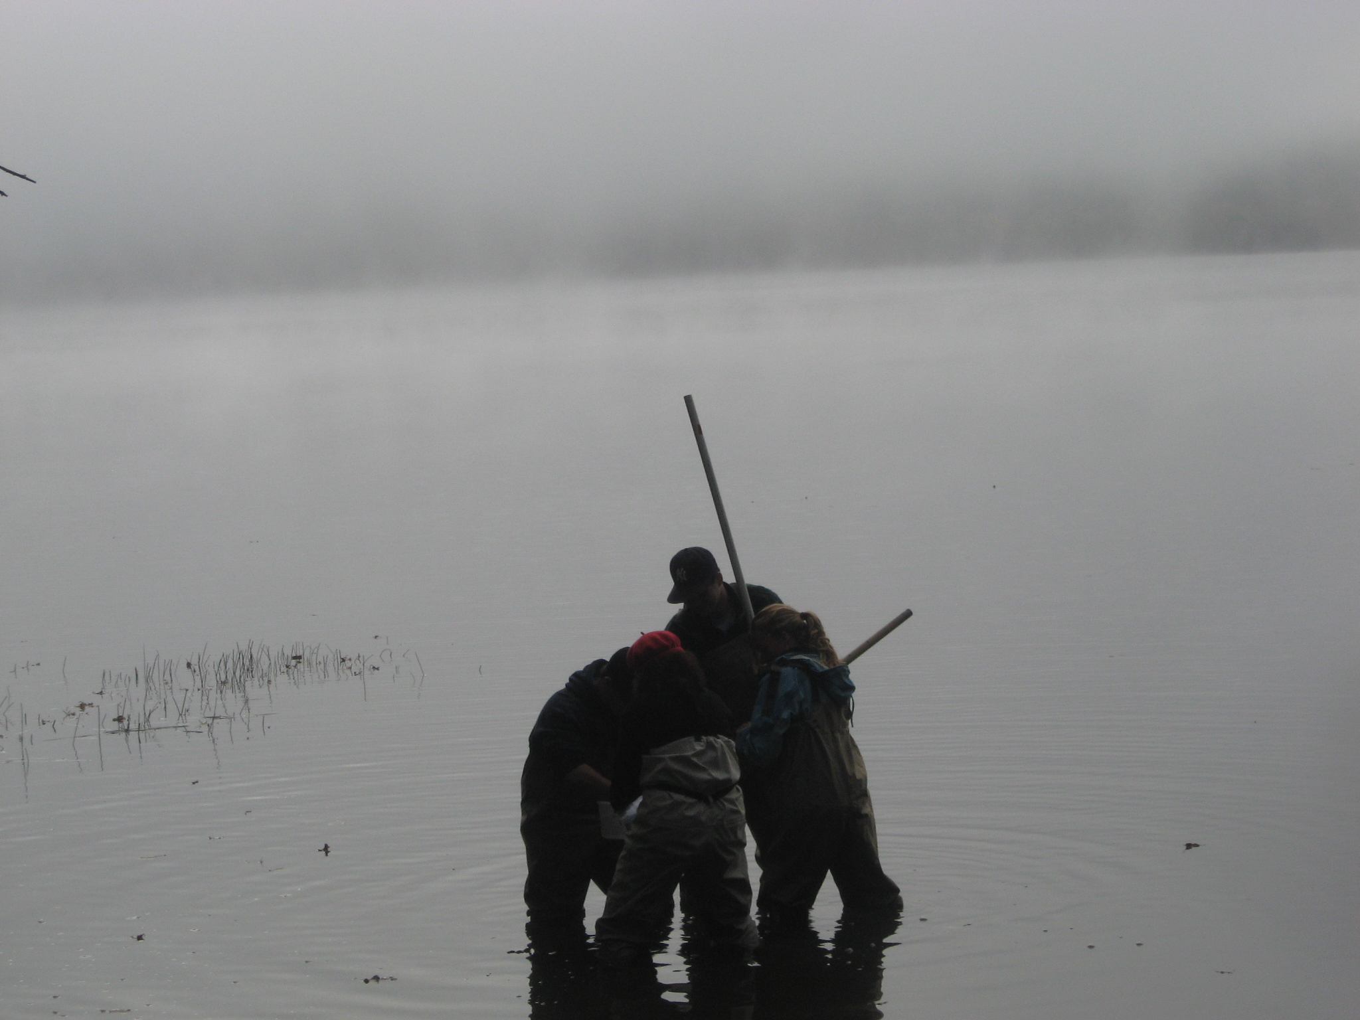
Surrounding Land Use: Forested 83%, Beach 5%; Urban/residential 7%; Industrial Commercial 5%; (average of 3 groups)
Sampling Site: Beach area, Shoreline includes tidal mud flats in the southeast, with a rocky shore further south. To the north of the tidal mud flat there is an old bulkhead, with another tidal flat to the north of the bulkhead, rip rap in sections.
The banks have been altered at the bulkhead (entire ice house area is likely dredge spoil), wood and debris are collected in the southern mudflat, there is lots of vegetation and no pipes entering the water.
Water Depth: We fish at the southern mud flat, which has a muddy bottom and a variable depth, depending on tide.
River Bottom: Muddy, sand in sediments and some rocks, bigger rocks towards shore
Plants in area: Cover 30% - 10% water celery, Arrow arum, Arrowhead, Jewelweed, pickerelweed, spatterdock. wildrice
ITEM | Time |  | Reading 1 | Reading 2 | Comments
Physical
Air Temperature | 9:40 AM |  | 7.9 °C | 46.2°F
 | 10:23 AM |  | 9.7 | 49.4
 | 11:05 AM |  | 11.2 | 52.1
Wind Speed | 9 AM |  | 0 mph
 | 10:23 AM |  | 3 mph | SE
 | 11:05 AM |  | 3 mph | SE
Cloud Cover | Mostly cloudy |  |  |  | Winds from NW
Weather today | fog burned off and became partly sunny
Weather recently | lovely
Water Temperature | 9:45 AM | 13°C  56°F
 | 10:33AM | 14.2°C  57.5°F
 | 11:25AM | 14.5°C  58.1°F
Water | calm
Turbidity | 11:05 AM | 20 JTU  20 JTU
Chlorophyll | 9:30 AM | 0.7
Chemical
DO  (drop count kit) | 9:55AM | 10.0 ppm |  | 14°C | 95%
pH – color match kit | 9:55 AM | 7.5  7.5  7.5
Salinity | 10:00AM | <Quantab units |  | 0.5  0.6  0.8 | <28 ppm chloride
Fish Catch  60 ft. seine X 30 ft. | Total # | Species – 7 species & 21 total |  | Length | TOTALS
 | 5 | Tesselated Darter
 | 5 | Spottail Shiner
 | 1 | Bluegill sunfish
 | 1 | Golden shiner
 | 8 | Banded Killifish
 | 1 | Mummichog (male) |  | * looks like a banded killifish, but has a spot on the dorsal fin
Tides | 9:35 AM | 2 cm
 | 10:05AM | 0 cm |  | Falling
 | 10:45AM | 0 cm |  | Falling
Currents | Cm/60 sec | Cm/sec |  | Kts | flow
9:45AM |  |  |  |  | South/Ebb
10:24 AM | 400 | 6.67 cm/sec |  | 0.13 kts. | South/ebb
11:15 AM | 40 | 0.5 |  | 0.010 | North/still
Core Description

Shipping | 10:50 | Barge & |  | Noelle Cutler | Northbound Loaded
 |  | Tug |  | Kimberly Poling | Green & white
Other | 10:05 AM | Flock of geese
 | 10:30 AM | Cormorant
 | 10:25 AM | Flock of geese
 | 10:45 AM | Squirrel and 2 wrens

