Snapshot Day 10/14/10 Data
(Salt Front RM 36)
RIVER MILE 153
River Park, Green Island Park, Green Island NY
Kate Perry, Robert C. Parker School
35 students (14) 2nd & 3rd grade students and (21) 6th and 7th grade students
42.74 N -73.69 W
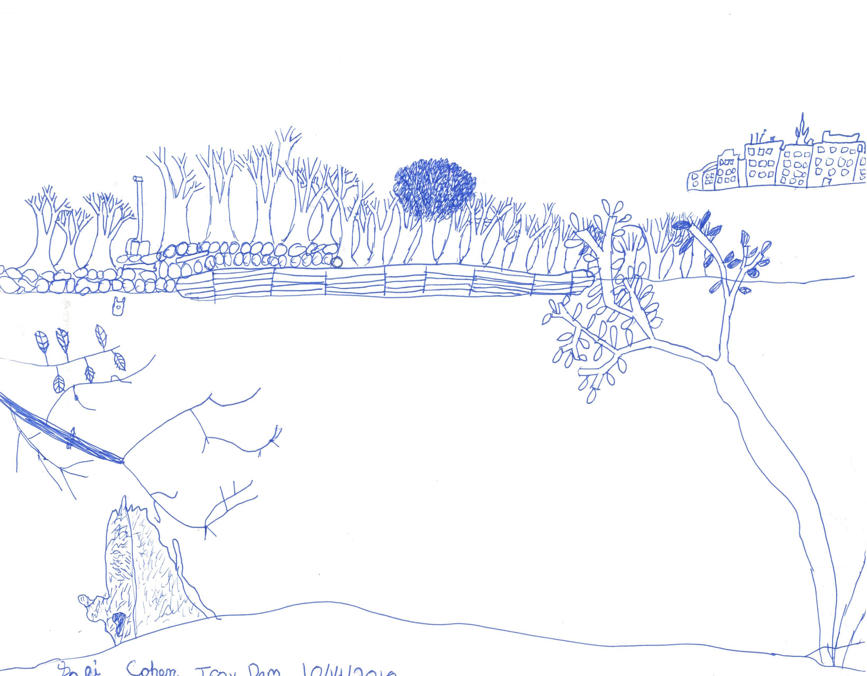

Location: Park @ Green Island, Albany County, NY
Area: park above bluff and then beach below just south of the Troy dam
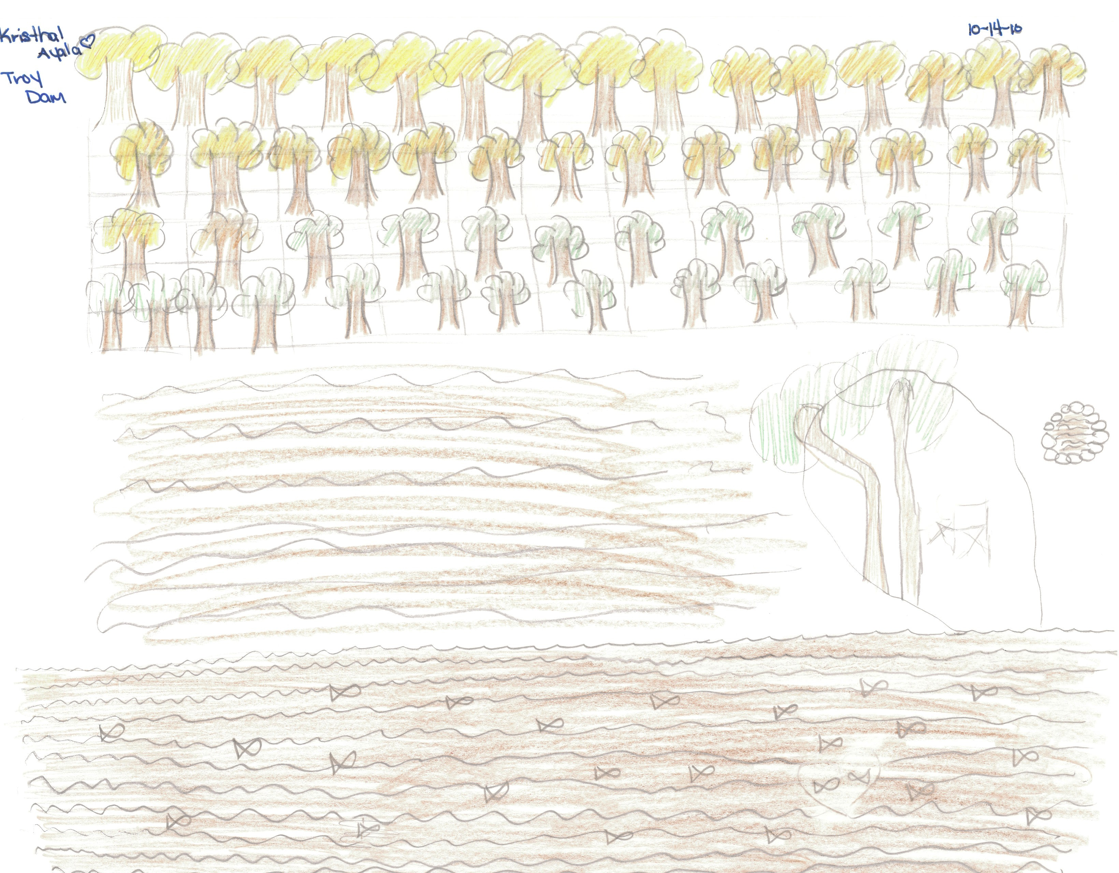
Surrounding Land Use: Fishing launch, Rocky with weedy vegetation and a few small shrubs (gravelly)
Sampling Site: 100% urban/residential,
Shoreline: broken concrete docking, smaller rocks and gravel cover the shoreline, human added concrete at the launch
Plants in area: 15% - During high tide many goldenrod, sumac and green scrubby plants were growing in the water. 2% water celery, 3% spatterdock, 20% purple loosestrife, 5% narrow leaf cattail, smartweed, grasses, reeds, more under water that were unable to be identified. Maple trees on shore.
Water depth: 20-30 cm along shore
River Bottom: muddy, rocky bottom around vegetation

ITEM | Time |  | Reading 1 | Reading 2 | Comments
Physical
Air Temperature | 10:15 AM |  | 54 °F  11°C
 | 10:45 AM |  | 62 °F  17°C
 | 11:12 Am |  | 58 °F  15°C
Wind Speed | 1 Beaufort |  | 1-3 kts.  1-3 mph | NE
Cloud Cover | Partly cloudy
Weather today | No rain
Weather recently | Dry cool nights with frost, warm partly cloudy days
Water surface | Mostly calm
Water Temperature  (2 ft. water) | 10:30 AM | 15°C  59° F |  | 14°C  58° F
no plants, direct sun | 11:00 AM | 15°C  59° F
 | 11:30 AM | 13°C  56 ° F
Turbidity – site tube | 10:40 AM | 26.2 cm  14 cm  30 cm |  | Average 23.4 cm | student observation: “dirty water”
Chlorophyll | 11:12 AM | 0.7
Chemical
DO  (Drop count kit | 11:28 Am | 10 mg/L |  | 14°C | 95%
pH | 10:25 AM | 7.4  7.5  7.3 |  |  | Average 7.4
Salinity | 11:00 AM | 28 mg/L Cl |  | 35 ppm salinity
Fish Catch –5 dip nets and a minnow trap | Time | Number Caught |  | Species | Macroinvert.
 | 10:15 AM | No fish |  | Saw one small fish but couldn’t catch it | snails  insect larvae (2 types)  isopod  worm
Tides  * High tide at Troy was 10:52 AM | Time | Height in cm |  | Rising/Falling | Rate of change
 | 10:07 AM | 29cm
• apparent tidal fall probably due to wave movement | 10:25 AM | 27 cm |  | •Falling | 0.11
 | 10:35 AM | 28 cm |  | Rising | 0.1
 | 10:40 AM | 29 cm |  | Rising | 0.2
 | 10:57 AM | 25 cm |  | falling | 0.24
 | 11:05 AM | 20 cm |  | Falling | 0.63
 | 11:13 AM | 20 cm |  | Still | 0.0
 | 11:20 AM | 16 cm |  | Falling | 0.57
 | 11:31 AM | 14 cm |  | Falling | 0.18
Currents - 10:40 AM | 31.0 cm/60 secs | 0.52 cm/sec |  | 0.01 kts | South - ebb
comments | • we noticed that there was an area further out in the river that was moving faster  • current is large because of dam
Traffic | 11:05 AM | Passenger boat |  | Southbound | People
 | 11:05 AM | 2nd passenger boat |  | Southbound | People
Other Items | Canada Geese | Bald Eagle! |  | Dragonflies & butterflies | gulls
Core Description
Almanac | Look a snail! We are having little luck catching fish but small macroinvertebrates captured the imagination of my 2nd and 3rd graders. Peering into nets they searched for tiny shells and wiggling creatures. Gentle fingers probed clumps of decaying leaves and gravel while seeking signs of life. Students couldn’t help but wonder how their catch would be different if the tide were low. Even though one student fell in ☺ and many had wet feet. All enjoyed the day.
Student Observations on Possible Impacts to their Sampling | - There is a giant dam, boats, buildings ad fisherman. The dam adds D.O. to the water. The roads that lead to the buildings add pollution and salt. Litter comes from the people who fish and work and live near the river. Chemicals seep into the water, and boats add oil. The chemicals add salt and acid to the water when the litter decomposes the chemicals inside them seeps into the water and kills fish and other life. Things can also get stuck on creatures.  - There are signs, pipes and a dam. The pipes dump litter in the water and the litter poisons the fish  - Litter (bad water quality, poisons living things)  - Factories (pollution)  - Lots of trees  - Broken glass and fishing line. They both kill fish and wildlife. Glass cuts fish and fishing line hurts by strangling fish  - Fishing decreases fish numbers, dam influences tides, litter kills animals so we will catch less fish, get less accurate measures of the tide and see less animals because the litter kills animals if ingested.  - The road requires space, which means less trees.  - Sailboat – it spins DO around a lot  - There is a metal sign which over time gets in the water  - At the Hudson River there is a dam, a dam makes oxygen and also cleans the water
Student journal comments | - When I fell in I made a splash which might have temporarily changed the water level.  - Driftwood is common. Stones are mostly small. Some small rocks. No visible fish or animal life. Water slightly cloudy. Submerged rocks covered in small rocks. Shoreline is rocky.  - Lots of pollution (glass bottle, batteries, driftwood made into signs, paint on wood, plastic bags, beer cans).  - We saw people fishing and they were smoking and there were cigarettes on the ground  - Litter makes the water dirty and make the fishes and other stuff that lives under water die because of chemicals  - Moss covered rocks

