Snapshot Day 10/14/10 Data
(Salt Front RM 36)
RIVER MILE 300
Upper Works Trailhead (Adk High Peaks Wilderness), Tahawus Rd.
Adirondac (abandoned mining village), Newcomb NY
GPS Latitude 44°05.370’ N Longitude 74°03.358’ W
Elevation 1,820 ft/550 meters
Doug Reed, Hudson Basin River Watch
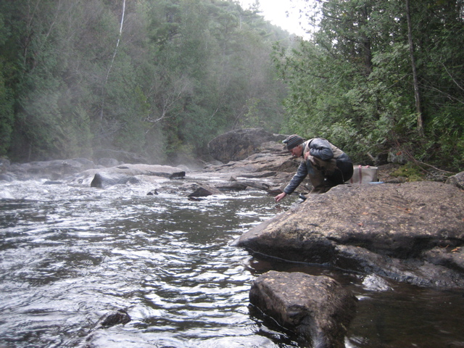
Location: Adirondac (abandoned mining village), Newcomb NY, where the Hudson takes its name
Area: a rushing river
Surrounding Land Use: 100% forested
Sampling Site:
Plants in area:
Water depth:
River Bottom : cobbles

ITEM | Time |  | Reading 1 |  | Reading 2 | Comments
Physical
Air Temperature | 6:00 AM |  | 32°F  0°C
Wind Speed
Cloud Cover | Clear skies with some high clouds
Weather today | No precipitation
Weather recently | Cold and dry
Water Temperature | 6:00 AM | 42°F  6°C
Water calm
Turbidity short
Site tube
Chlorophyll | 6:00 AM | 01.
Chemical
DO  ampules | 6:00 AM | 8.4 mg/L |  | 6°C |  | 68% saturated
pH –
Salinity - Quantab | Below detection
Tides
Currents
Traffic
Reflections | Reflections: It was precisely freezing, cold and dark at 6 am at this uppermost Hudson River location, where the Hudson first takes its name, below the confluence of Calamity Brook and Henderson Lake Outlet. All quiet except the roar of water over boulders under a thick canopy of hemlock, cedar, and maple trees. Fog was lifting off the river in great plumes of vapor.

