Snapshot Day 10/14/10 Data
(Salt Front RM 36)
RIVER MILE 41
Steamboat Dock Park, Verplanck, Westchester
Beth Rhines, Teatown Lake Reservation
Bob Connick, Sott Rizzo, Mahopac High School - Chem Honors, Regents and APES - 9th - 12th graders – 41 students
Latitude N 41°14’.56” Longitude W 73°57’.52"
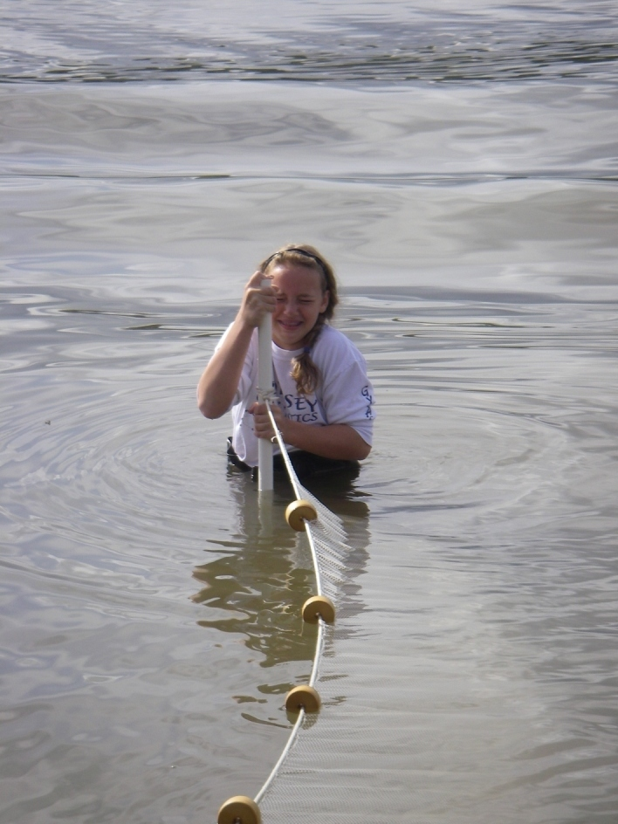 | 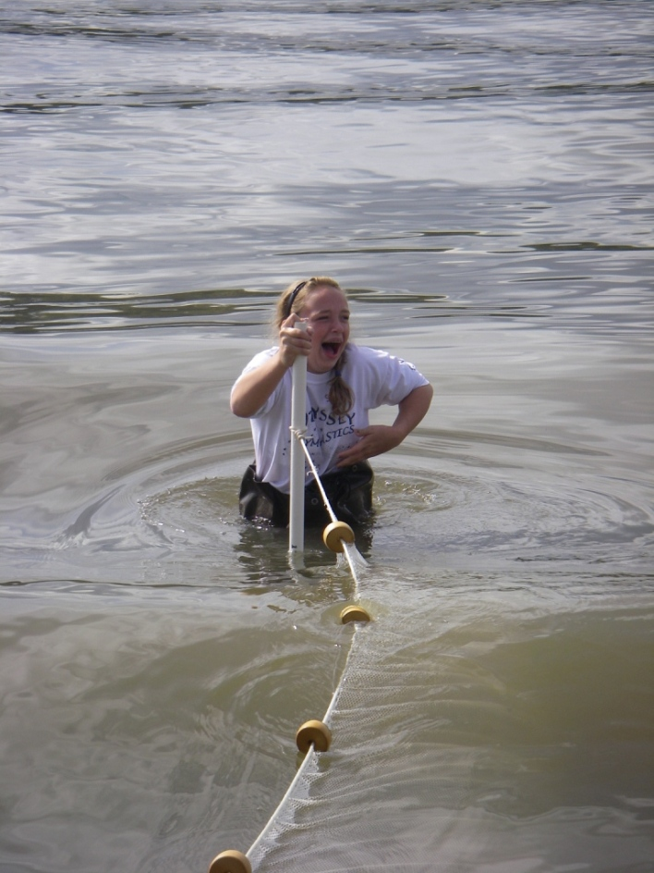
Seining – Before | Seining – After!

Location: Steamboat Dock Park beach, City of Verplanck in Westchester County
Area: located in a small cove between a point and a bulkhead – sampled approximately 30 ft. from south end of dock/parking lot
Surrounding Land Use: Urban/residential 50% , beach 50%. Some buildings with large parking lots in front to the north. Beach, a street with houses with some trees to the south
Sampling Site: beach, riprap, banks altered, dock, bulkhead, vegetation
Plants in area: eel grass, Virginia creeper, wild grape, poison ivy, tree of heaven
Water depth: 61 cm
River Bottom – sandy and rocky
Observations- Bricks, houses, rockwalls, fences, parking lot, picnic benches, fencing
.
ITEM | Time |  | Reading 1 | Reading 2 | Comments
Physical
Air Temperature |  |  | 17.3 °C
Sampled in direct sun off the dock for chemistry | Sampled in small cove for biology and physical
Wind Speed |  |  | 0-5 knots | Northwest
Cloud Cover | none
Weather today | Partly cloudy
Weather recently | Clear, cool, light showers
Water Surface | Calm
Water Temperature – | 10:30 AM | 18.6°C |  |  | Water depth 1ft.
 | 11:05 PM | 18.5°C |  |  | Water depth 1 ft.
 | 12:15 PM | 19°C |  |  | Water depth 1 ft.
Turbidity – long-site tube | 10:33 AM | 26.4 cm  28.2 cm  26.0 cm  26.8 cm |  |  | 26.9 cm
 | 11:16 AM | 26.8 cm  28.2 cm  26 cm  27 cm |  |  | 27 cm
 | 12:01 PM | 29.2 cm  32.8 cm  34.0 cm |  |  | 32.0 cm
Chlorophyll
Chemical
DO  (drop kits) | 10:30 AM | 4 mg/L (?)  8 mg/L  7 mg/L |  | 18.5°C  18.6  18.6 | 41 %  82%  74%
 | 11:00 AM | 8 mg/L  8 mg/L |  | 18.5°C  18.5 | 85%  85%
 | 11:45 AM | 7 mg/L  7 mg/L |  | 19°C  18 | 75%  61%
 | 12:00 PM | 7 mg/L |  | 18°C | 61%
pH  Indicator sol | 10:25 AM | 7.5 |  | 11:25 Am | 8.5
 | 11:05 AM | 7.5 |  | 11:50 Am | 7.5
 | 11:16 AM | 8.5 |  | 12:03 PM | 7.5
Salinity  meter | 11:05 AM | 0.1 ppt  0.1  0.1 |  | 12:15 PM | 0.1 ppt  0.1  0.1
Conductivity |  | 231  234  235 |  | milliseimen/cm
NOTES | Very low compared to other years. Possible reasons – lots of rain, very low tide
Alkalinity |  | 120 mg/L  100  110 |  |  | Average 110 mg/L
Nitrates |  | 7.0 mg/L |  |  | Seems very high
Phosphate |  | 0.33 ppm  0.33 ppm
Fish Catch- 11:30 AM | Number Caught | Species |  | CPUE | Seine
20 ft net X 4ft– 50 ft. pull | 1 | White Perch
4X6 mm openings | 2 | Striped Bass
 | 1 | Blueback Herring
Tides | TIME | Water height |  | Rise/Fall
 | 10:11 AM
 | 11:40 AM | 57 cm |  | rising
 | 12:11 AM | 215 cm |  | rising
Currents | Time | Cm/60 sec |  | Knots | Direction
Core – | TIME | Rare |  | Common | Abundant
 | 12:05 PM | Clay  Mud |  | Gravel  Pebbles | Sand
Traffic | 11:45 AM | Millenium |  | White | Southbound
 | 11:49 AM | Coast guard |  | Grey | Northbound
 | 11:02 AM | Indian Point Guard |  | Grey Blue | Northbound
 | 11:16 AM | Indian point guard |  | Grey/blue | Southbound
 | 11:28 AM | Speedboat |  | White | Southbound
Other Items | 11 Ringed-Bill Gulls, 3 song birds (11:56 AM), 18 cormorants, 1 black duck, 2 mute swans and 1 dog

