Snapshot Day 10/14/10 Data
(Salt Front RM 36)
RIVER MILE 53
Garrison Landing Park
Charley Wilkinson, Rich Anderson, Eric Lind, Constitution Marsh Audubon Center & Sanctuary
Cathy Bakker, Hudson Highlands Land Trust
Kevin Keegan, Garrison Union Free School
7th graders 30 students
41°22.956’N - 73°56.880’W
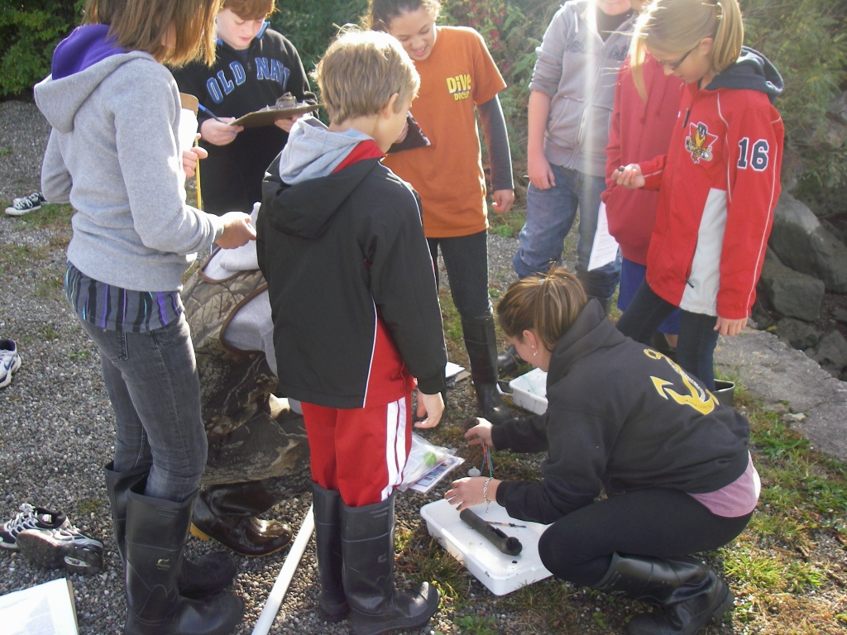
Location: Garrison Landing Park, Garrison, Putnam County, NY
Area: Waterfront beach area on front of park primarily used for boating & picnics
Surrounding Land Use: Urban/residential 50%, Industrial/Commercial 50%
Sampling Site: Pier, shore with bulkhead, riprap, grassy
Plants in area: yes, ~ 10% of the sampling area is covered with plants: Water Milfoil (invasive), Water Celery (native), Water Chestnut (invasive)
Water depth:
River Bottom – muddy/rocky bottom

ITEM | Time |  | Reading 1 |  |  | Comments
Physical
Air Temperature | 9:15 AM |  | 50 °F |  |  | Partly cloudy
 | 10:10 AM |  | 55 °F |  |  | Partly Cloudy
 | 11:12 AM |  | 54°F |  |  | Partly Cloudy
 | 12:03 PM |  | 62°F |  |  | Partly Cloudy
Wind Speed | Beaufort # |  | Knots | Time |  | Direction
 | Force #1.5 to 2.0 |  |  | 11:12 AM |  | NW
 |  |  |  | 11:17 AM |  | E
 |  |  |  | 11:30 AM |  | S
 |  |  |  | 11:45 AM |  | SE
 |  |  |  | 12:03 PM |  | S
Cloud Cover | Partly cloudy in AM |  | Turned mostly cloudy @ midday
Weather today | No rain
Weather recently | Cool, warm, cloudy, foggy
Water Surface | calm
Water Temperature | 9:23 AM | 15°C  59° F |  |  | 13°C  58° F | 14°C  58.5° F
 | 10:10AM | 15°C  60° F |  |  | 16°C  64° F | 15.5°C  62° F
 | 11:01AM | 18°C  64° F |  |  | 17.5°C  62° F | 17.75°C  63° F
 | 11:40AM | 17°C  61° F
Turbidity - secchi | 9:40AM | 24 inch  18  12 |  |  |  | 18 inch
Chlorophyll | 9:30AM | 1.0 |  |  | 11:10AM | 1.5
 | 9:36 Am | 0.5 |  |  | 11:53 AM | 1.0
 | 10:11 AM | 1.0
Chemical
DO - drop count | 10:44AM | 8.5 mg/L |  |  | 15.5°C | 84%
pH – color match & litmus paper | Time | indicator solution |  |  | litmus paper | Averages
 | 9:23 AM | 7.5, 7.0, 7.0, 7.0 –  Avg- 7.125 |  |  | 6.5, 6.5, 7.0, 6.5 - Avg- 6.625
Salinity - quantab | 10:20 AM | 28 ppm Cl  28 ppm Cl  28 ppm Cl |  |  | 35 ppm salinity
Tides | Time | Tide Stick
 | 9:15 AM | 33 inches
 | 9:53 AM | 30.5 in |  |  | falling
 | 10:10AM | 30 in |  |  | falling
 | 10:38AM | 28.5 in |  |  | falling
 | 11:00AM | 29 in |  |  | rising
 | 11:30AM | 30 in |  |  | rising
 | 11:45AM | 31 in |  |  | rising
 | 12:00PM | 32 in |  |  | rising
 | 12:10PM | 33 in |  |  | rising
Currents/Time | Cm/60 secs | Cm/Sec |  |  | Knots | Ebb/Flood/ Still
9:15 AM | 126/sec | 2.1 cm/sec |  |  | .04 kts | Ebb
10:15 AM | 150/sec | 2.5 cm/sec |  |  | .05 kts. | Ebb
11:10 AM | 270/sec | 4.5 cm.sec |  |  | .09 kts | Ebb
11:52 AM |  |  |  |  |  | Still
12:07 AM |  |  |  |  |  | Still
Seine – 60 ft. X 94.2 ft. pull – ¼ inch mesh | TIME | SPECIES |  |  | CATCH | SIZE
Seine #1 | 9:30AM | Pumpkin Seed |  |  | 2 | 7.2 cm
Total catch 15 |  | Striped Bass |  |  | 1 | 9.9 cm
 |  | Spottail Shiner |  |  | 8 | 10.7 cm
 |  | Blueback Herring |  |  | 4 | 7.2 cm
Seine #2 | 10:00 AM | American Eel |  |  | 1 | 20.2 cm
Total catch 14 |  | Atlantic Blue Crab |  |  | 2
 |  | Pumpkinseed Sunfish |  |  | 2 | 8.2 cm
 |  | Striped Bass |  |  | 3 | 8 cm
 |  | Spottail Shiner |  |  | 4 | 12 cm
 |  | White Perch |  |  | 2 | 15.5 cm
 |  | Barnacles
Seine #3 | 10:57 AM | White Perch |  |  | 2 | 12.4 cm
Total catch 10 |  | Blueback Herring |  |  | 4 | 9.8 cm
 |  | Striped Bass |  |  | 1 | 7.1 cm
 |  | Spottail Shiner |  |  | 1 | 7.8 cm
 |  | Pumpkinseed |  |  | 2 | 8cm
Grand Total = 39
Traffic | 10:48 AM | Semi large white boat |  |  | South | Slightly loaded
 | 11:06 Am | tug |  |  | South | Empty
 | 11:45 AM | Large boat |  |  | South | Full
Sediment Core | Core # | Total Length |  |  | Top Length | Bottom Length
9:49 AM | * #1 | 31 cm |  |  | 15.5 | 15.5
 | #2 | 16 cm |  |  | 10 | 6
 | #3 | 31 cm
 | #4 | 19 cm |  |  | 10 | 19
 | * Description – water depth 2.5 ft. – south of Marina, 10 ft. from shoreline. No H2S smell. Abundant Clay and Mud. Rare pebbles,
Other Items | This is a beautiful site. There are Weeping Willows, Mulberry Trees, a grassy area with a small gazebo, sculptures and benches. A peaceful yet active location with boating and trains and housing.

