Snapshot Day 10/14/10 Data
(Salt Front RM 36)
RIVER MILE 57
Donahue Memorial Park, Cornwall Landing, Village of Cornwall-On-Hudson, Town of Cornwall, Orange County, NY
Christopher O’Sullivan, NYSOPRHP Trailside Museums & Zoo
Deborah Gilson, Willow Ave. Elementary - 4th grade – 70 plus - students
GPS Latitude 41°26’36”N Longitude 74°0’1”W

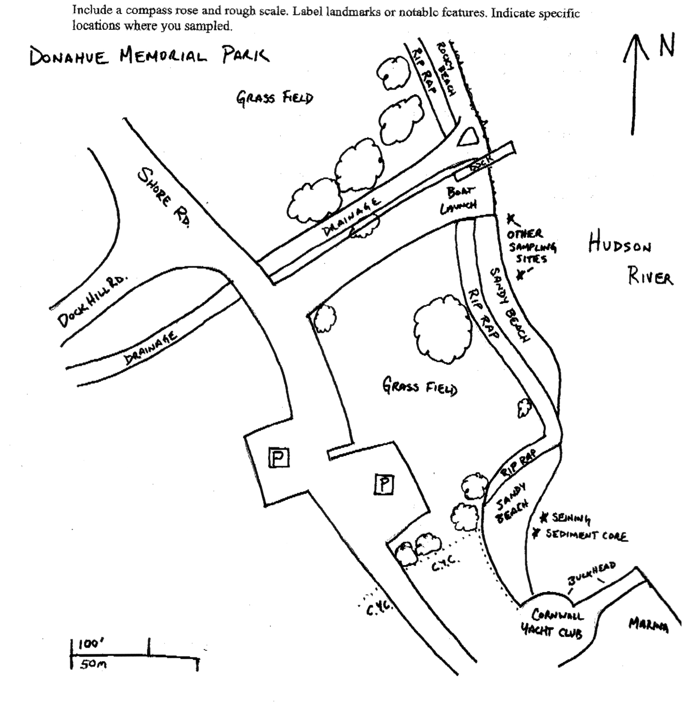
Location: Donahue Memorial Park
Area: Sandy beach used for seining & sediment core, 2nd beach are for other sampling.
Surrounding Land Use: Forested 5%, beach 20%, 75% open and grassy
Sampling Site: sandy beach, altered banks, shoreline riprap, bulkhead, collected wood & debris in area,
Plants in area: yes but only about 1%
Water depth:
River Bottom – rocky

ITEM | Time |  | Reading 1 | Reading 2 | Comments
Physical
Air Temperature | 11:25 AM |  | 20°C  68°F
Wind Speed | BEAUFORT #1 |  |  |  | NW
Cloud Cover | partly cloudy
Weather today | Dry in the AM
Weather recently | A little Rain on Tuesday Oct. 12th but nice otherwise
Water Temperature | 9:55 AM | 69°F  59 °F |  | 16 °C  15°C |  |  | 60°F  15.5°C
 | 1:00 PM | 64°F |  | 18°C |  | 64°F  18°C
Water Calm
Turbidity  Long sight tube | 10:25 PM | 32.2 cm  31.2 cm  31.5 |  |  |  | 31.5 cm
Chlorophyll | 10:34 AM | 0.0
Chemical
DO  Drop count kit | 1:00 PM | 11 mg/L |  | 18°C |  | 115%
pH (indicator sol.) | 10:08 AM | 7.4
Salinity -  Quantabs – low range strips – | 10:00 AM | 29 ppm Cl |  | 36.3 ppm total salinity
Fish Catch  80 ft. seine X 4 ft. with bag – ¼ inch mesh - | Number Caught | Species |  | CPUE |  | Seine -  1 seine
Tides | TIME | RISING/  FALLING |  | HEIGHT IN CM |  | RATE OF CHANGE
 | 10:45 am | Falling
 | 11:00 am | Falling
 | 11:30 am | Falling
 | 11:45 am | Unchanged
 | 12:00 pm | Rising
Currents | 10:45 AM | Flood
 | 11:00 AM | Flood
 | 11:30 PM | Still
 | 12:00 PM | Ebb

