Snapshot Day 10/14/10 Data
(Salt Front RM 36)
RIVER MILE 61E
Riverfront Park, City of Beacon, Dutchess County
Susan Hereth, Scenic Hudson
Kelley Bender, Aaron Burke, Rebecca Ansen - South Ave. Elementary –
Terry Udell, J.V. Forrestal Elementary – 4th grade
100 4th and 5th graders
Latitude 41°50’ Longitude 73°98’
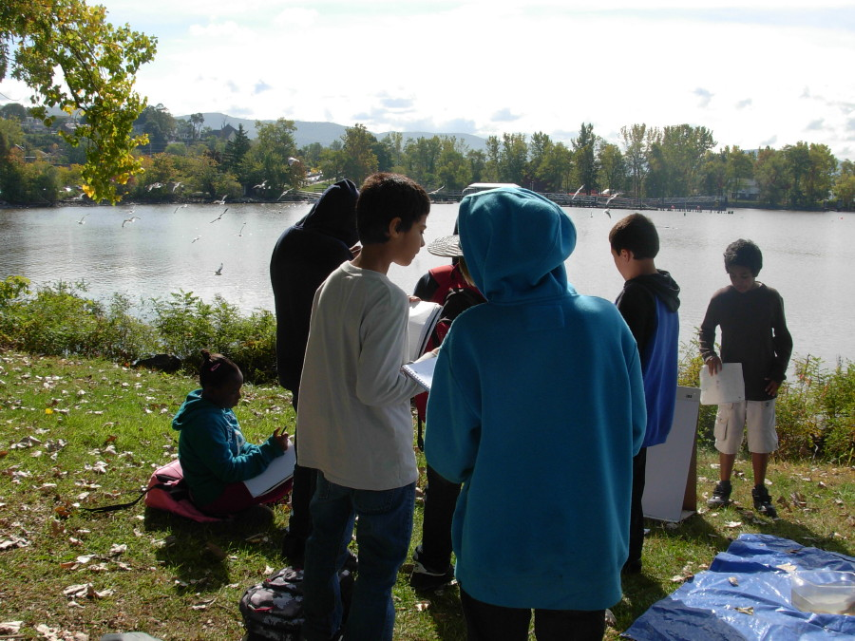 | 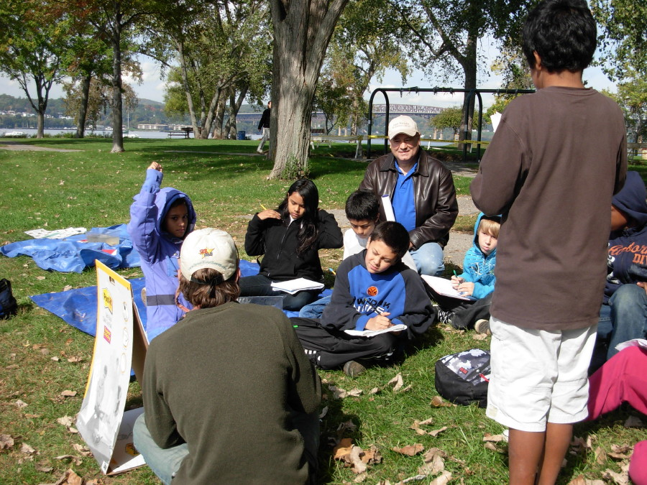
Location: Riverfront Park, Beacon, Dutchess County NY
Area: Area used for public park, playground, grass, paved paths, basketball courts
Surrounding Land Use: Forested 20%, Urban 50%, beach 2% , other 28% (planned park area with trees etc.
Sampling Site: very small beach at northwest corner of park, banks altered
Plants in water: yes, less than 10% has plants
Water depth:
Bottom Surface: muddy, rocky
Tidal Shallows Plants – Water Celery floating on shore
ITEM | Time |  | Reading 1 | Reading | Comments
Physical
Air Temperature | 10:15 AM |  | 10°C  50 °F
Wind Speed | 10:15am |  | Beaufort 1 | SW | Dense fog at 10:15 AM but clear at 11:00 AM
Cloud Cover
Weather today | Dense fog 8:30-10:30 AM  Clear blue skies ~ 10:30 AM-noon  Cloud cover 100% after noon
Weather recently | Not really any different than today
water calm | calm
Water Temperature | Time | Test one |  |  |  | Northside of park, shaded area, water collected by bucket - no direct access to water
 | 10:00am | 15.6°C  60 °F
 | 10:45 am | 15.6°C  60 °F
Turbidity
 | 10:00AM | 60 JTU |  | 10:45 AM |  | 40 JTU
Chlorophyll
Chemical
DO  (drop kit) | 9:00 AM | 8 ppm |  | 15.6 °C |  | 80% saturated
pH –  color match(Hach) | 10:15AM | 7.1 |  |  |  | Northside of park
 | 11:15AM | 7.1 |  |  |  | Northside of park
 | 11:29AM | 7.5 |  |  |  | Southside of park
Salinity –
Fish Catch | Number Caught | Species |  | CPUE |  | MACROs
9:45 AM seine | 1 | Bluegill sunfish |  | 5 inch |  | northeast corner seine
 | 14 | Spottail shiner |  | 3 inch
 | 1 | Striped Bass |  | 3 inch
 | 2 | Banded Killifish |  | 1 inch
19 total seine | 1 | Blueback Herring |  | 2 inch
Eel Pot | 1 | Bluegill sunfish |  | 1/2 inch |  | eel pot set night before
3 total pot | 2 | American eel
Tides | 10:15 AM | Falling tide
 | 1:00 PM | Rising
Currents | 11:15AM | Flood
 | 1:00 PM | Flood
Shipping | 12:30AM | Buchanan & barge |  | South |  | 3 flat barges pushed by a tug
Observation: Lots of trash in the park!

