Snapshot Day 10/14/10 Data
(Salt Front RM 36)
RIVER MILE -11
Breezy Point, Queens
Jennifer Wolff, Carol Williams, National Parks Service Rangers
Leah Sarasohn –MS366 – District 18
28 students, 6th grade
GPS latitude N40.33.449 W 073.55.992
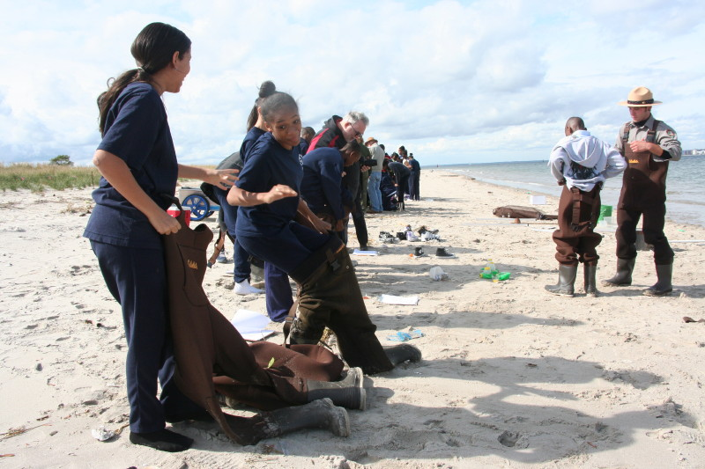 | 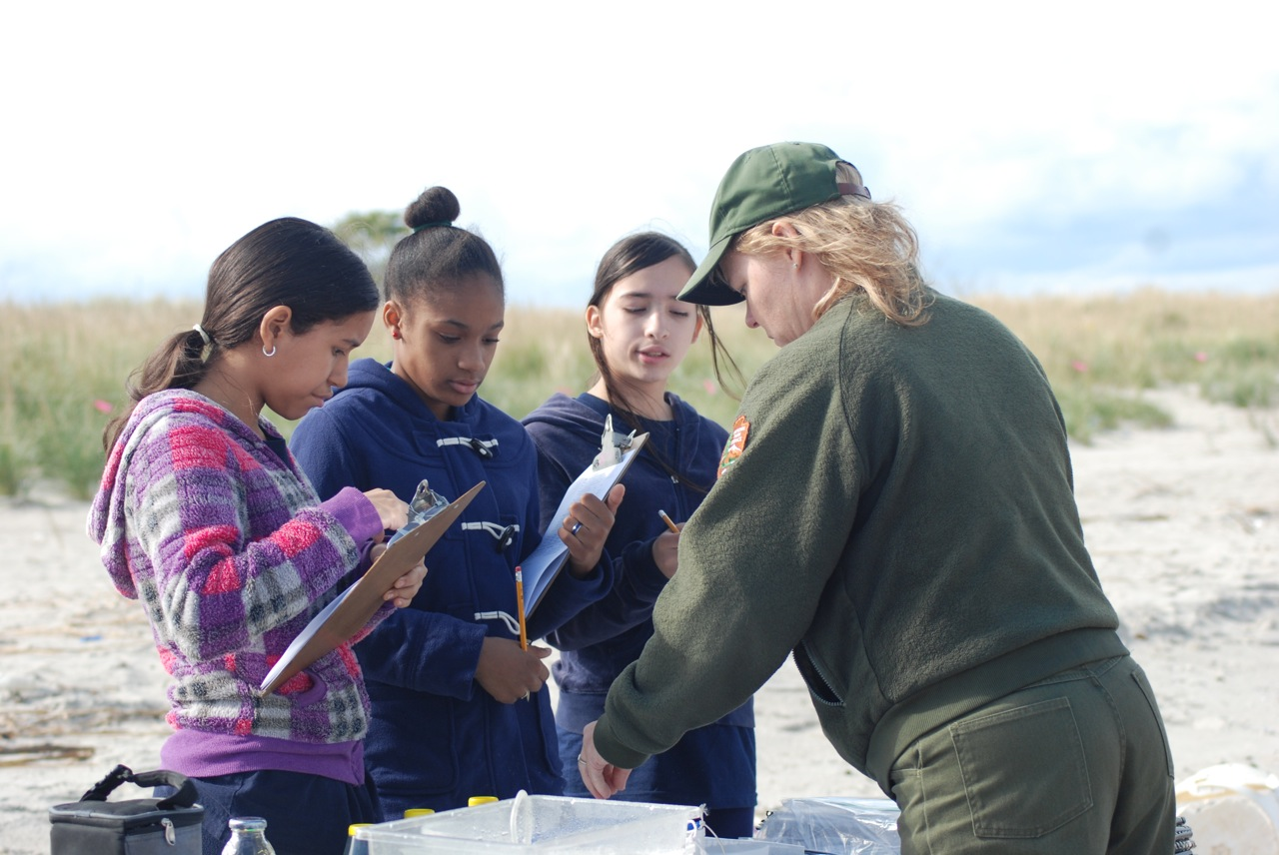
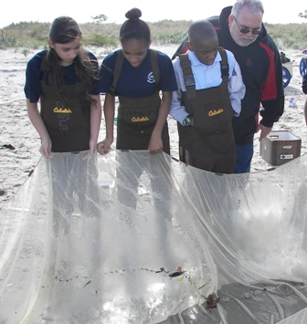
Location: Beach on bay side of Breezy Point, Queens, Jamaica Bay
Sampling site: Fishing beach area, dune system behind beach, used for recreational boating, commercial traffic, kite sailing
Surrounding Uses: 100% beach
Area: All beach, sandy, grassy dunes
River Bottom: sandy, gravel
Plants in area: Not in the water but in the area - Ammophila breviligulata (Beach grass) 85%, Seaside goldenrod 4%, Poison Ivy 10%, Sea Rocket 1%
Water Depth: 4 ft.

ITEM | Time |  | Reading 1 | Reading 2 | Comments
Physical
Air Temperature | 11:32 AM |  | 67.5 ° F  19.7° C
 | 12:32 PM |  | 65 ° F  18° C
Wind Speed | Beaufort force 3 |  | 9.7 mph | SE
Cloud Cover | Mostly cloudy |  | By 1PM the wind picked up, the sun was covered by clouds, it was chillier and darker
Weather yesterday | Temperatures in the 60s
Water Surface | calm
Water Temperature | 11:01 AM | 65 ° F  17° C
 | 11:55 AM | 65 ° F  18° C
 | 12:29 PM | 65 ° F  18° C
Turbidity | 12:13 AM | 70 cm  86.3 cm  94 cm |  |  | Avg:  83.4
Chlorophyll | 11:29 AM | 0.0
Chemical
DO  LaMotte | 11:06 AM | 4.0 mg/L |  | Temp. 17° C | 40% saturated
pH – tabs | 11:00 AM | 7  7  7 |  |  | 7
Salinity -  hydrometer | 11:01 AM | 27.7 ppt  29.2 ppt  27.7 ppt |  |  | Average  28.2 ppt
Fish Catch –  12 ft. X 12 ft. pull/6 pulls total | Number Caught – fish 72 | Species |  | Size of largest | Seine net - CPUE on fish only
10:37 AM |  | Moon jelly |  | 9 cm | Seine #1  CPUE zero
10:46 AM | 12 | Atlantic Silversides |  | 9 cm | Seine #2  CPUE 0.27
 |  | Moon jelly |  | 6 cm
 |  | Comb jelly |  | 1.5 cm
10:57 AM |  | Moon jelly |  | 6 cm | Seine #3
 |  | Comb jelly |  | 1.8 cm | CPUE zero
11:32 AM |  | nothing |  |  | Seine #4  CPUE zero
11:58 AM | 21 | Atlantic Silversides |  | 6 cm | Seine #5  CPUE 0.48
 |  | Comb Jelly |  | 0.7 cm
12:41 PM | 39 | Atlantic Silversides |  | 8 cm | Seine #6  CPUE 0.89
 |  | Moon jelly |  | 7 cm
 | 1 | Lion’s Mane Jelly |  | 20 cm | Chris Bowser seine
 |  | Slipper shells on horseshoe crab shell
Tides | 11:25 AM | 18 cm |  | Rising
 | 11:36 AM | 22 cm |  | Rising
 | 11:48 AM | 28 cm |  | Rising
 | 12:01 PM | 33 cm |  | Rising
 | 12:25 PM | 44 cm |  | Rising
Currents | CM/60 sec | Cm/Sec |  | North/South | Ebb/Fllod/Still
11:26 AM | 300 | 5 cm –  0.097 kts |  | *W | Ebb
11:46 AM | 600 | 10 cm –  0.195 kts |  | *W | Ebb
*This site is located inside the Rockaway Inlet on the East side of the Hudson River. The current flowing West would pull the water out into the NY Bight where it would be move up into Hudson River on the Flood (Rising) tide.
Core-  Noon  Water depth 4 ft, | 16 cm total length | 6 cm top |  | Dark anoxic layer, some shells | Light on the bottom
Shipping | 11:10 AM | White Boat – |  | recreational | Eastbound
 | 11:10 AM | Commercial ship – oil or gas |  | Yellow Black | Eastbound/full
 | 11:11 AM | Sailboat |  | White | Anchored in Rockaway Inlet
 | 11:15 AM | Ship |  | DEP | Eastbound/full
Journal | The children from MS366 were very excited to participate in “A Day in the Life” as soon as they stepped off the bus. Channeling their energy to conduct the research and experiments on the beach took a bit of time, but once they started they were able to focus on their responsibilities. It was a beautiful, sunny day. Many of the students were not familiar with the park and the resources available to them within a few miles of their neighborhood. The beach environment sparked their interest/curiosity to learn more about the physical aspects of the land.  Sandpipers were seen feeding at the edge of the water.  Chris Bowser went seining and caught a large lions mane jellyfish!

