Snapshot Day 10/14/10 Data
(Salt Front RM 36.0)
RIVER MILE 127 – Stuyvesant Landing
Chelsea Benson & Leanna O’Grady - Columbia County Soil & Water Conservation District
& Doug Reed, HBRW
Sarah Howard, The Alternative Learning Center (TALC) – 16-12 yrs. – 8 students & 10 adults
Latitude 47 N Longitude 73W (topo map)
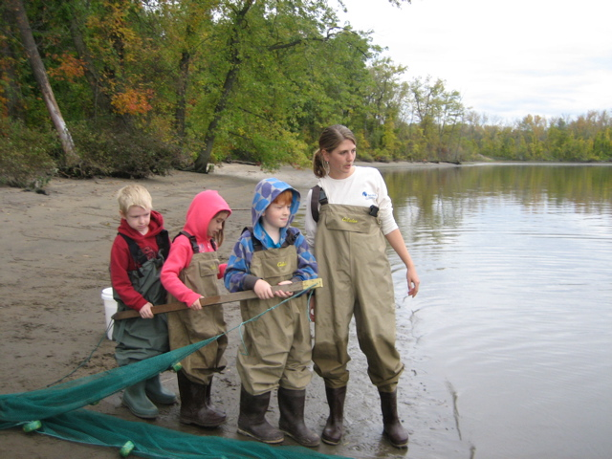

Location: Sandy point of Stuyvesant Landing, Columbia County. The sandy point is just south of the parking lot.
Area: forested area used for swimming, picnics & camping Park/Boat launch, sandy beach area on the point
Surrounding Land Use: 95% forested, 5% beach – used for picnics, swimming, campfires, sandy beach and dense woods behind
Sampling Site: Beach, fallen trees,
water area is sandy with little mud further out – gently sloped beach, shallow quite a distance and then shipping channel
Plants in area: no plants in water
Water depth: waded in approx. 2 ft.
River Bottom –gradual slope, sandy

ITEM | Time |  | Reading 1 |  | Reading 2 | Comments
Physical
Air Temperature | 3:50 PM |  | 68°F  20°C |  | 4:08 PM | 60°F  15°C
Wind Speed | 1.5 knots |  | Anemometer |  | NW
Cloud Cover | overcast |  | Sprinkles 4:50 PM
Weather today | Started off overcast – by the time we were leaving few sprinkles had developed
Weather last 3 days | Daytime sunny 60°F but at night cool in the 30°F range. Some locations near the river had frost.
Water | Calm – no waves
Water Temperature | 3:50 PM | 58°F  14°C
 | 4:10 PM | 58°F  14°C
Turbidity – short site tube | 3:55 PM | 60 JTU |  | 4:15 PM |  | 60 JTU
Chlorophyll | 3:30 PM | 5.0 |  | Had sand in it
Chemical
DO  Drop count | 3:45 PM | 8.6 mg/L |  | 15 ° C |  | 85%
pH  pen | 3:30 PM | 7.5  7.4  7.8 |  |  |  | Average 7.56
Nitrates | 4:10 PM | 0.22 ppm
Phosphates | 4:05 PM | 0.47 ppm
Alkalinity | 3:35 PM | 104 ppm  92 ppm  98 ppm |  |  |  | Average  98 ppm
Salinity  Test strip | 3:45 PM | 28 ppm / Chloride |  | (0.8 Quantab reading) |  | 35 ppm Salinity
Fish Catch – 4:45 PM – 2 pulls | Number Caught | Species |  | Size of largest |  | 2 seine with fish catch
Seine 40 ft. X 3 ft.  Mesh 0.25 inch | 3 | Spottail shiner |  | 10 cm
3 minute pull- seine #1 | 4:20 PM | 0 catch |  | 8 yd pull |  | CPUE - 0
Seine #2 | 4:40 PM | 3 catch |  | 10 yd. pull |  | CPUE .86
Tides | 3:35 PM |  |  | 35 cm
 | 4:00 PM | Falling |  | 33 cm |  | .08 cm/min
 | 4:15 PM | Rising |  | 35 cm |  | .13 cm/min
 | 4:30 PM | Rising |  | 39 cm |  | .26 cm/min
Currents | 3:40 PM | North |  | Flood
 | 4:10 PM | North |  | Flood
Beach is set back from the direct current of the river. There is an outcrop of land 1/8 mi south of our sampling location; may cause a swirling current.
Other Items
Core Description | Total Length | Top Layer |  |  | Second Layer | Describe
 | 8 inches | Gray on bottom |  |  | Dark tan at top | All sand but color layers
Shipping | 4:05 PM | Pleasure Boat |  |  | Northbound
Traffic | 4:30 PM | Pleasure Boat |  |  | Southbound | (return of above)
Observations | We saw a flock of approx 20 birds that we thought were cormorants. They landed near the sampling area, stuck around for 1-2 minutes and then flew south. Doug, Leanna, and I have never seen that many together at once and they flew a slightly higher than cormorants normally do… So, who knows? Great sight though. (Comment from Steve Stanne - Cormorants do migrate in flocks so this would not be unusual behavior, although wonderful to see.)

