Snapshot Day 10/14/10
(Salt Front RM 36.0)
RIVER MILE 13
Bloomers Beach @ Engelwood Boat Basin
Kirk Weber – Meadowlands Environmental Center
Judi Bettencourt – West New York Middle School – 7th & 8th graders
N40.881297 -W73.943948

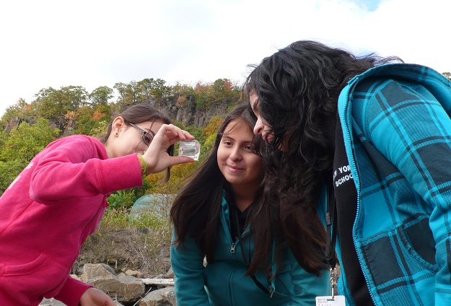 | 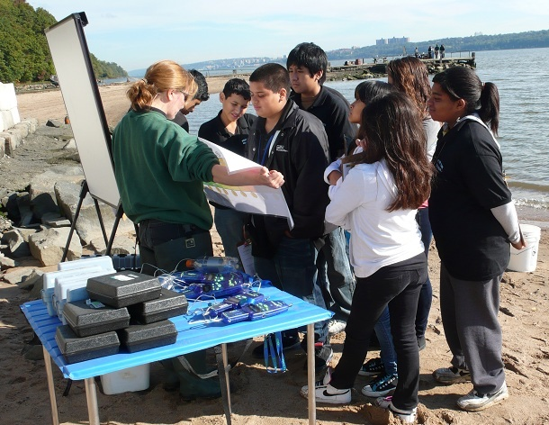
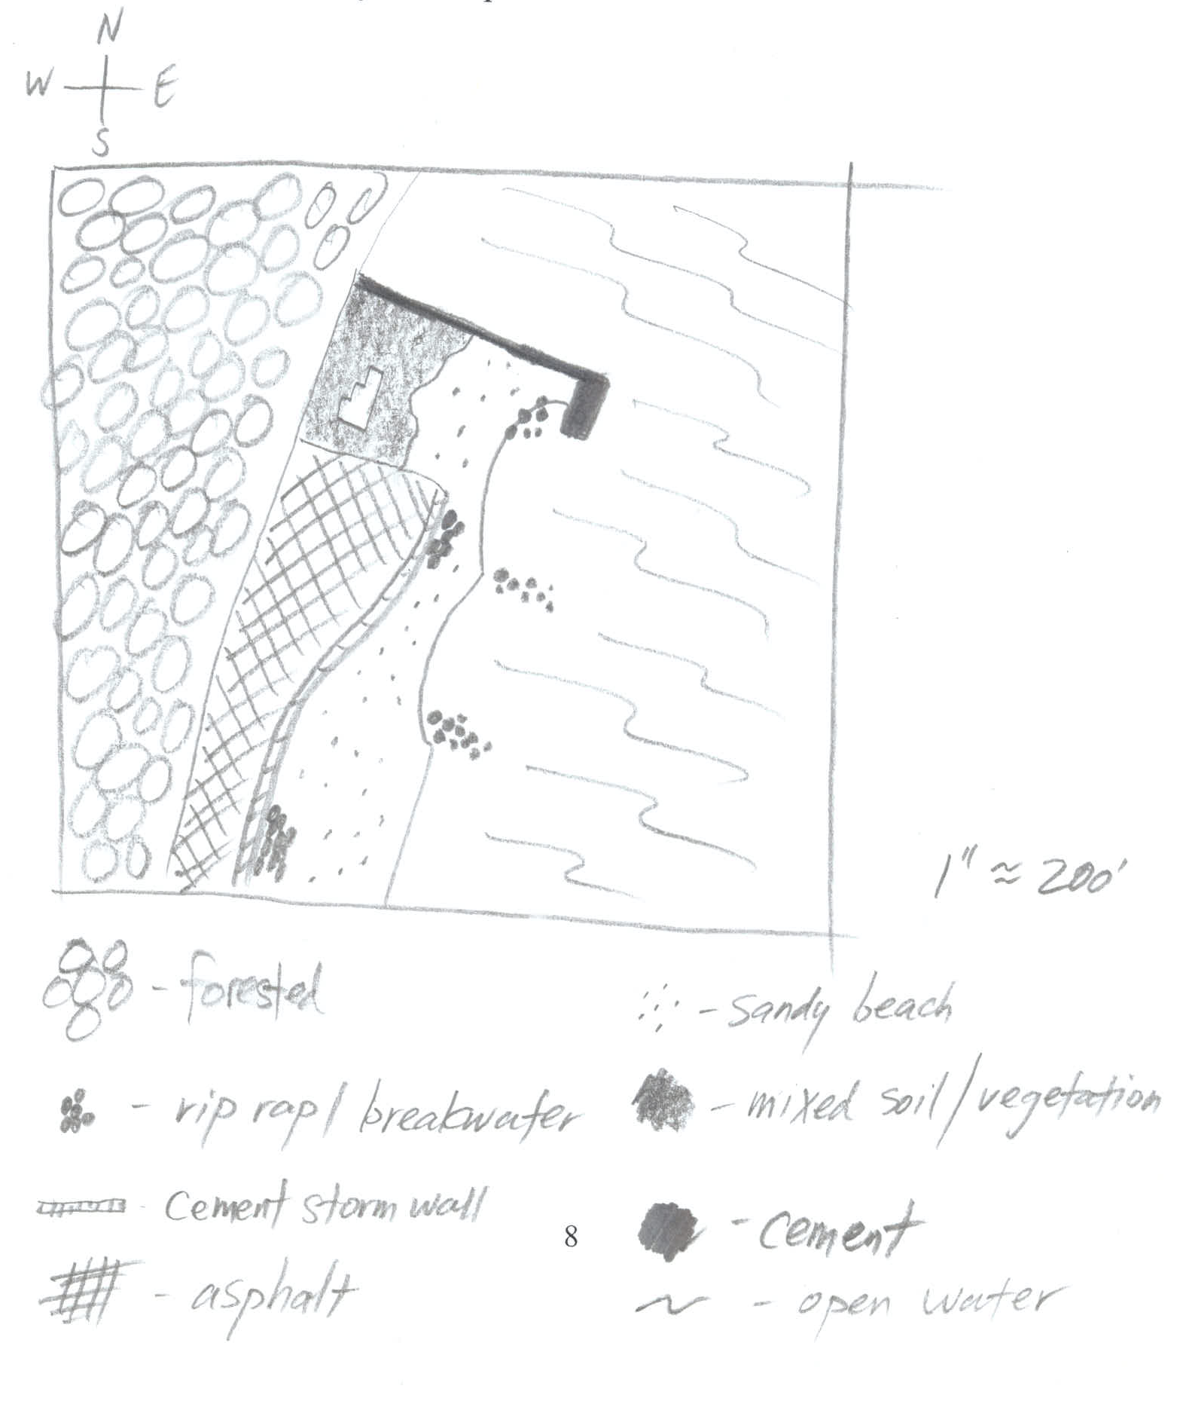 | Location: Bloomers Beach – north end  Area: sandy beach, banks altered, pier with rip rap sections, wood bulkhead, collected wood/debris in area, piping approx. 30” located at sampling site, 2 stone breakwaters as well as on shoreline, + cement storm wall  Surrounding Land Use: 20% urban/residential; 40% forested; 20% beach; 20% Industrial/commercial  Bottom: sandy & muddy  Plants in area: none in the water  Water Depth:170 cm at high tide, or 5 ft. 7 inches

ITEM | Time |  | Reading 1 | Reading 2 | Comments
Physical
Air Temperature | 10:15 AM |  | 18.8°C
 | 11:30 AM |  | 18.3°C
 | 12:30 PM |  | 16.6°C
Wind Speed | Beaufort #2 |  | 5.82 kts  7.21 kts | 6.7 mph | NE
Cloud Cover | Sky became increasingly cloudy throughout the observation period
Weather today | No precipitation
Weather recently | Nothing unusual to note
Water | Choppy
Water Temperature | 9:50 AM | 16.9°C  17.7°C  18.3°C |  | 62.4 °F  63.9°F  64.8°F | 17.6°C  63.7°F
 | 11:15 AM | 18.3°C  18°C  18°C |  | 64.9°F  64.3°F  64.3°F | 18.1°C  64.5°F
 | 12:05 AM | 18.3°C  18.4°C  18°C |  | 64.9°F  65.1°F  64.4°F | 18.2°C  64.8°F
Turbidity – long site tube | 11 AM | 41cm  37 cm  44 cm |  |  | 40.6 cm
Chemical
Chlorophyll | 8;40 AM | 0.5
DO – ampules | 11:45AM | 8 mg/L |  | 18.1° C | 82.5% saturated
pH – indicator sol. | 12:25 PM | 8.0  7.5  8.0 |  |  | 7.8 avg.
Salinity (hydrometer) | 12:40 PM | 6 ppt  6 ppt  6 ppt |  |  | 6ppt average
Fish Catch | Count | Fish |  | Size of largest | Macros
14 ft. X 3 ft seine – pulled 20 ft. | 50 plus | Atlantic Silverside |  | 9 cm | Blue Crab
3/16 inch mesh | 1 | Striped Bass |  | 6.5 cm | Moon Jellies
 | 1 | White Perch |  | 9 cm | Shore shrimp
Seine #1 | 11:00 AM | 15 fish |  | 20 ft pull | .18
Seine #2 | 11:45 AM | 11 fish |  | 20 ft pull | .13
Seine #3 | 12:15 PM | 12 fish |  | 20 ft pull | .14
Tides | 8:50 | falling |  | 47.5 cm
 | 10:15 | rising |  | 65 cm | .21 cm/min
 | 11:20 | rising |  | 75 cm | .15 cm/min
 | 12:15 | rising |  | 97.5 cm | .41 cm/min
Currents | 11:30 | 13.6 cm/sec |  | North | Flood
 | 12:25 | 30 cm/sec |  | North | Flood
Core – | 20 cm total – overall black in color | Top layer 6 cm – dark blackish, pudding like |  | Second layer 14 cm –clayey
Boats

