Snapshot Day 10/14/10 Data
(Salt Front RM 36.0)
RIVER MILE 200
Lock 5, Schuylerville , Hudson River
Nancy Robertson, Cornell Cooperative Extension
4 H Homeschool Group, 16 students K-9th graders
43°06.989 N, 73°34.34.589’W
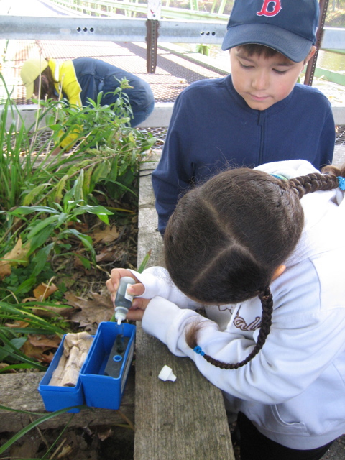
Location: Upper Hudson Lock 5 in Schylerville, NY
Area: Above the Dix Bridge abutment : Note- this is the position of General Burgoyne's "bridge of bateaux", where his troops and 5,000 other stragglers crossed the Hudson River in the fall of 1777. The site is the exact spot where General Burgoyne crossed the Hudson during the Rev. War. He picked that site because the river is narrow there and the banks are not as steep. He built a bridge out of boats. Today there is a battle raging about whether to destroy the bridge or save it for recreation. Either way will cost millions.
Surrounding Land Use: mainly forested, old industrial (old mills, railroad structures), some residential
Sampling Site: Rocky and steep, forested, covered with vegetation;
Plants in area: Grasses, ferns, moss, wildflowers, mushrooms, golden rod
Trees- red oak, beech, sugar maple, red maple
Water depth: rocky bottom

ITEM | Time |  | Reading 1 | Reading 2 | Comments
Physical
Air Temperature | 9:30 AM |  | 11 °C  49 °F
Wind Speed | 9:30 AM |  | Beaufort #2
Cloud Cover | clear, light cirrus clouds, some contrails
Weather yesterday | Sunny and cool
Water Temperature | 10:00 AM | 10°C  50 °F
Water surface | Water calm but moving fast
Turbidity
Chlorophyll | 10:00 AM | 0.3 |  | X 3 tests
Chemical
pH – color drop kit | 10:18 AM | 7.0 |  | 10:30 AM | 7.0
Salinity |  | Below detection
Dissolved Oxygen |  | 8.72 ppm |  | @ 10° C | 76% saturation
Fish Catch | Number Caught | Species |  |  | Minnow traps
Currents | 9:30 AM | 1 meter/sec |  | 100 cm/sec | South
Traffic | small motor boats and sailboats going through the lock
Other | 150 to 200 Canadian Geese Flock  1 Blue Heron

