Snapshot Day 10/14/10 Data
(Salt Front RM 36)
RIVER MILE 31 – Hook Mountain State Park
Laurie Seeman & Joanne Dickey– Strawtown Art & Garden Studio
Lorraine Marden, Jennifer Armoceda and Natalie Harris -Blue Rock School –
4^{th,} - 8th – 25 students
40°7.18N Latitude - 73°54.76 W Longitude
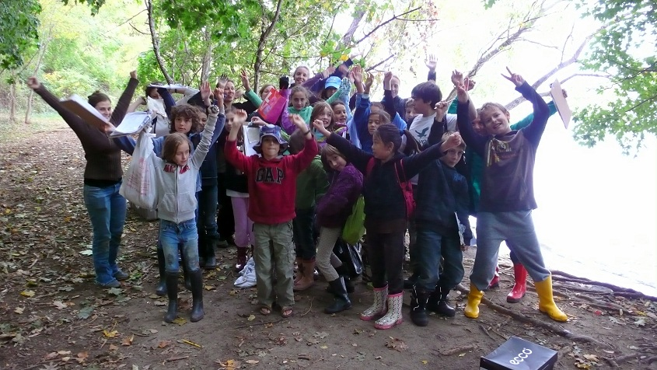
Location: Nyack Beach near Hook Mountain Sandy Beach right side of riverfront area
Area: Park/Boat launch, sandy beach area on the point with riprap
Surrounding Land Use: 100% beach
Sampling Site: Sandy beach – with a lot of trees, picnic tables, sandy and rocky at edges, covered with vegetation beyond the beach, stone wall, riprap shore, collected wood debris –not many houses.
Piping coming into river south of sampling site
Plants in water: 1% water celery
Plants in area: Japanese Knotweed 50%; Sumac
Water depth: 36 inches
River Bottom –rocky
Student site description: I see lots of trees. I see some evergreens and willows. Its pretty rocky and sandy on the beach, and the water is pretty rough. The water is murky and you can’t see through it. I think this place is used for fun! Wavy water.
ITEM | Time |  | Reading 1 | Reading 2 | Comments
Physical
Air Temperature | 10:22 AM |  | 12.8°C  55.2°F
 | 1:15 PM |  | 14.46°C  58°F
Wind Speed | Beaufort 2-5 |  |  | N
Cloud Cover | Mostly cloudy
Weather today | It started cloudy and clouds increased during the day
Weather last 3 days | Rain on Monday (1.2 inches); Tuesday 64° and sunny; Wednesday 59° and Sunny.
Water | Choppy - wavy
Water Temperature | 10:20 AM | 63°F  17.23°C |  | 64.4°F  18°C | 63.7°F  17.62°C
 | 11:13 AM | 68°F  20°C |  | 64.4°F  18°C | 66.2°F  19°C
 | 12:00 PM | 65°F  18.3°C |  | 68°F  20°C | 66.5°F  19.15°C
 | 1:10 PM | 64°F  18°C |  | 64°F  18°C | 64°F  18°C
Turbidity | 10:25 AM | 0
 | 11:20 AM | 40 JTU
 | 12:00 PM | 40 JTU
Chlorophyll | 11:20 AM | 1.0 |  | 12:20 PM | 0.3
Chemical
DO  Drop count | 11:20 AM | 4 mg/L |  | 18 ° C | 50%
pH  Indicator solution | 10:20 AM | 8.0  8.0  8.0 |  |  | Average 8.0
Phosphate
Nitrates
Salinity  Test strip | 10:45 AM | 302 ppm chloride |  | 377.5 ppm | 0.3775 ppt
Fish Catch | Seine # | Number Caught |  | Species | Length of largest
Seine 12 ft. X 6ft.  Mesh 0.25 inch | #1 | 3 |  | * Rainbow Smelt | 2.5 inch
 |  | 2 |  | Crab
 | #2 | 5 |  | Silverside | 2 inch
 |  | 4 |  | Crab
 | #3 | 1 |  | Shiner | 2.5 inch
*while not impossible this would be an unusual catch – perhaps Silverside |  | 3 |  | * Rainbow Smelt | 5.5 inch
 | #4 | 4 |  | Silverside | 3 inch
 | #5 | 5 |  | Silverside | 3 inch
Tides | 10:18 AM | 27 cm
Low tide here was ~ 10:30 AM | 11:05 AM | 35 cm |  | rising
 | 11:45 AM | 47 cm |  | rising
 | 12:30PM | 60 cm |  | rising
Currents* | CM/60 secs | Cm/Sec |  | North/South Ebb/Flood/Still | Knots
10:20 AM | 0 cm | 0 |  | South (Still) | 0
11:15 AM | 282 cm | 4.7 |  | North (Flood) | 0.08 kts
11:55 AM | 38 | 0.6 |  | North (Flood) | 0.01
1:10 PM | 450 | 7.5 |  | North (Flood) | 0.145
Turbidity  Short site tube | 10:45 Am | 40 JTU |  | 40 JTU | Average 40 JTU
Core Description
Shipping Traffic | 12:30 PM | Dredge |  | Blue | Southbound
 | 12:40 PM | RIverkeeper |  |  | Northbound
 | 1:30 PM | Cruise |  | White | Southbound
Other Observations | There are not a lot of people. We did find some blue jay feathers on the shore.
*Currents note – group noted that closer to shore current went north, farther out it went south! (looking at the sample time the tide was just starting to turn which could account for this difference)

