Snapshot Day 10/14/10 Data
(Salt Front RM 36)
RIVER MILE 35 – Bowline Park, Haverstraw Waterfront
Sarah Sterner, DEC
Jeanne Maguire, North Rockland High School – 12th grade – 14 students
41.203°N 73.958°W
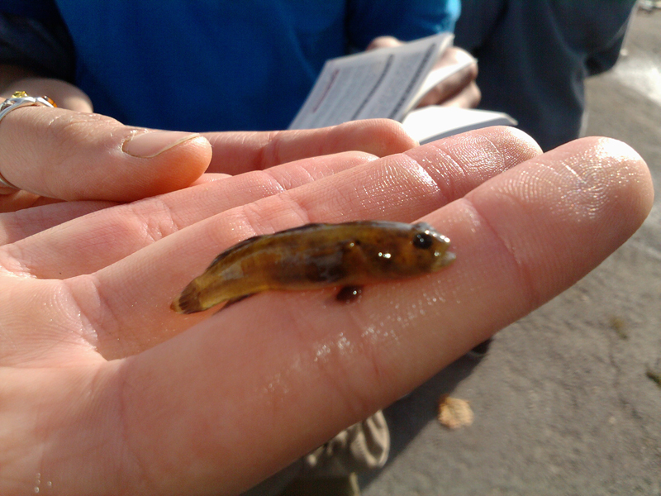
Naked Goby Caught at Bowline Park
Location: Bowline Park, Haverstraw waterfront, Rockland County NY
Area: Parking lot, recreation, fishing
Surrounding Land Use: 10% beach, 50% urban/residential, 40% other
Sampling Site: shoreline is sandy, muddy, rocky, small beach, bank altered, large rip rap, bulkhead,
Piping coming into river
Plants in area: milkweed 2%, water chestnut seed pods in area 1% (traveled on waterway)
Water depth: 3 ft.
River Bottom –muddy
ITEM | Time | Reading 1 | Reading 2 | Comments
Physical
Air Temperature | 8:30 am | 41°F  5°C | 9:25 am | 51°F  10.5°C
Wind Speed | Beaufort #2 | 4-7 km/hr | 4-6 knots | N
Cloud Cover | Partly cloudy
Weather today | No rain
Weather last 3 days | Nightfall rains on Tuesday | Temp. seasonal  Mild wind
Water Temperature | 8:30am | 16.66 C  62 F
Direct sun, barely plants, fairly still water, a lot of bricks and rocks | 10:27 am | 16.66 C  62 F
 | 11:47 AM | 22 C  70 F | 20 C  68 F
Turbidity |  |  |  | Water was cloudy
9:02 am | 27 cm | 30 cm | 72 cm | Avg 43 cm
Chlorophyll | 10:28 am | 0.7
Chemical
DO  Drop count | 8:30 am | 16.67C | 6 PPM | 60 % sat
 | 10:30 am | 16.67C | 6 PPM | 60 % sat
 | 11:30 am | 20C | 8 PPM | 90 % sat
pH  Colormetric kit | 8:35 AM  9:20 AM | 7.5  7.5
 | 10:10 AM | 8.0  7.5  7.5 |  | Average 7.66
 | 11:33 AM | 7.2
Salinity  Titrator strips – high range |  | Quantab strip .75 | .04 mg/L chloride | *striped might have been too high to read this correctly
Fish Catch | Number Caught | Species | Length of largest | Catch per Seine - CPUE
Seine 12 ft. X 6ft.  Mesh 0.25 inch | 3 | Killifish | 7.5 cm | 8:45 AM - 3
 | 3 | Striped Bass | 8 cm | 9:30 AM - 5
 | 1 | Naked goby | 4 cm | 10:45 AM - 0
Macroinvert. | 1 | Blue crab | 3.4 inch | 11:45 AM - 0
Tides | 8:15 am | 30 cm
 | 8:20 am | 29 cm | falling
 | 9:17 am | 20 cm | falling
 | 9:45 am | 16 cm | falling
 | 11:00 am | 21cm | rising
NOTE: Low Tide 10:38 AM
Currents | CM/60 secs | Cm/Sec | North/South Ebb/Flood/Still | Knots
8:47 am |  |  | Ebb | 0.04Knots
9:23 am |  |  | Ebb | 0.12Knots
11:20 am |  |  | Flood | 0.168 knots
Core – 4 cores | Length | Rare | Common | Abundant
Recorded here is one given to Sarah | 16 cm | Mud  Leaves  Wood  Oyster shell  Macro  Coal  Living veg. | Sand  slag | gravel  pebbles  brick
Shipping | 10:15 AM | Large red barge with white tug | Southbound | Full of construction material
Observations | Garbage was along the shores and many bricks were along the beach showing how there were old brick factories in the area. Also spotted a falcon in a tree.

