Snapshot Day 10/14/10 Data
(Salt Front RM 36.0)
RIVER MILE 4
Pier 84
N 40.76544 W-73.99765
Lauren Donnelly & Crist Figueroa, Hudson River Park Trust
Mark Soobyiah, Dana Goldberg & PS 51 Elias Howe School (50 fourth graders)
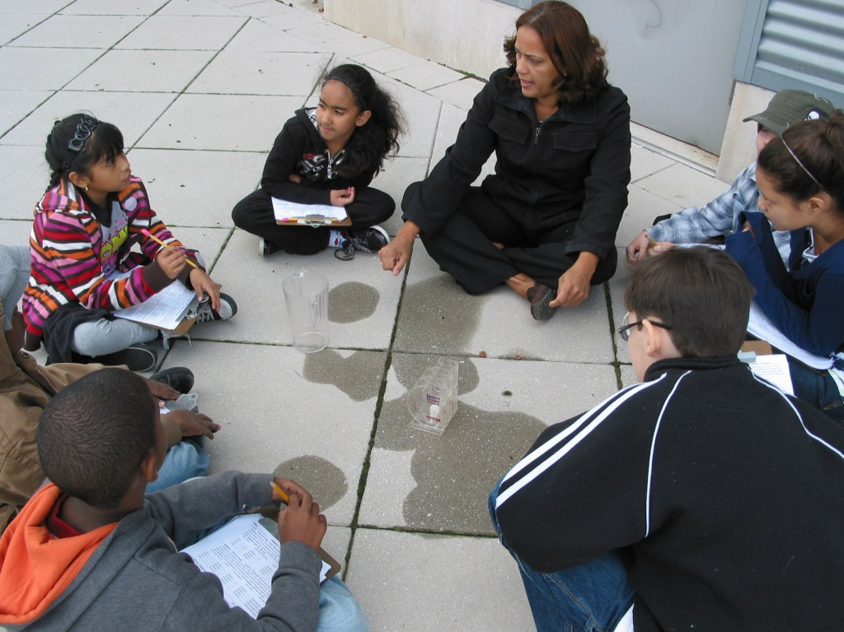

Location: Pier 84, an educational pier. Picnics, boating, fishing take place at our sample site.
Area: Pier – bulkhead – mainly concrete & wood
Surrounding Land Use: 100% urban/residential
Sampling Site: Recreational pier – rocks near the edge, banks altered
Bottom: sandy, muddy, rocky
Plants in area: None
ITEM | Time |  | Reading 1 | Reading 2 | Comments
Physical
Air Temperature | 11:18 AM |  | 14.4°C  58 °F
Wind Speed | Beaufort #2 |  | 4-7 mph | West
Cloud Cover | Mostly cloudy
Weather today | No rain -
Weather recently | Monday rainy, Tues & Wed sunny
Water | calm
Water Temperature | 10:05 AM | 20°C |  | 68 °F | Collected water in a shady area next to building – water calm
Turbidity  Short site tube | 10:35 AM | 20 JTU  20 JTU  20 JTU |  |  | 20 JTU
Chemical
DO  (drop count kit) | 10:50 AM | 4.0 mg/L |  | 20 ° C | 40% saturated
pH  indicator solution | 9:30 AM | 7  8 |  |  | 7.5
Salinity (hydrometer) | 10:55 AM | 6 ppt |  |  | 6 ppt
Fish Catch
Tides (from dock) | 11:09 AM | 550cm |  | 5.5 m
Currents | Cm/60 secs | Cm/sec  North/South |  | Knots | Ebb/Flood/  Still
10:47 AM | Too fast to measure rate |  |  |  | Ebb
11:17 AM |  |  |  |  | Ebb
Boats | 10:30 AM | NY Waterway |  | Intrepid | Docked
Other Observations

