Snapshot Day 10/14/10 Data
(Salt Front RM 36)
RIVER MILE 5
Pier 95
Penina Steinberg Midtown West School – 28 students 3-5th graders
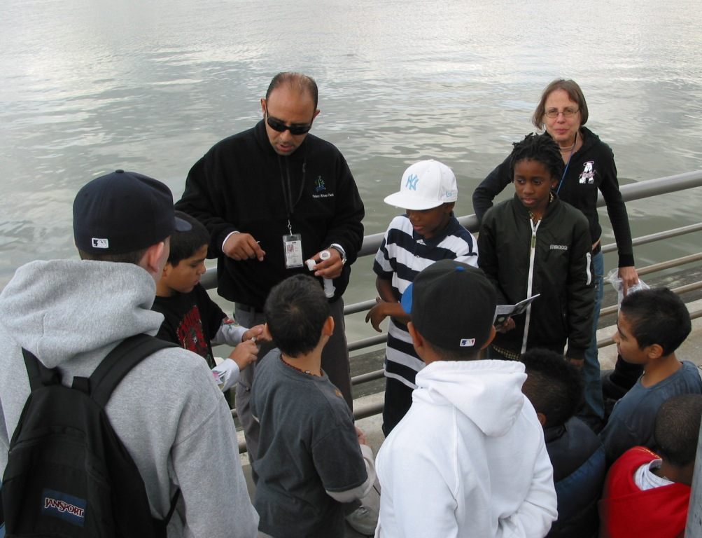
Location: NYC 12th Ave. & 54th St. Manhattan
Area: Pier
Surrounding Land Use: roads and parking lots nearby, area is park-like with grass and trees, a large grassy area for recreation. Grass, trees and a sunflower visible.
Sampling Site: Recreational pier
Plants in water: grass, trees, leaves. plankton
Sampling Times: 10AM to Noon
ITEM | Time |  | Reading 1 | Reading 2 | Comments
Physical
Air Temperature
Wind Speed |  |  |  |  | Water choppy
Cloud Cover | cloudy
Weather today | sunny shifting to cloudy, windy, cool
Weather recently | Cooling down temperatures
Water Temp. | 10:00 AM | 19° C |  | 65° F
Turbidity  Site tube | 10:00 AM | 40 JTU
Chlorophyll | 10:30 AM | 0.1
Chemical
DO  (Test Tabs/LaMotte) | 11:00 AM | 8.0 mg/L |  | 19° C | 87% saturated
pH (pH tabs) | 11:00 AM | 8.0
Phosphate | 10:00AM | 2 ppm
Nitrate | 10:30 AM | 0 ppm |  |  | .
Alkalinity | n/a
Salinity (hydrometer) | Between 10 and noon | 6 ppt
Tides
Currents
Shipping | ships, boats, barge, tugboat, tire in the water, orange buoy
Other Observations | seagulls, ducks, geese, birds, pigeons

