Snapshot Day 10/14/10 Data
(Salt Front RM 36)
HARLEM RIVER MILE 13
Sherman Cove/Swindler’s Cove Park on the Harlem River
Obed Fulcar, Maria Teresa Mirabal MS # 319 -6th-8th graders – 6 students
657452.5 E Lat & 766785.8 N Long.
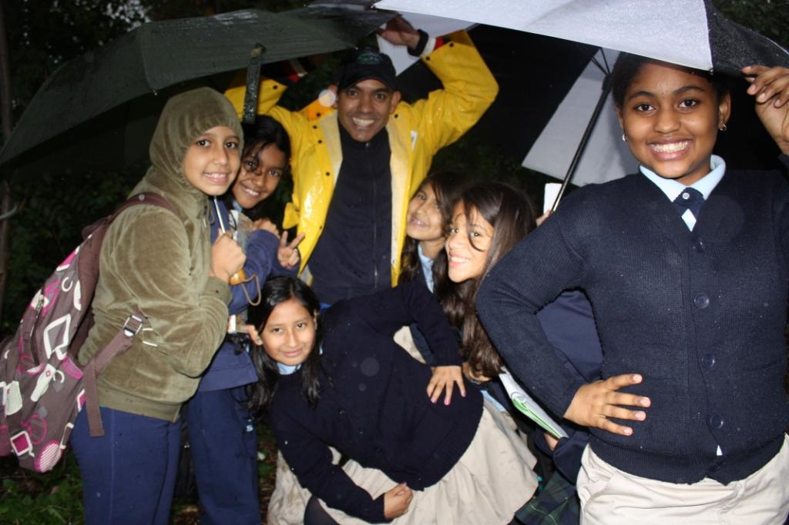

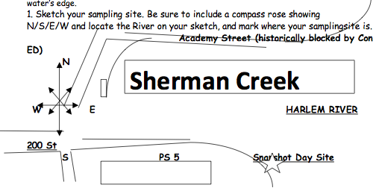
Location: Saltmarsh/mudflats at Sherman Cove Park next to a side road/school building, adjacent to Swindler Cove next to the north end of Harlem River Drive, Manhattan – a forever wild area.
Surrounding Land Use: 50% urban/residential, 20% forested, 15% beach, 5% Industrial/commercial, 5% other
Sampling Site: Beach area, covered with vegetation - Sampled in salt marsh covered with phragmites on one side and a mudflat with gravel on the shore
Plants in area: 50% of site is invasive Phragmites, 5% native spartina, 10% native milkweed, 35% other
Water depth:
River Bottom: muddy bottom
ITEM | Time |  | Reading 1 |  | Reading 2 | Comments
Physical
Air Temperature | 4:50 PM |  | 55°F
Wind Speed
Cloud Cover | overcast
Weather today | Rain - Morning was partly cloudy with developing Noreaster towards afternoon. Light drizzle turned to heavy precipitation/ strong winds
Weather recently | Windy and rain
Water | calm | (occasional boat wake)
Water Temperature – water depth 1 ft. | 4:50 PM | 17.8°C  17.7°C |  |  |  | Average  17.7 °C
 | 5:05 PM | 18°C  18 °C |  |  |  | 18 °C
Turbidity | 5:05 PM | 54 cm |  | long sight tube |  | Water not very turbid despite the rain and high level of tide
Chlorophyll | 5:15 PM | 0.5
Chemical
DO  (LaMotte Green force kit) | 5:25 PM | 0.0 ppm |  | 18°C |  | 0% saturated
pH – LaMotte | 4:50 PM | 8  8  8 |  |  |  | Average 8
Salinity - hydrometer | 5:20 PM | * 42/ specific gravity 1.032 ppt |  | (standardized salinity sample read 10 ppt) |  | * This measure has to be in error
Tide | 4:50 PM | High tide
Fish Catch | Number Caught | Species |  | CPUE |  | Size
 | We were unable to cast our seine nets and conduct the Fish & Macro invertebrate activity due to the rain event and short time after school.
E Coli | Positive Results | We tested the water quality of the site by using the LaMotte Greenforce tablet reagents. We followed the protocol by pouring the sample to 10mm in the glass vial containing the tablet, and mixing it until the tablet dissolved. We stored the sample upright, covered from any light source for 24 hours, and when we compared the color (yellow with foam in the top layer) to the ID card the sample showed positive for the presence of E-coli. Friends of Sherman Creek have tested the site for the past 3 years, and the last 5 tests have come out positive. We are trying to build a database to convinced the NYCDEP (NYC Dept of Environmental Protection) to shut down or to retrofit the CSOs (Combined Sewer Overflow) that drains and discharge raw sewage into the Sherman Creek and the Harlem River. We cannot achieve the Governor’s Goal of a Swimmable Hudson River with this level of pollution that risks the many kayakers, college rowers, and rising number of citizens that currently enjoy the Harlem River.
Commercial Traffic | 5:10 PM | Circle Line |  | Northbound |  | Half full
Core Sample Sediments | Whole core | Top layer |  | Bottom layer |  | description
 | 2 inches | 0.5 inches Light brown |  | 1.5 inches Dark brown |  | Grain size mixed, plant material in the bottom
 | We tried sampling a few times unsuccessfully due to high tide. After the third try with the core sampler we obtained a nice core that came off nice and tight. Top layer smell like gun powder due to presence of sulfur, and bottom part showed presence of plant and organic material.
Other Observations | Seagulls | Canadian geese |  | Bluejays |  | Saltmarsh Sparrow
Observations | Area usually populated by Harbor Herons in the summer (Egrets, Black Crown Night Herons, Green Herons) but already migrated. Over 10 bird species has been counted at the site (Red-Wing blackbird, mourning dove, Red cardinal, sandpipers, Grackles, yellow warblers, American robins, Snowy woodpeckers, Red tail hawks, Cormorants). Site was used by boat clubs during early 19th century but all that is left is remains of a collapsed marina and old piers. Sherman Creek is one of the last remaining wetlands left in NYC, and in great need of restoration after years of illegal dumping of car parts, engine blocks, and tires buried in the mud. Wetlands common reeds serve as natural filters by trapping floatables like plastic bags, bottles, and cans during low tide. Friends of Sherman Creek is fighting to help cleanup and restore the wetlands, and promote public access to the waterfront (historically denied to the community) by advocating the creation of a new waterfront park by reopening Academy Street (adjacent to Sherman Creek) as a pedestrian walkway by the river. We hope the data collected can help promote the creation of an Community Ecology/Environmental Center to help educate the community about the need to protect this natural area that we like to call “Wildlife in the ‘Hood”

