Snapshot Day 10/18/11 Data
(Salt Front RM 35.7)
RIVER MILE 18
Groundwork Hudson Valley
Science Barge Educator Jeremy Teperman
Alethea Lynch, Fox Meadow School, 25 third graders
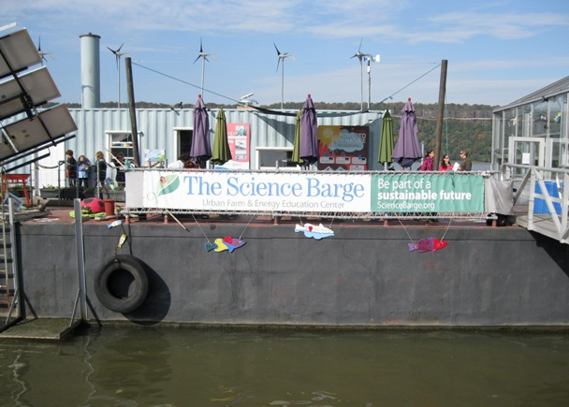

Location: Hudson River @ the Science Barge, Yonkers waterfront south of Beczak
Area: Urban housing and waterfront redevelopment
Surrounding Land Use: In order of use: Industrial/Commerical (1); Urban/Residential (2); Park/picnic (3)
Sampling Site: Docks/pier, bulkheaded concrete, banks changed by people
Plants in area: > 50% of total area has: grass, deciduous trees, coniferous trees, deciduous trees, coniferous shrubs, cultivated flowers
Water depth:
River Bottom
ITEM | Time | Reading 1 | Reading 2 | Comments
Physical
Air Temperature * *edited the C #s in posting since they did not match the F degrees. | 10:45 AM | 60°F-15.5°C | 11:03 AM  11:25 AM | 60°F – 15.5°C  62°F - 17°C
 | 11:58 AM shade | 68°F - 20°C  68°F - 20°C | 11:58 AM sun | 81°F – 27.2°C  73°F – 22.8°C
 | 12:30 PM  shade | 64°F-17.8°C  65°F-18.3°C | 12:30 PM  sun | 77°F – 25°C  71°F – 21.7°C
Wind Speed | 10:45 AM | Beaufort 1 | 1-3 kts | South
 | 11:25 AM | Beaufort 2 | 4-6 kts | South

 | 11:58 AM | Beaufort 1 | 1-3 kts | South

 | 1:00 PM |  |  | Beaufort 1 |  | 1-3 kts | South
Cloud Cover | Mostly – partly cloudy
Weather today | No rain
Weather recently | Wet fall but not too much rain in last 3 days
Water | calm
Water Temperature | 10:10 AM | 16.3°C
 | 10:58 AM | 15.8°C
 | 12:08 PM | 17.4°C
Turbidity  (secchi)_ | 10:36 AM | 49 cm  69  54  55 |  |  |  |  | 54.5 cm average
 | 11:20 AM | 65 cm  70  68  65 |  |  |  |  | 67 cm average
 | 12:21 PM | 45 cm  35  45  47 |  |  |  |  | 43 cm average
 | 12:44 PM | 40 cm  50  52  50 |  |  |  |  | 55 cm average
Chlorophyll | 11:43 AM | 0.5 |  |  |  | 1:31 PM | 0.0
Chemical
DO  (drop count kit) | 10:40 AM | 6 ppm |  |  |  | 16.3 °C | 60% saturation
 | 10:58 AM | 7 ppm |  |  |  | 15.8°C | 70% saturation
 | 12:00 Noon | 8 ppm |  |  |  | 17.4°C | 80% saturation
 | 12:35 PM | 5 ppm |  |  |  | 18°C | 60% saturated
pH – color match test kit | 10:10 AM | 8
 | 11:10 AM | 7.5
 | 12:15 PM | 8
 | 12:45 PM | 7
Salinity - hydrometer | 10:36 AM | 2 ppt  2 ppt  3 ppt |  |  |  |  | Average 2.33 ppt
Hydrometer and refractometer | 11:20 AM | 2 ppt (R)  0 ppt (H)  3 ppt (H) |  |  |  |  | Average 1.66 ppt
hydrometer | 12:15 PM | 0 ppt  2  3 |  |  |  |  | Average 1.66 ppt
Hydrometer | 12:45 PM | 3 ppt  2 ppt |  |  |  |  | Average 2.5 ppt
Nitrates | 5:06 PM | 2.5 ppm  0 ppm  0 ppm |  |  |  |  | 0.83 ppm
Tides | Start Time | End Time |  |  |  | Change
 | 10:15 AM | 10:45 AM |  |  |  | Rising tide
 | 10:54 AM | 11:23 AM |  |  |  | 7 cm rise
 | 11:54 AM | 12:21 PM |  |  |  | 7 cm rise
 | 12:28 PM | 12:59 PM |  |  |  | 7 cm rise
Current | Time | Ebb/Flood/ Still |  |  |  | Notes
 | 10:15 AM | Flood |  |  |  | Current moving east closer to shoreline. Maybe pushed by boats or wind
 | 11:10 AM | Flood |  |  |  | Current near shore is slower
 | 12:13 AM | Flood
 | 12:46 AM | Flood |  |  |  | Little flow by the shore
Shipping – All Commercial | 10:25 AM |  | Bouchard |  | Black & Red |  |  | Southbound/ empty
 | 10:25 AM |  |  |  | Grey ship |  |  | Anchored/ Empty
 | 11:07 AM |  |  |  | White /red & yellow |  |  | Northbound/ empty
 | 12:08 PM |  | Blue Jay |  | Blue |  |  | Southbound/ full
 | 12:08 PM |  |  |  | Grey |  |  | Still/ Full
Recreational Boats | 10:45 AM |  | Speed boat |  | White |  |  | Gas - south

 | 10:45 AM | Fishing Boat | White | Gas South
 | 11:33 AM | Speed Boat | White | Gas South

What we saw! | People | Fishing (1) | Boating (3) | Walking (15)
 |  | In Airplane (4) | Train (1) | Bike (1)
 |  | Helicopter (2)

 | Birds | Pigeons (2) | Ducks (3) | Geese (15)
 |  | Sparrow (7) | Seagull (11)

