Snapshot Day 10/18/11
(Salt Front RM 35.7)
HARLEM RIVER MILE 13
Swindler’s Cove Park on the Harlem River
Omari Washington, Jasmine Santana, Ifeoma Nwoke, Joseph Hayes, New York Restoration Project and 4 other educators (8 total)
Queila Cordera, Amistad Dual Language School 5th grade PS/MS311 (45 students), Anne Marie Nowak, Booker T. Washington MS 54 8th grade (40 students) ,
Ms. Fenyo, Ms. Milligan, Ms. Cuevas, Ms. Lopez, Ms. Blumentritt, Ms. Feng, PS 5 Ellen Lurie School– 5th grade and 4th grade (130 students!)
(225 students total!)
GPS Latitude 40° 51’36”N – Longitude 73°55’12”W
40° 86 N -73° 92 W
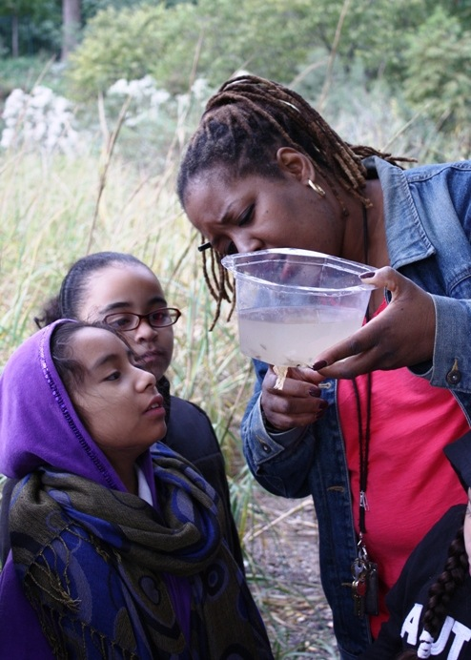 | 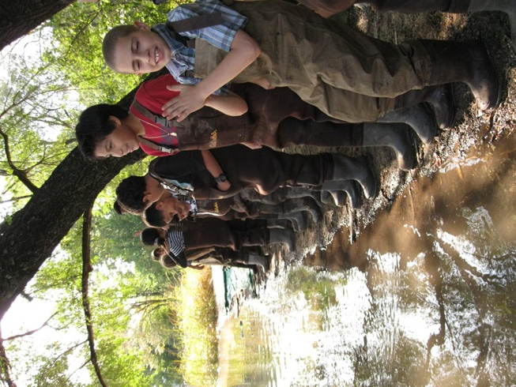
Location: Beach at Swindler Cove Park, next to the north end of Harlem River Drive, Manhattan
Area: There is a pier, beach, floating boathouse with a dock. Area used for boating, rowing, biking, walking, school groups
Surrounding Land Use: 98% Urban/residential, 2% beach
Sampling Site: Beach area, covered with vegetation, rocky, and altered banks
Plants in area: Spartina and phragmites
Water depth:
River Bottom: sandy, muddy & rocky bottom
Plant Names:

ITEM | Time | Reading 1 | Reading 2 | Comments
Physical | Sampling occurred between 10:00 AM to 2:00 PM
Air Temperature | 11:00 AM | 21°C  69.9 °F
Wind Speed | 11 AM | Beaufort Force #2 South | 6.12 km/hr
Cloud Cover | Partly cloudy | Clearing throughout the day | Light precipitation early in day
Weather today | Light rain early in day | Clearing after
Weather recently | Overcast, light rain at night – temps like today
Water
Water Temperature | AM | 20°C  68 °F
Turbidity | 8 AM | 36 cm
 | 9 AM | 34 cm

 | 10 AM | 32 cm
 | 11AM | 32 cm
 | 12PM | 31 cm
 | 1PM | 29 cm

Chlorophyll | 8:45 AM | 2.0 | 1:00 PM | 2.0-3.0
Chemical | TIME | DO | Temp
DO | 8 AM | 6 ppm | 17.6°C  64°F
 | 9 AM | 6 ppm | 18.1°C  65°F
 | 10 AM | 7 ppm | 19.2°C  67°F
 | 11 AM | 7 ppm | 19.2°C  67°F
 | 12 PM | 8 ppm | 20.9°C  70°F
 | 1 PM | 8 ppm | 20.9°C  70°F
pH – | 8AM | 7 | 11 AM | 7.5
 | 9AM | 7 | 12 PM | 8
 | 10 AM | 7.5 | 1PM | 8
Salinity | 8AM | 12 ppt
 | 9AM | 12 ppt

 | 10AM | 11 ppt
 | 11AM | 10 ppt
 | 12 PM | 9 ppt
 | 1 PM | 8 ppt

Fish Catch – more than 30 seine attempts made during day | Species | Number caught |  | Size
18 AM catch | Killifish | ~10 |  | 4 inch
25 PM catch | White Perch | 1 |  | 8 inch

 | Smallmouth Bass | 2
 | Silversides | plenty |  | 4 inch
 | Bluegill | 2 |  | 3 inch

Macros | Blue Crabs | 9 | (3 AM, 6 PM)
 | Comb Jellies
Tides | 8:56 AM | 15 ft. | 457.2 cm
 | 9:21 AM | 14 ft. | 426.7 cm

 | 10:00 AM | 13 ft. | 396.2 cm

 | 1:00 PM | 12 ft. | 365.8 cm
Currents | 9:05 AM | 44.19 cm/sec
 | 9:46 AM | 56.89 cm/sec
 | 10:09 AM | 72.12 cm/sec
Core Sample Sediments | Length | Common | Present | Description
1st core | 7 cm – no layers | Fine grain (98%)  Large grain 2%  Clay common, mud abundant  Sand, gravel, pebbles rare | 1 leaf, old oyster shell part, | 2 rocks present;
2nd core | 11 cm – top layer 4 cm, bottom 7 cm | Fine grain 99%; large grain 1%, Clay common, mud abundant  Sand, gravel, pebbles rare | Piece of wood, old oyster shell, tiny worm discovered | 1 rock present
Traffic | Circle line sightseeing cruise headed north
Other | Laughing gulls spotted in sampling site

