Snapshot Day 10/18/11Data
(Salt Front RM 35.7)
RIVER MILE 118
Lia Harris, Cary Institute of Ecosystem Studies
Sandy Fischer, Chatham High School, Chatham NY
43 students 11th -12th grade, 3 teacher and 1 educator
Latitude – N 42.233937 Latitude – W -73.799957
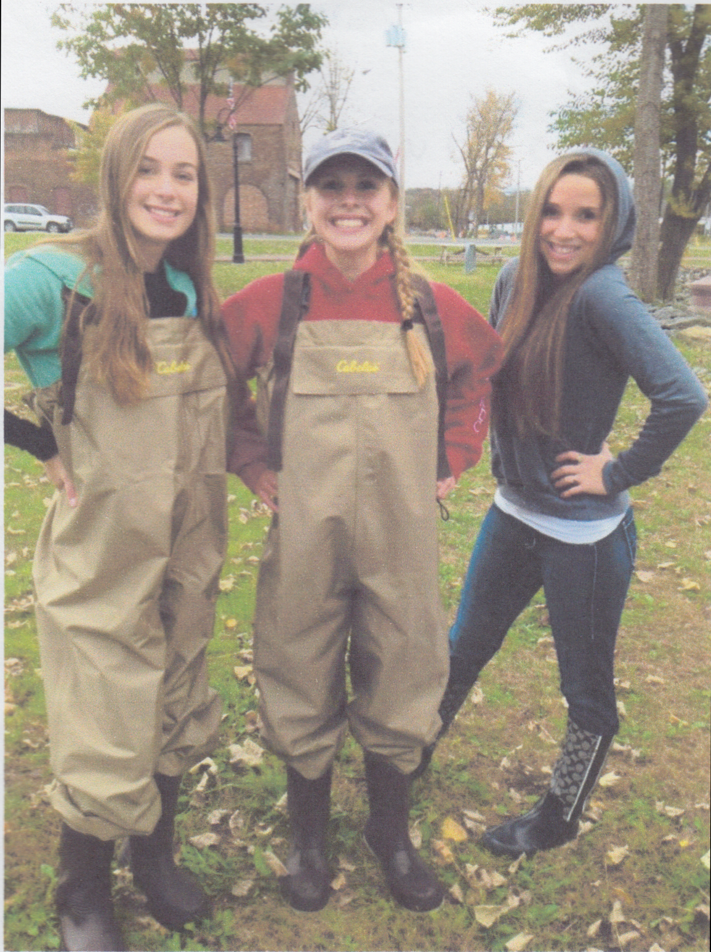
Location: Hudson River Waterfront Park, City of Hudson, Columbia County
Area: 1st dock in the waterfront property used for fishing, marina, picnics, large grassy area, just north of the old quarry site
Surrounding Land Use: 50% urban/residential, 10% beach, 20% park, 20% Industrial/commercial
Sampling Site: waterfront , banks altered, large riprap on shoreline,
Plants in area:
Water depth – 2.7 meters off dock
River Bottom – sandy, muddy
Plants in area – Grass 60%, dandelions 20%, clover 30%, Maple Trees 10%, willow trees 2%, poison ivy 1% - water Chestnut floating

ITEM | Time |  | Reading 1 | Reading 2 | Comments
Physical
Air Temperature | 9:32 AM – |  | 11°C  52°F  Beaufort 0  0 km/hr  0 kts | 9:55 AM – | 17.1°C  62.6°F  Beaufort  km/hr  0.03 kts
Cloud Cover | Overcast
Weather today | No rain, very slight wind but no gusts, chilly
Weather recently
Water calm | calm
Water Temperature – | 9:19 AM  2 ft. | 14.4 °C  15.2  22  15.2  14.7  22.55  15.3  15.3  15.3 |  | 58°F  59  58.5  59  58  58.5  59  59  59 | 15.3°C  66°F
 | 10:40-10:55 AM | 15.2°C  15.4  15.23  15.7  15.4  15.7  15.8  15.72 |  | 59.36 °F  59.72  59.54  60.86  59.9  60.08  60.2  60.44  60.35 | 15.5°C  60.05°F
Turbidity –circles long site tube & turbidimeter– varied reporting between NTUs or cms | 9:45 AM | 200 NTUs  120 NTUs  270 NTUs |  |  | 196.66 Avg NTUs
 | 10:47 AM | 14.2 cms  15.1  13.8 |  |  | 14.36 cm
 | 11:56 AM | 18 NTUs  33  89 |  |  | 46.67 NTU
Chlorophyll | 10:16 AM | 0.3 |  | 10:45 AM | 2.0
 | 12:03 PM | 2.0
Chemical | Time | Temp |  | DO | Avg.
DO *not realistic | 9:35 AM  9:39  9:40 | 15.3  15.3  15.3 |  | 7.1  7.2  8.4 | 7.56 ppm
 | 10.45 AM  10:50 AM  10:55 AM | 15.3°C  15.2  14.9 |  | 10.0  8.4  7.7 | 8.7 ppm
 | 12:05 PM | 13.7°C  15.2  14.6 |  | 6.9  9.5  11 | 9.1 ppm
pH – meter | 9:15 AM | 7.4  7.78  7.75 |  | 7.64 avg
 | 10:30 AM  10:52  10:55  11:00 | 7.83  7:36  7.96  7:36 |  | 7.63 avg.
 | 12:12  12:15  12:23  12:31 | 7.6  7.6  7.7  7.5 |  | 7.6 avg
Salinity - Quantabs | 10:13 AM – 11:25 AM | .005 |  | <29 ppm CL-
Salinity meter | 9:15 AM | 20 ppm  17.5  22 |  | Avg 19.8 ppm
 | 9:20 AM | 29  16  22 |  | Avg 22.3 ppm
 | 9:33 AM | 20  20  21 |  | Avg 20.3 ppm
 | 9:42 AM | 21  22  20 |  | Avg 21 ppm
 | 12:10 PM | 25 ppm  25  24  24.5 |  | Avg 24.7 ppm
Nitrates | 9:35 AM-9:40 AM | *5.35 avg |  |  | Test seems too high
Fish Catch | Time | Number Caught |  | Species | Size of largest
Seine net 30 feet X 4 ft., 1.4 inch mesh | 9:33 AM | 3 |  | Banded Killifish
 |  | 8 |  | American shad (herring)
 |  | 2 |  | White perch
 |  | 49 |  | Spottail shiner
 | 10:30 | 2 |  | Pumpkinseed sunfish | 5.5 inch
 |  | 7 |  | Bluegill sunfish | 4 inch
 | 12:29 pm | 2 |  | Banded Killifish
 |  | 26 |  | American (Shad Herring)
 |  | 20 |  | White Perch
 |  | 3 |  | Bluegill Sunfish
 |  | 11 |  | Spottail Shiner
 |  | 1 |  | Pumpkinseed sunfish
*8 reported as striped | 1:08 PM | 9 |  | *Banded Killifish
 |  | 1 |  | Smallmouth Bass
 |  | 5 |  | Golden Shiner
 |  | 1 |  | American Shad
Macro invertebrates | During day | *Paramercium  *Spirostomum  * Lacrymaria  • Flagellates  • Dinoflagellates  • Algea (Green, Pond scum and a non-branching form of algea) |  | Protozoa | Multiple types
 |  | Mosquito |  | Anthropods
 |  | Fresh water shrimp
Tides | 9:22 AM | 58 cm |  |  | Tide stick
 | 9:48 AM | 46 cm |  | Falling
 | 10:21 AM | 32.5 cm |  | Falling
 | 10:30 AM | 32 cm |  | Falling
 | 10:35 AM | 31 cm |  | Falling
 | 10:39 Am | 28 cm |  | Falling
 | 10:44 AM | 24.5 cm |  | falling
 | 1:03 PM | 11 cm
 | 1:15 PM | 8.75 cm
 | 1:20 PM | 7.5 cm
 | 1:30 PM | 6.5 cm
Currents | Time | Cm/60 secs |  | Cm/sec | Knots E/F/S
 | 9:40 AM. | 1125 |  | 18.75 | 0.36 Ebb
 | 10:35 AM | 1828.8 cm |  | 30.48 | 0.59 Ebb
 | 10:44 AM | 2133.6 |  | 35.56 | 0.69 Ebb
 | 10:52 AM | 3048 |  | 50.5 | 0.99 Ebb
 | 11:15 AM
 | 11:28 AM
 | 3:37 PM | 333/60 sec |  | 5.6 cm/sec | 0.11 Ebb
Core Sample | Length/Grain size/H2S | Abundant |  | Common | Rare
10:15 AM | 7 inches - Fine grain, H2S smell | Clay, Mud |  | Sand, Pebbles | Gravel, leaves, wood, slag
10:45 AM | 3 inch – layered 1 inch top & 2 inch bottom –  large grain mix  H2S smell | Gravel, Pebbles |  | Clay, mud | brick
11:56 Am | 5 in – 2 in top, 3 in bottom- fine grain | Clay, Mud (dense, smooth and gritty feel) |  | Macro invertebrates | Sand, living vegetation
1:00 PM | 3.5 inches | Mud |  | Clay, sand | Gravel, shells, coal
Traffic | 10:00 AM | Tug boat |  | Blue/white | South/full
 | 10:15 AM | Barge |  | Red | South, empty
 | 11:09 AM | Margot - Barge (Cargo ship) |  | Blue/grey | South, Empty
 | 11:40 AM | Boat |  | White, black, red | South, people
 | 11:44 AM | American Spirit ship |  | White | South, full
 | 12:16 PM | Edwin A Poling Barge |  | Teal, white | South, Empty
 | 12:30 PM | Water taxi |  | White | South, full
 | 1:07 PM | American Spirit |  | white | Northbound full
Other Items | Lot of seagulls, small fox seen across the Hudson! Found iron ore slag on the shore. Dead fish on shoreline. Water chestnut is an invasive species.

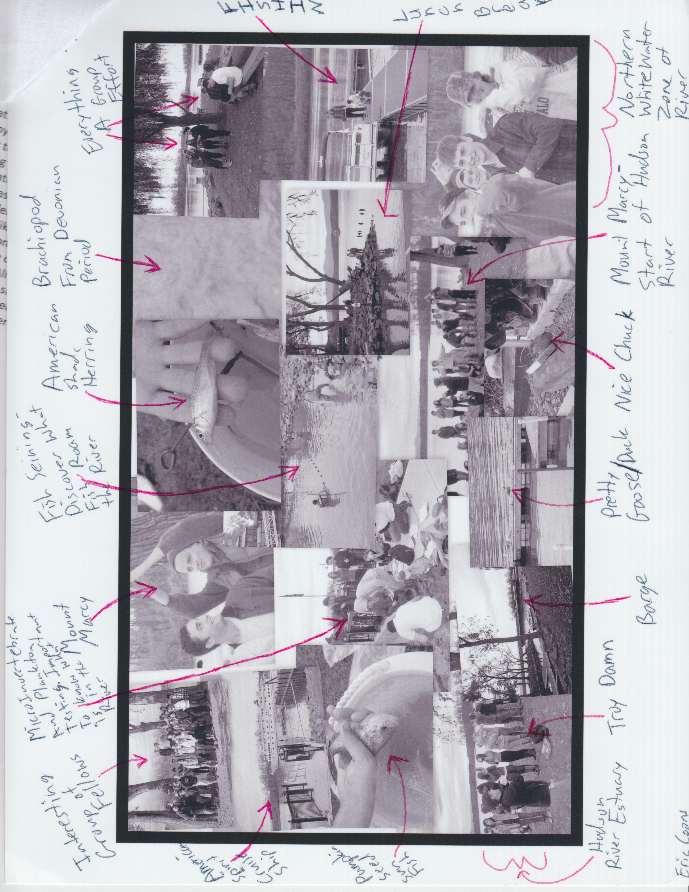
Photo Collage by Eric Coons 10/18/11

