Snapshot Day 10/18/11 Data
(Salt Front RM 35.7)
RIVER MILE 144
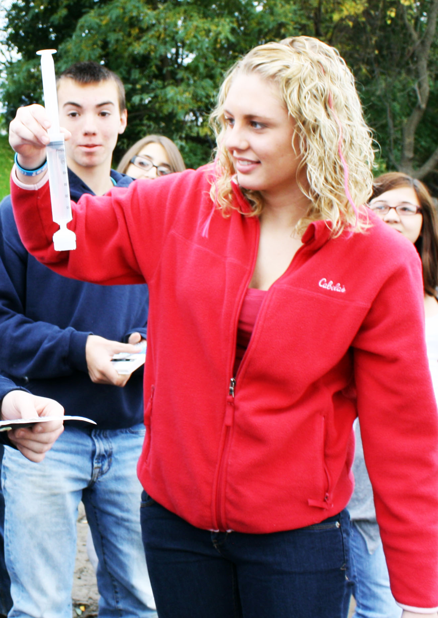
Rensselaer Boat Launch, Forbes Rd., Rensselaer, NY
Alene Onion, Hudson River Estuary Program
Leah Penniman, Tech Valley High School - 9th grade
Environmental Science & Geography – 28 students
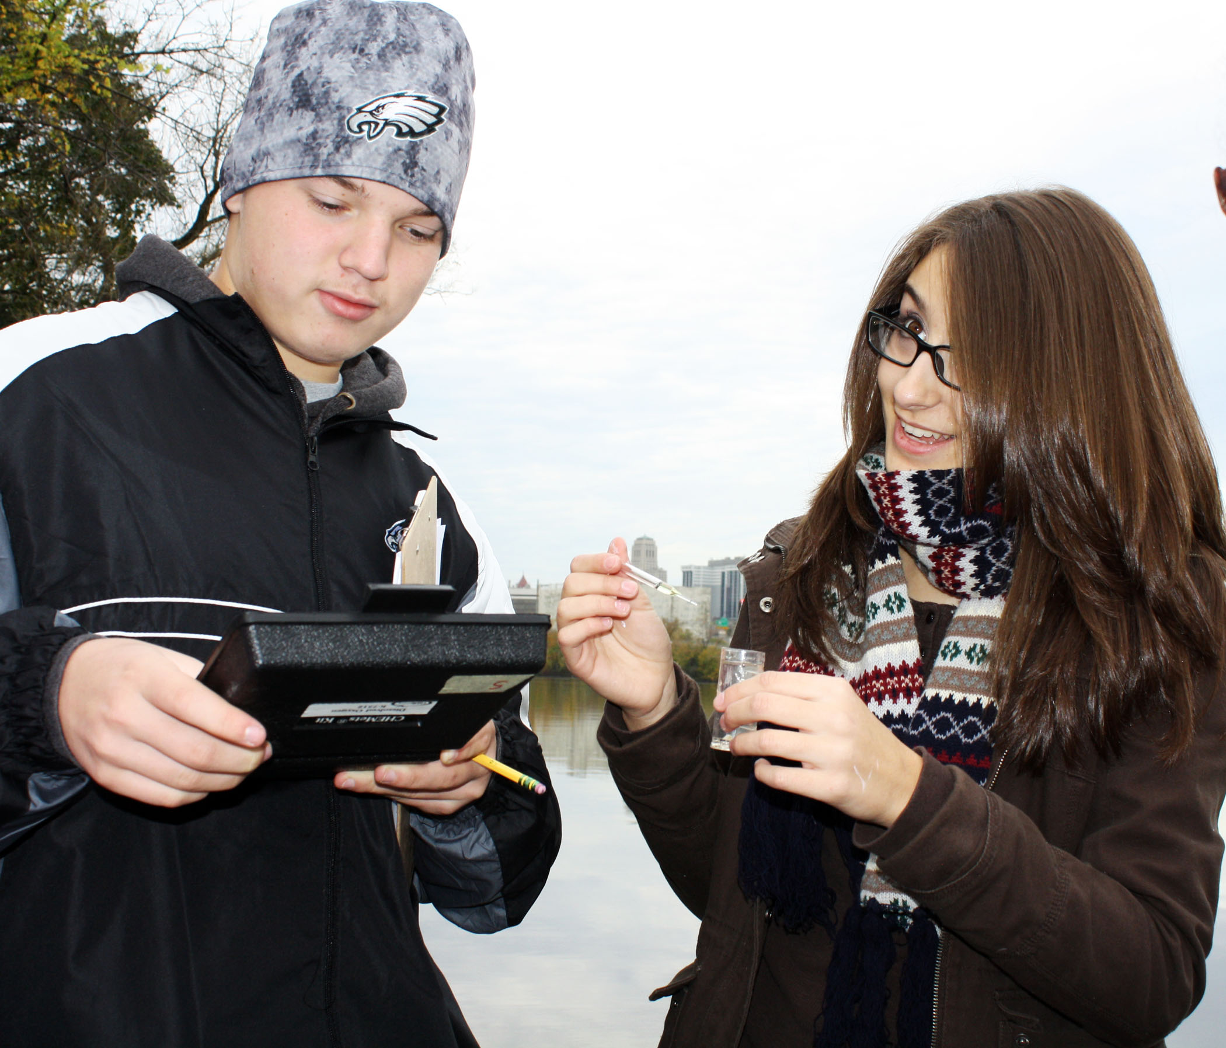 | 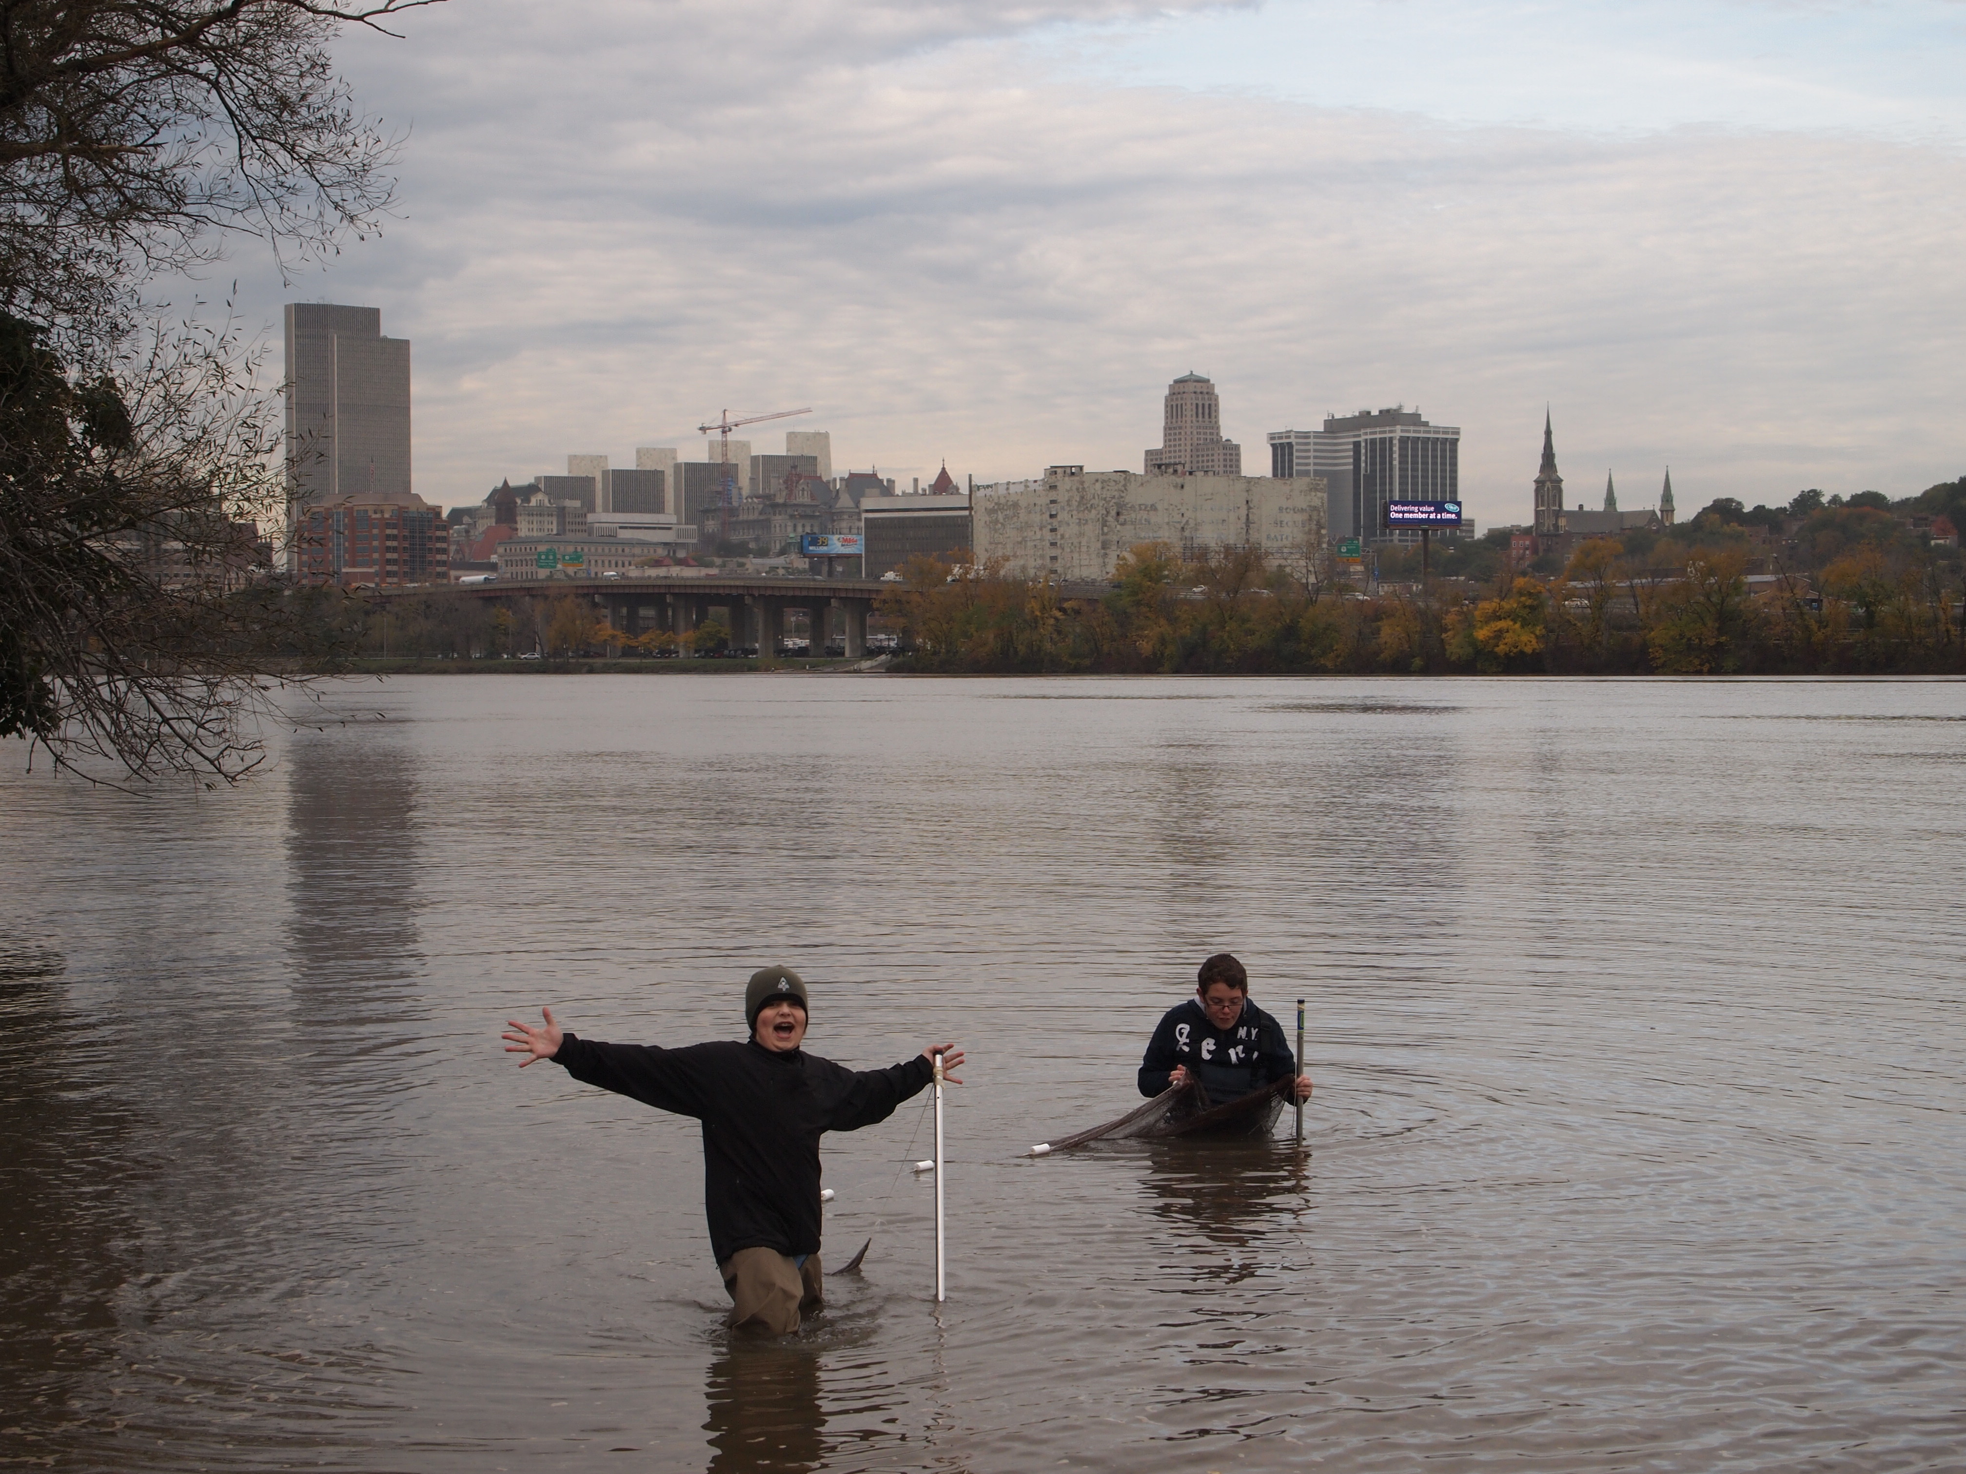
Location: Rensselaer Boat Launch
Area: Boat launch – beach area
Surrounding Land Use: Boat launch with small beach, wooded, landscaped, adjacent to urban residential area
Sampling Site: boat launch with surrounding beach area
Plants in area:
Water depth: unknown
River Bottom :
Times: All sampling 9:00AM to 10:00 AM
ITEM | Time |  | Readings | Average Reading | Comments
Physical | 9:00 AM-10:00 AM
Air Temperature |  |  | 16.5°C  15  15  15.2  14.82  15.6 | 13.35 avg
Wind Speed | Very slight breeze
Cloud Cover | Mostly cloudy
Weather today
Weather recently
Water | calm
Water Temperature |  | 15.3°C  16  15  15.3  15.72  15.18  15.4 |  | 15.41 avg
Turbidity (LaMotte) |  | 13.28 cm  12 cm  15 cm  12 cm  15 cm |  | 13.5 avg | 50 JTU (one of the sample teams used a LaMotte testkit)
Chlorophyll |  | 0.9
Chemical
DO  (chemet color comparator) |  | 10 ppm  10  10  10  7 |  | 9.4 ppm
pH – pH meter |  | 8  7.5  7.17 |  | 7.56 ppm
Phosphate -  Chemet Color comparator |  | 0.1 mg/L
Nitrate –  LaMotte color comparator |  | 4 ppm  3 ppm  4.4 ppm  1 ppm |  | 3.1 ppm
Alkalinity |  | 140 ppm
Salinity* | < 29 ppm Cl- | Below scale
Electrical Conductivity |  | 219.0  184.0  108  118  215 |  | microseimens
Coliform  Petrifilm plate 1 ml water  • stated range is based on a 100 ml sample |  | 8600  9000  6300  4900  4200  12,200  5100 |  | NOTE: Each sample exceeds the acceptable level | * Acceptable range more than 20% of the samples NOT in excess of 2,400-5,000
Fish Data | 2 | Shiner |  | Length ~1.5 inch

