Snapshot Day 10/18/11 Data
(Salt Front RM 35.7)
RIVER MILE 145
Karen Strong, Sean Madden, NYDEC HREP, Corning Preserve, Albany
Natalie Aiello, Montessori Magnet School, 4th grade, 48 students

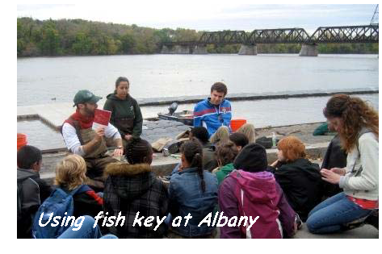
Location: Floating dock at riverfront park
Area: A path along the beach with rising forested hills
Surrounding Land Use: Urban with sidewalks & amphitheater, picnic tables
Sampling Site: vegetation, banks altered, shoreline with raprap – floating dock

ITEM | Time |  | Reading 1 | Reading 2 | Comments
Physical
Air Temperature
Wind Speed | 12:55 PM |  | Beaufort #3
Cloud Cover
Weather today
Weather recently
Water Temperature | 12:55 PM | 14.5°C
 | 11:10 AM | 14.5°C
Water calm
Turbidity – long site tube | 12:30 PM | 16 cm
Chlorophyll | Time | Color Code
Chemical
DO  (drop count kit) | 1:22 PM | 11 mg/L |  | 14.5°C | 110%
pH | 1:15 PM | 7.75
Salinity - quantab | 1:22 PM | Less than 0.005 on strip |  | <29 ppm Cl- | <52.39 ppm Salinity
Fish Catch  Seine 293 X 42 inches | Number Caught | Species |  | Length | Seine
8:00 AM | 8 | Spottail Shiner |  | 10.5 cm | Group 1
 | 3 | Herring |  | 7.7 cm
10:30 AM | 2 | Banded Killifish |  | 5.4 cm

 | 15 | Herring | 6.2 cm | Group 2
 | 18 | Brook Silverside | 7.4 cm
11:00 AM | 7 | Spottail Shiner | 9.9 cm | Group 3
 | 7 | Herring | 6.5 cm
 | 1 | Smallmouth Bass | 9.7 cm
12:45 PM | 8 | Spottail Shiner | 10.8 cm | Group 4
 | 1 | Brook Silverside | 7.1 cm

1:15 PM | 1 | White Perch | 12.1 cm | Group 5
 | 1 or > | Herring | 6.2 cm
Total catch | 72 or > | Diversity | 6 species
Currents - 12:25 PM | Veolicty | Cm/sec | Knots – (cm/sec)/51.4 | N/S -  Ebb/Flood/Still
 | 25 ft. (762 cm)/ 30.2 secs | 25.23 cm/sec | 0.49

