Snapshot Day 10/18/11
(Salt Front RM 35.7)
RIVER MILE 14
Inwood Hill Park Nature Center, NYC
Olivia Ramirez - Marble Hill School for International Studies – 9th grade – 15 students
Sunny Carrao, Urban Park Ranger
Latitude 40°50’N/ Longitude 73°55 W
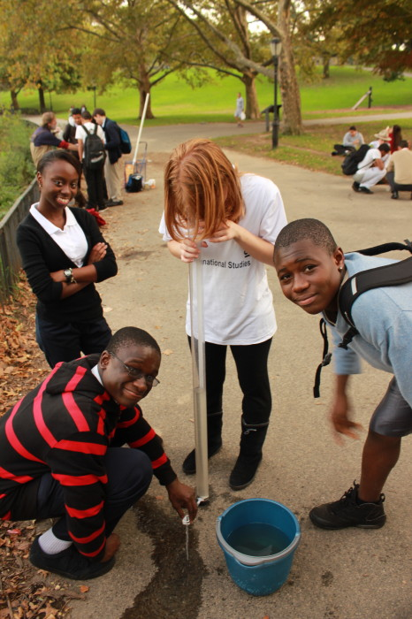 | 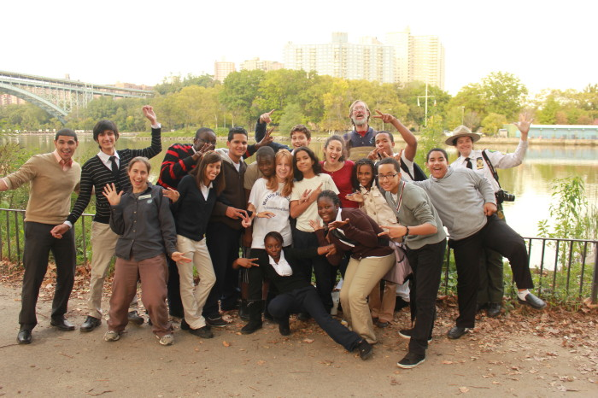

Location: In the cove of Inwood Hill Park
Area: Forested
Surrounding Land Use: Forested 60%; urban residential 10%; Industrial/commercial 10%; 20% paved. Pier, bulk-headed, rip rap shoreline. Forested and used by people for picnics, jogging, sitting on park benches.
Sampling Site: large riprap on shoreline, drainage pipes in area, vegetation
Plants in area: Yes less than half area has plants. 10% of water area has plants. 10% mud wort, 10% common reed, 10% reed grass
Water depth: 55 cm
River Bottom – muddy, rocky
ITEM | Time |  | Reading 1 | Reading 2 | Comments
Physical
Air Temperature
Wind Speed
Cloud Cover | 4:30 PM |  | Clear skies
Weather today | No precipitation
Weather recently | Windy
Water Temperature | 4:30 PM | 57°F  13.89 °C
Water surface: | calm
Turbidity  (long Site tube)_ | 4:40 PM | 16 cm  17 cm  18 cm |  |  | Average 17 cm
 | 5:00 PM | 28 cm  29 cm |  |  | Average 28.5 cm
Chlorophyll | 4:50 PM | 2
Chemical
DO
meter
pH | 5:00 PM | 8.0
Salinity – quantabs | 4:50 PM | 1896 ppm Cl- |  | 3425 ppm total salinity
 | 5:10 PM | 2660 ppm Cl- |  | 4805 ppm total salinity
Fish Catch | Number Caught | Species |  | CPUE | Seine
Seined | 28 | Mummichog
 | 4 | Striped Bass
 | 3 | White Perch
 | 3 | Gizzard Shad
 | Few | Silversides
Totals | >40 | Diversity |  | 5
Tides
Currents
Traffic
Sediment Core description
Other observations | Key Words: | Cause – Effect  Compare – Contrast  Graph Interpretations  Analogies

