Snapshot Day 10/18/11 Data
(Salt Front RM 35.7)
RIVER MILE 18.5W
Alpine Boat Basin
Christina Fehre, Alpine Park, Palisades Interstate Park
Lisa, Wolfelsperger, & Rivka Rosenstein, Alpine Elementary School
Alpine NJ – 6th grade – 16 students
N 40.56.45– W -73.55,6
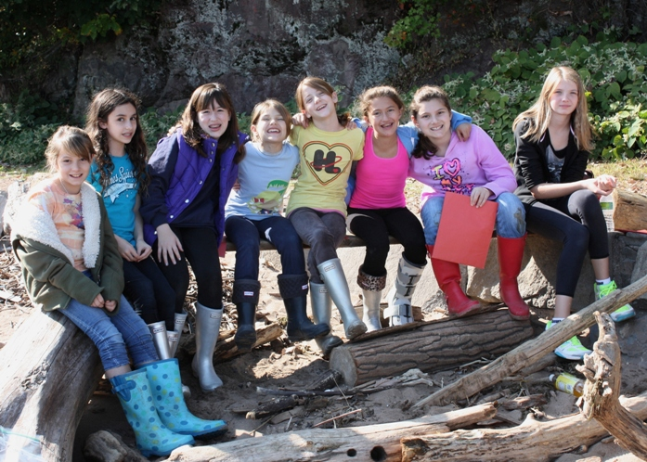

Location: North end of the Alpine Boat Basin, adjacent to a sandy beach area
Area: Used for picnics, boats, seining and education programs
Surrounding Land Use: Forested 50% (at the foot of the Palisades, Man made Sandy Beach 50%, Recreationally developed boat mooring & picnic table, parking lot
Sampling Site: sandy beach, banks altered, rip rap, bulkhead
Plants in area: none but found water chestnut pods on the beach
Water depth:
River Bottom – muddy, rock

ITEM | Time |  | Reading 1 | Reading 2 | Comments
Physical
Air Temperature | 10:42 AM |  | 60 °F  18°C | 11:30 PM | 67 °F  19°C
Wind Speed | Beaufort #3 |  | 7-10 kts | 8-12 mph | S
Cloud Cover | Partly cloudy
Weather today | No rain
Weather recently | Some rain and light wind
Water | calm
Water Temperature | 12:19 PM | 15°C
Turbidity | 12:15 PM | 23.1 cm  31.2  45 |  | Average 35 cm | Secchi Disk
Chlorophyll
Chemical
DO -  Drop count kits | 12:19 PM | 8 mg/L |  | 15°C | 90%
pH | 11:45 AM | 6 |  |  | 6 average
Nitrate
Salinity - hydrometer | 10:00 AM | 6 ppt
Fish Catch | Number Caught | Species |  | Size | Seine
8X4 ft. seine net | 8 | Bay Anchovy |  | 2.5-3 inch
 | 5 | American Shad |  | 3 inch
 | 1 | Striped Bass
Total Catch | 14 | Diversity |  | 3
Tides | 9:52 AM | 66 cm
 | 10:05 AM | 72 cm |  | Rising
 | 10:12 AM | 76 cm |  | Rising
Currents- | 10:10 AM | 2215 cm/60 secs |  | 38 cm/sec  AND  .75 kts | North/flood
Sediment Core | TOTAL Length | Common |  | Rare | Description
Shipping | 1:00 PM | Barge |  | Red/Black | southbound
 | 1:00 PM | Barge |  | Black/Green | Northbound
 |  | Barge |  | Blue/White
Observations | 3 people fishing | Someone caught an eel

