Snapshot Day 10/18/11Data
(Salt Front RM 35.7)
RIVER MILE 18
Vicki Garufi - Beczak Environmental Education Center
Harry Hall - Saunders Trade & Technical High School
(17 students) 10th -11th grade, 1 teacher and 2 educators
Latitude – N 40.93813129 Latitude – W -73.902888894
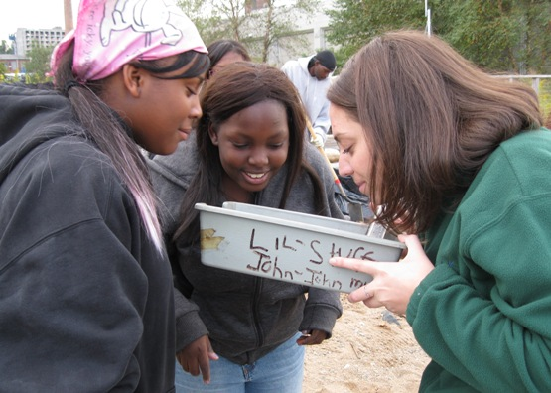
Location: Habirshaw County Park, Seining beach, Beczak Center, Yonkers in Westchester County
Area: 2 acre riverfront property used for fishing, boats, seining, field trips and education programs - 60% grassy, 20% parking lot, 20% shore
Surrounding Land Use: 89% Industrial /commercial, 10% beach, 1% urban/residential
Sampling Site: beach, tidal marsh area covered with vegetation, sandy area, banks altered, large riprap on shoreline, collected wood/debris in area,
Plants in area: no plants in the water
Water depth –
River Bottom – sandy, muddy (sticky), rocky
Plants –80% Spartina alterniflora in marsh, grasses, trees

ITEM | Time |  | Reading 1 | Reading 2 | Comments
Physical
Air Temperature | 9:30 AM – |  | 17°C  61°F  Beaufort 1  2-5 km/hr  1-3 kts South | 9:37 AM – | 17°C  61°F  Beaufort 1  2-5 km/hr  1-3 kts South
 | 10:07 AM – |  | 20°C  65°C  Beaufort 1  2-5 km/hr  1-3 kts South | 10:42 AM – | 19°C  66°F  Beaufort 2  4-7 km/hr  4-6 kts South
 | 10:54AM – |  | 20°C  70°C  Beaufort 1  1-3 km/hr  1-3 kts South | 11:19 AM – | 18°C  64.4°F  Beaufort 2  4-7 km/hr  4-6 kts East
 | 11:31 AM – |  | 18°C  63°C  Beaufort 2  4-7 km/hr  4-6 kts South
Cloud Cover | Partly cloudy
Weather today | No rain
Weather recently
Water calm | calm
Water Temperature – | 9:29AM – 1 ft. depth | 16°C  18  17 |  | 60.8 °F  64.4  62.6 | 17 °C  62.6°F
 | 10:10 AM – 2 ft. depth | 17C  63.5 °F |  | 62.6°F | 17 °C  62.6°F
 | 10:40 AM -2 ft. depth | 15 °C |  | 59 °F
 | 10:50 AM – 2 ft. | 16.8 °C |  | 61.4 °F
 | 11:15 AM – 2 ft. | 18 °C |  | 64.4 °F
Turbidity – sight tube – NOTE used in area where group was seining – so stirred up the mud | AM | 18 cm  18 cm  18 cm  24 cm  24 cm  26 cm  30 cm  31 cm |  |  | 23.63 cm  average
Chlorophyll | 9:50 AM  11:34 AM | 0.7  0.7
Chemical | Time | Temp |  | DO | Saturated
DO Hach (H) &  Chemette (C) | 9:50 AM | 16°C |  | 9 mg/L - H  5 mg/L - C | 95%  50%
 | 10:20 AM | 17°C |  | 9 mg/L - H  6 mg/L - C | 90%  62%
 | 10:40 AM | 15°C |  | 9 mg/L | 90%
 | 11:00 AM | 16.5°C |  | 8 mg/L | 80%
 | 11:35 AM | 18 °C |  | 5 mg/L - C | 50%
pH – color match | 9:35 AM | 7.5 X 2
 | 10:10AM | 8.0 X 2
 | 10:45 AM | 8.0 X 2
 | 11:20 AM | 8.0 X 2
Salinity - hydrometer | 9:28 AM – 11:25 AM | None detectable this method
Fish Catch | Number Caught | Species |  | Size of largest | Type
Seine net 30 feet X 4 ft., 1.4 inch mesh - 34 ft. pull | 18 | Atlantic Silverside |  | 8.5 cm
11:30 AM | 33 | Atlantic Silverside
 | 10 | Herring
 | 3 | Striped Bass
Tides | 9:27 AM | 19 cm |  |  | Tide stick kept floating off with current & needed to be reset
 | 9:35AM | 21 cm |  | rising
 | 10:04 AM | 34 cm
 | 10:17 AM | 42 cm |  | rising
 | 10:38 AM | 44 cm
 | 10:51 AM | 44 cm |  | rising
 | 11:13AM | 48 cm
 | 11:37AM | 53 cm |  | rising
Currents
 | 9:30 AM. |  |  | flood
 | 9:535 AM |  |  | flood
 | 10:05AM |  |  | flood
 | 10:18 AM |  |  | flood
 | 10:40 AM |  |  | flood
 | 10:52 AM |  |  | flood
 | 11:15 AM |  |  | flood
 | 11:28 AM |  |  | still
Core Sample | Entire Length | Grain Size |  | Smell | Description
Group 1
Marsh sample
Traffic | 9:49 AM | Personal craft |  | White, red | North, empty
 | 9:49 AM | Personal craft |  | White, navy | North, full
 | 9:56 AM | Speed boats |  | White, black | South, empty
 | 10:19 AM | Cargo boat/Bouchard Transportation Co. |  | Red | South, empty (oil barge)
Other Items | Lot of seagulls, people planting plants,

