Snapshot Day 10/18/11
(Salt Front RM 35.7)
RIVER MILE 2
Chris Anderson - The River Project
Bob Wallace - NYU
Karen Johnson, Dora Kong, Kim Esther, Jane O’Donnell
3rd grade Trevor Day School – 56 students + 12 parents + 4 teachers + RP staff
Latitude N 40°43’71 N Longitude 74°00’89 W
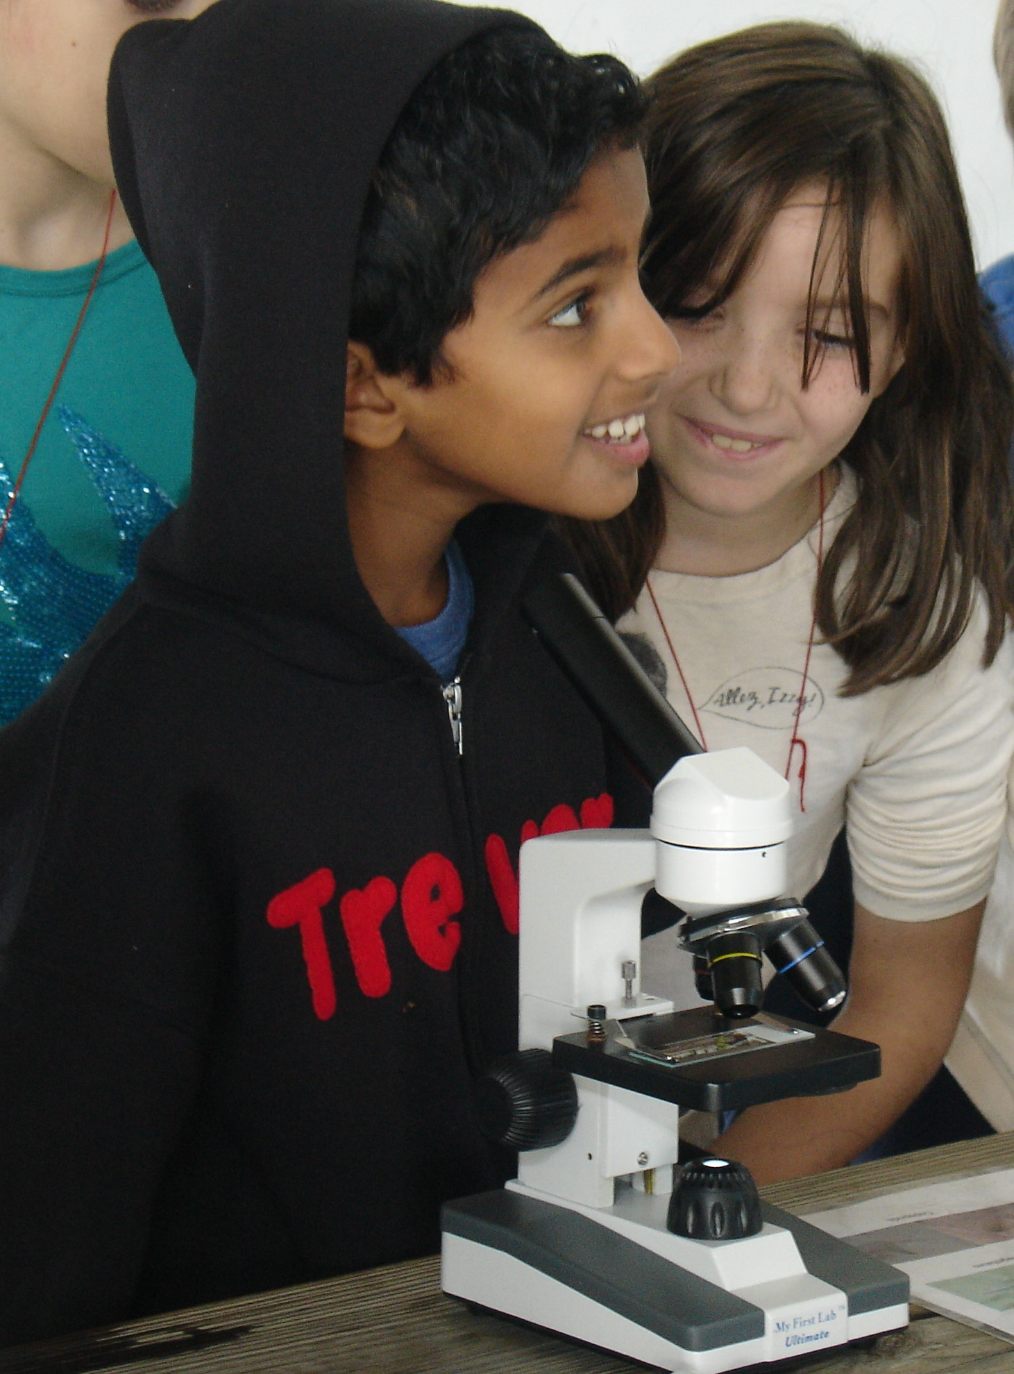 | 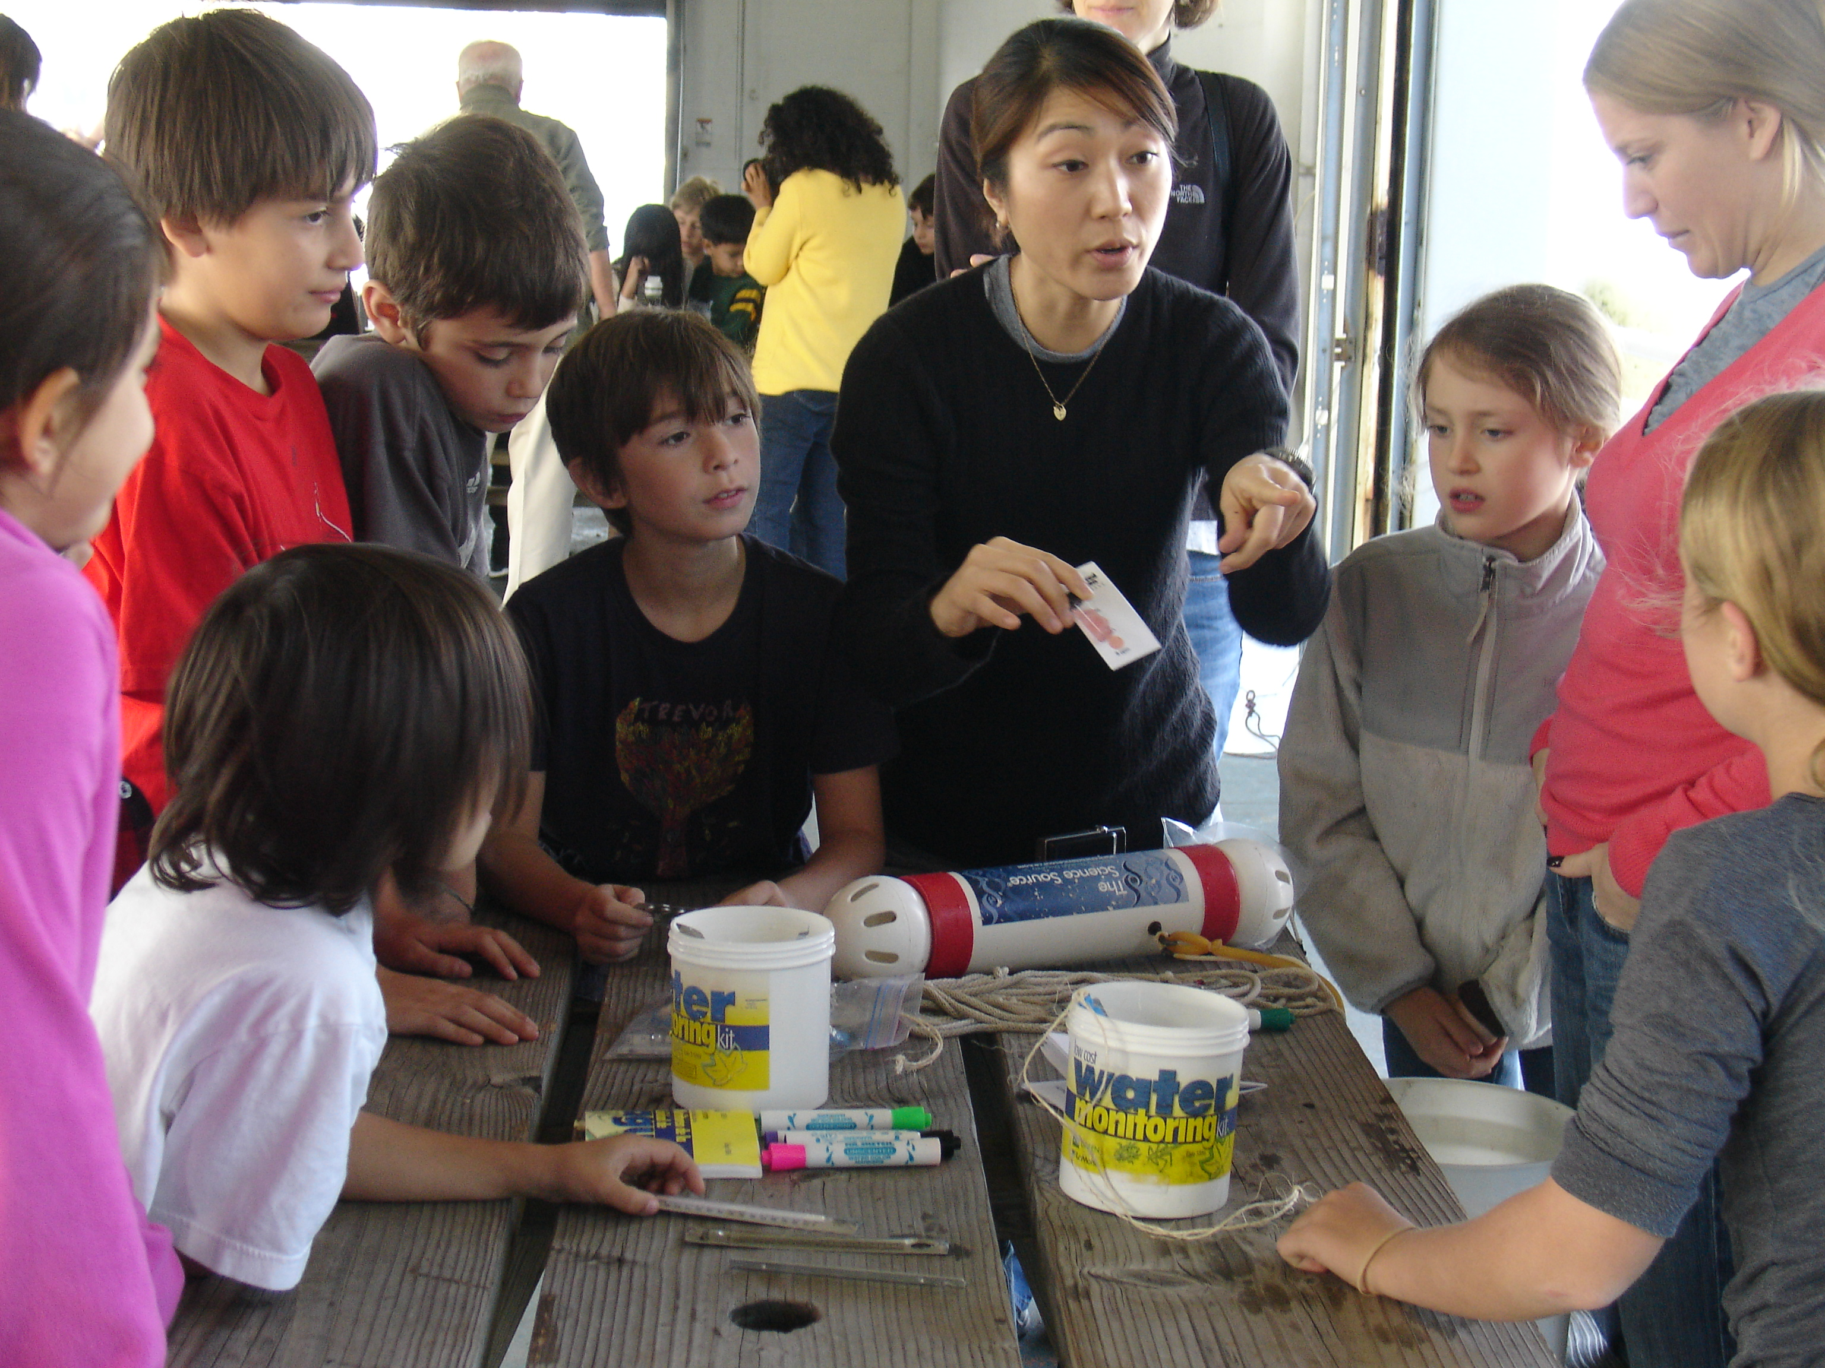
Location: Pier 40 Hudson River (also called North River)
Area: Large pier with many facilities: athletic fields, kayaking and boathouse, seasonal moorings available, parking, fishing on the pier, benches & picnic tables for the public Surrounding Land Use: parking lot – area used for picnics, boating, fishing
Sampling Site: Banks altered; concrete & wood pilings, pier extends into river/cement bulkhead
Plants in area: None visible
Water depth:
River Bottom –
NOTE:
This highly urban site is just west of the busy Westside Highway – it is the largest pier in Hudson River Park (with a 14 acre footprint); Pier 40 is used for recreation; school groups use the athletic fields; there are 3 public boathouses; there are many people by on the river’s edge: jogging, bike riding, walking; River Project’s temporary home is on Pier 40.
(Measurements were taken from 10:45 AM to 11:45 AM, average given)

ITEM | Time |  | Reading F | Reading C | Comments
Physical
Air Temperature | 10:45-11:45 AM |  | 63.3 °F | 17.4 °C | Average –
Wind Speed | Time |  | Beaufort Chart | Kestral Meter
 | 10:45-11:45 |  | #2 | 1.03 kts | South
Cloud Cover | 10:30-noon - Partly cloudy to rapidly increasing clouds
Weather today | partly cloudy, beginning to clear, light rain for about 15 mins
Weather recently | Cool (high 50s - low 60s)/ breezy, windy recently/ no rain
Water | Fairly calm, minimally choppy
Water Temperature - | 10:56 AM  11:02  11:15  11:26  11:37  11:50 | 15°C  15  18  17  17  20 |  | 60 °F  60 °F  65 °F  63 °F  63 °F  68 °F | Collected in the sun, off the pier ~ 500 feet into the water in ~ 6-10 feet of water
Turbidity (long site tube | 10:50-11:13  11:25  11:40  11:50 AM | 77.8 cm  71.25  79.8  69.8  81 |  |  | Water looked brownish/greenish and rather murky
Chlorophyll
Chemical | TIME | TEMP. |  | PPM | % SAT.
DO  (drop count kit) | 10:56 AM  11:15  11:26  11:37  11:50 | 15°C  18  17  17  20 |  | 5 PPM  6 PPM  4PPM  5 PPM  6 PPM | 49  62  40  50  65
pH – color match LaMotte kit | 10:45 AM  11:58  11:10  11:22  11:33  11:45 | 7.5  8.5  7.5  8.5  7.5  8 |  |  | Average 7.35
Salinity – hydrometer - | 10:45 AM  11:58  11:10  11:22  11:33  11:45 | 6.0 ppt  6.0 ppt  6.0 ppt  6.0 ppt  5.5 ppt  5 ppt
Vertebrate Catch | Number Caught | Species |  | Size | Minnow traps
Pots on the Lilac Ship – the pots were checked without the students since they are at a different location. | 1 | American Eel |  | 43 cm
Invertebrate Catch | 26 | Grass Shrimp
 | 1 | European green crab
 | 10-20 | Isopods & mud snails
Tides
Currents
Boat Traffic | 11:09 AM | Barge & Tugboat |  | The Evaleigh | Northbound
 | 11:15 AM | NY Waterway Ferry |  | The Henry Hudson | Northbound
 | 11:29 AM | Tug Boat |  | Harry Muncil | Northbound
 | 11:36 AM | Large Powerboat |  | Amusant | Southbound
This is a largely commercial area but there is also a paved walkway along the river used by pedestrians, joggers & bicyclists

