Snapshot Day 10/18/11 Data
(Salt Front RM 35.7)
RIVER MILE 300
Upper Works Trailhead (Adk High Peaks Wilderness), Tahawus Rd.
Adirondac (abandoned mining village), Newcomb NY
GPS Latitude 44°05.370’ N Longitude 74°03.358’ W
Elevation 1,820 ft/550 meters
Doug Reed, Hudson Basin River Watch
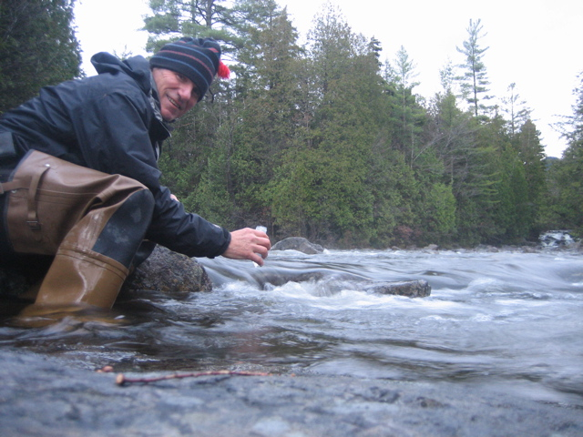
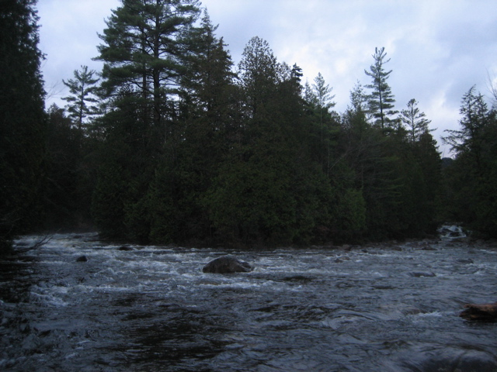
Location: Adirondack (abandoned mining village), Newcomb NY, where the Hudson takes its name
Area: a rushing river
Surrounding Land Use: 100% forested
Sampling Site:
Plants in area:
Water depth:
River Bottom : cobbles

ITEM | Time |  | Reading 1 |  | Reading 2 | Comments
Physical
Air Temperature | 6:00 AM |  | 38°F  3.33°C
Wind Speed
Cloud Cover | Clear skies with some high clouds
Weather today | Light rain all night |  | Mostly cloudy at dawn, slight breeze
Weather recently | Cool, slight rain
Water Temperature | 6:00 AM | 44°F  6.67°C
Water calm
Turbidity short
Site tube
Chlorophyll | 6:00 AM | 0.0
Chemical
DO  Hach DO kit model OX-DT | 6:00 AM | 9.32 mg/L |  | 6.67°C |  | 75% saturated
pH – Lamotte Brom. Blue kit pH model B-BTB |  | 6.2
Salinity - Quantab | No reading – below detection
Tides | n/a
FLOW (not current) | Riverbank full  2 meters/sec
Traffic | n/a
Reflections | Reflections I woke up at 12:20 am in the trailhead parking lot near where the river is born. It was full and fast, roaring all night out of the mountains, like the powerhouse it is through the Troy Dam and down the Hudson Valley.

