Snapshot Day 10/19/11
(Salt Front RM 35.7)
RIVER MILE 4.1
Shay Saleem – Intrepid Sea, Air and Space Museum
Julie Soriano, Amistad Dual Language School PS/MS 311, 6th grade, 40 students
Latitude N 40°45 Longitude W074°00
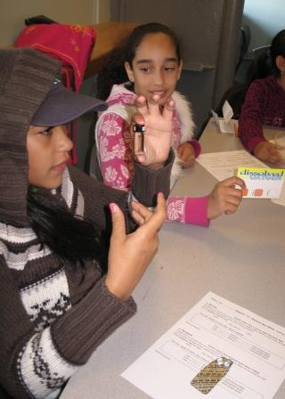

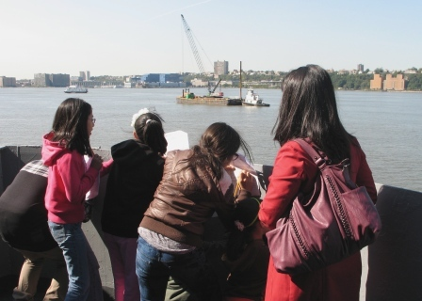
Location: The Intrepid next to Pier 84
Area: large ship at pier surrounding water access
Surrounding Land Use: 40% urban/residential, 10% forested, 40% industrial commercial
Sampling Site: Pier, Bulkhead (wood timbers), used for boating, banks altered, covered in vegetation
Plants in area: None
Water depth: 20 ft.
River Bottom –muddy

ITEM | Time |  | Reading 1 | Reading 2 | Comments
Physical
Air Temperature | 11:20 AM |  | 57 °F  14 °C
 | 12:20 PM |  | 60 °F  16 °C
Wind Speed | Beaufort 2 |  | 6 km/hr | SW-NE
Cloud Cover | Partly cloudy
Weather today | Dry
Weather recently
Water surface | calm
Water Temperature
Turbidity
Chlorophyll
Chemical
DO  Color reaction | 11:12 AM | 0 ppm |  | 0 ppm | Avg. 0 ppm
. | 12:00 PM | 2 ppm |  | 4 ppm | Avg. 3 ppm
pH – Lamotte colormetric | 11:07 AM | 7.0  6.5  7.0 |  |  | Avg. 6.83
 | 12:02 PM | 7  7 |  | 8  8 | Avg. 7.5
Nitrate (color reaction) | 11:09 AM | 0 ppm  0 ppm |  |  | Avg. 0 ppm
 | 12:04 PM | 5 ppm  0 ppm |  |  | Avg. 2.5 ppm
Phosphate (color reaction) | 11:05 AM | 2 ppm  2 ppm |  |  | Avg. 2 ppm
 | 12:00 PM | 2 ppm  1 ppm |  |  | Avg. 1.5 ppm
Salinity  (Hydrometer) | 11:05 AM | 5 ppt  6 ppt |  |  | Avg. 5.5 ppt
 | 12:05 PM | 5 ppt  6 ppt |  |  | Avg. 5.5 ppt
Tides
Currents
Boats | 11:11 AM | NYP boat - |  | blue, white, black | Northbound
 | 11:11 AM | CIrcleline |  | White | Northbound
 | 11:14 AM | Coast Guard – |  | red, white | Southbound
 | 11:17 AM | NY waterway |  | Boat – white & navy | Northbound
 | 12:05 PM | Barges |  | Brown | South - full
 | 12:06 PM | Large boats |  | White | South - full
 | 12:07 PM | Fury - taxi |  | Yellow | North- full
 | 12:07 | City Line |  | White & B | South- full
 | 12:11 PM | Jug |  | Black | South
Other Observations | Butterflies

