Snapshot Day 10/14/11 Data
(Salt Front RM 35.7)
RIVER MILE 40 - Boat
Aboard the Clearwater, docking King Marina Dock, Verplanck, sampling to Montrose Point in Haverstraw
Tom O’Dowd, Hudson River Sloop Clearwater
June Complongo, The Peekskill Middle School
8th grade – 87 students
Latitude 41N Longitude 73W
Location: Docking at Verplanck with sampling up to Montrose Point in Haverstraw
Area: Channel Sampling
Surrounding Land Use: urban/residential 45%, forested 30%, beach 5%, industrial/commercial 20%
Sampling Site: Pier shoreline where started but sampled in open water
Plants in area:
Water depth: 10:30 AM = 33.2 Feet (Haverstraw Bay)
10:45 AM = 38.8 Feet (Greens Cove)
11:00 AM = 38.8 Feet (in transit)
11:30 AM = 37.8 Feet (Verplanck Point)
11:45 AM = 40.5 Feet (South of Verplanck)
River Bottom: Fishy!
Plants: No plants in sampling area – too deep

Two Sails during the day – One in the AM and one in the PM – Routes below:

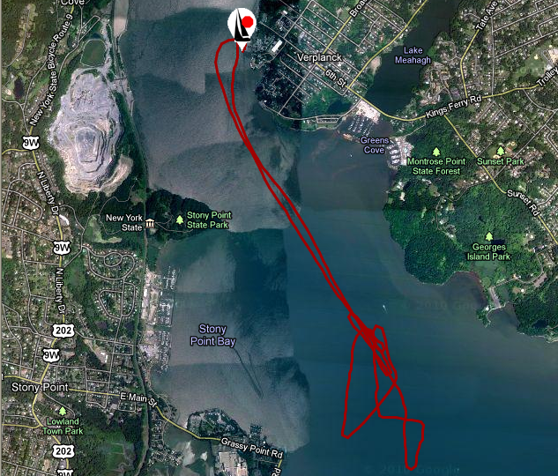 AM Sail
Fishing Spot 1
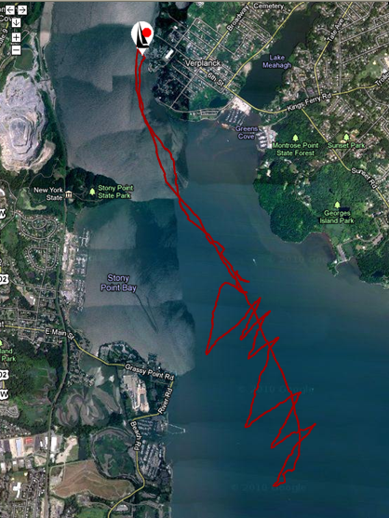
Fishing Spot 2

ITEM | Time |  | Reading 1 | Reading 2 | Comments
Physical
Air Temperature | 10:30 AM |  | 66° F  19° C | 10:45 AM | 70° F  21° C
 | 11:00 AM |  | 70° F  21° C | 11:30 AM | 74° F  23° C
 | 11:45 AM |  | 80° F  27° C
Wind Speed | 10:30 AM |  | Beaufort #2 | South
Cloud Cover | Partly cloudy AM |  | Some clouds PM
Weather yesterday | A little rainy yesterday
Water | calm
Water Temperature | 10:55 AM | 66° F |  | 19 ° C
 | 11:00 AM | 66° F |  | 19° C
 | 11:15 AM | 64° F |  | 18° C
Turbidity | Site tube | 1st reading
Long site tube | 10:45 AM | 16.75 cm
Chlorophyll | 11:40 AM | 1.5
Chemical
DO  (drop count kit) | 10:55 AM | 10 mg/L |  | 19 ° C | 110% saturated
 | 11:15 AM | 10mg/L |  | 18° C | 100 %
 | 11:40 AM | 10 mg/L |  | 18° C | 100%
Full day DO | HRECOS | 8.0- 8.4 mg/L |  | 18° C | 80%
pH strip | 11:30 AM | 6 |  |  | Average 6.25
 | 11:40AM | 6.5
Salinity | Time | Reading |  | Cl-Reading | Method
Quantabs | 10:55 AM  11:15 AM | .7 -  .8 |  | <32 ppm Cl-  OR <52.39 total salinity | 0.63 psu from HRECOS sonde = 630 ppm (Sonde set ~8 ft.)
Trawl | TIME | Species |  | Number | Max. Length
Fish | 9:50 AM | Hogchoker |  | 2 | 5 inches
 | 1:38 PM | Hogchoker |  | 11 | 5.5 inches
Macroinverts | 1:38 PM | scuds
Plankton Tow | 1:38 PM | Copepods
Tides
Currents | Time | Type |  | N/S | Full/Light & Carge
Traffic | 10:30 | Small Sailboat |  | SE
 | 10:30 | Powerboat |  | West
 | 10:45 | Sailboat under motor |  | S
 | 2:30 | Catamaran |  | S
 | 2:45 | Riverkeeper! |  | S
 | Eva Cutler | (Tug pushing fuel? barge) North |  | N | FULL (Fuel)
 | 4:00 | Miss Ink (Red Sailboat) |  | S
 | 4:10 | Commander |  | N
 | 4:15 | Sea Tow |  | N
 | 4:30 | NY 3324 UX |  | S | (one of two seados)
Other – | A reddish fish (carp?) jumped out of the water around 1:00 PM!  Stony Point Lighthouse (North of Haverstraw)  Working Quarry (North of Stony Point)

