Snapshot Day 10/18/11 Data
(Salt Front RM 35.7)
RIVER MILE 43
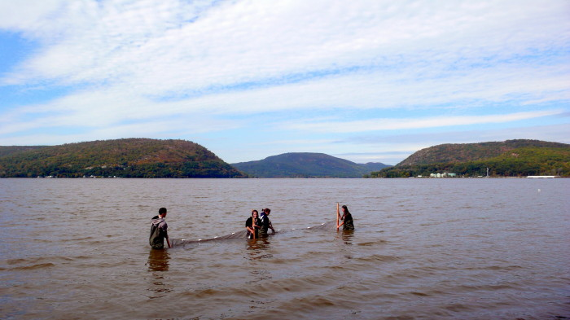
Riverfront Green, Peekskill, Westchester
Michael Billy & 3 adults from HS, Walter Panas High School - 11 students, 11/12th graders
Latitude N 41°17’12.85” Longitude W 73°55’.53.67"
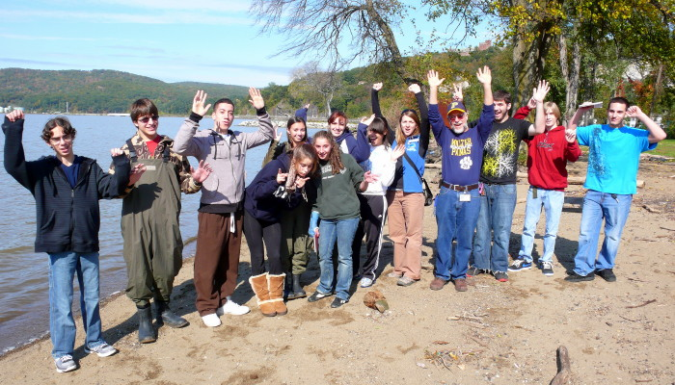
Location: Riverfront Green, Peekskill, Westchester County
Area: Grassy park area with beachfront
Surrounding Land Use: Grassy area for picnics, sandy beachfront
Sampling Site: beach, riprap, banks altered, dock, bulkhead, vegetation
Plants in area:
Water depth: 4 ft.
River Bottom – sandy, muddy, rocky.
SAMPLING TIMES: 11AM to 12:30 PM
ITEM | Time |  | Reading 1 | Reading 2 | Comments
Physical
Air Temperature |  |  | 68 °F
Wind Speed |  |  | 0-5 knots | Northwest
Cloud Cover | none
Weather today | Clear, no precipitation
Weather recently | Partly cloudy last 3 days
Water Surface | Calm
Water Temperature – | 12:00 noon | 64°F |  |  | In direct sun
Turbidity – long-site tube |  | 22.4cm  19.2 cm  18.6 cm |  |  | 20 cm
Chlorophyll |  | 1.0
Chemical
DO  (drop kits) | 12:00 PM | 7.73 |  | 64.33°F | 82.4%
pH |  | 7.72
Salinity -  meter |  | 0.13 psu
Alkalinity
Nitrates
Phosphate
Fish Catch- Noon | Number Caught | Species |  | Length | Seine
10 ft net X 4ft– | 5 | Spottail Shiner |  | 7 cm | #1
 | 1 | Striped Bass |  | 11 cm | #2
 | 1 | Gizzard Shad |  | 10 cm
 | 1 | Tessalated Darter |  | 5 cm
Tides | TIME | Water height |  | Rise/Fall
Currents | Time | Cm/60 sec |  | Cm/sec | Direction
 | Noon | 312/60 cm |  | 5.2 cm/sec | flood
Core – | TIME | Rare |  | Common | Abundant
Traffic
Other Items

