Snapshot Day 10/18/11 Data
(Salt Front RM 35.7)
RIVER MILE 5
Pier 95
Penina Steinberg Midtown West School – 14 students 2-5th graders
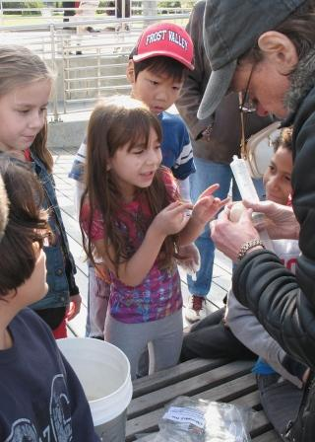 | 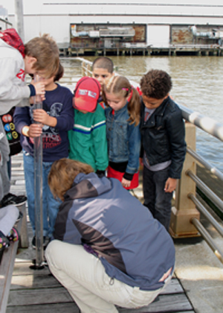
Location: NYC 12th Ave. & 54th St. Manhattan
Area: Pier
Surrounding Land Use: roads and parking lots nearby, area is park-like with grass and trees, a large grassy area for recreation. Grass, trees
Sampling Site: Recreational pier
Plants in water: n/a
Sampling Times: 9AM to 11AM
ITEM | Time |  | Reading 1 | Reading 2 | Comments
Physical
Air Temperature
Wind Speed
Cloud Cover | cloudy
Weather today | sunny clear, small breeze
Weather recently | Typical fall
Water Temp. | 9-11 AM | 18 C |  | ° F
Turbidity  Long Site tube | 9-11 AM | 13 cm visibility
Chlorophyll | 9-11 AM | 0.1
Chemical
DO  (Test Tabs/LaMotte) | 9-11 AM | 4.0 mg/L |  | 18° C | % saturated
pH (pH tabs) | 9-11 AM | 8.0
Phosphate | 9-11 AM | 1 ppm
Nitrate | 9-11 AM | 0 ppm |  |  | .
Salinity (hydrometer) | Not read
Tides
Currents
Shipping | Cruise ships, tugboat
Other Observations | ducks, geese,

