Snapshot Day 10/18/11 Data
(Salt Front RM 35.7)
RIVER MILE 57
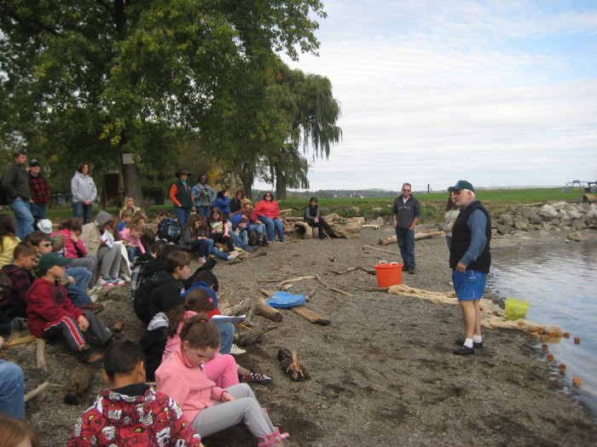
Donahue Memorial Park, Cornwall Landing, Village of Cornwall-On-Hudson, Town of Cornwall, Orange County, NY
Christopher O’Sullivan, NYSOPRHP Trailside Museums & Zoo
Deborah Gilson & 3 teachers, Willow Ave. Elementary - 4th grade – 78 - students
GPS Latitude 41°26’36”N Longitude 74°0’1”W
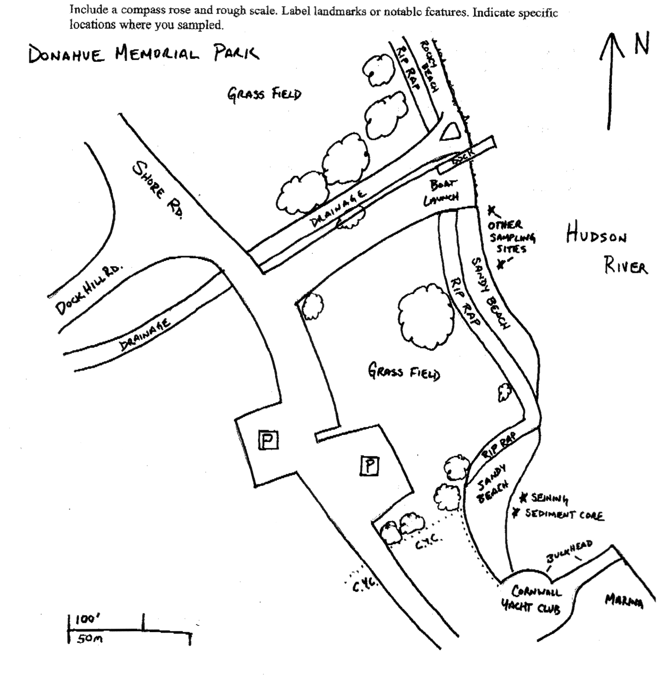

Location: Donahue Memorial Park
Area: Sandy beach used for seining & sediment core, 2nd beach are for other sampling.
Surrounding Land Use: Forested 15%, beach 5%, 80% open and grassy
Sampling Site: pier, sandy beach, altered banks, shoreline riprap, bulkhead, collected wood & debris in area,
Plants in area:
Water depth:
River Bottom – muddy, rocky

ITEM | Time |  | Reading 1 | Reading 2 | Comments
Physical
Air Temperature | 10:10 AM (students) |  | 71°F | 10:45 AM (Tom Lake) | 18°C  64°F
Wind Speed | BEAUFORT #1 |  | South
Cloud Cover | partly cloudy
Weather today | Dry
Weather recently
Water Temperature | 11:00 AM (Tom Lake) | 16.4 °C  62°F |  | 1:00 PM (student) |  |  | 17°C  18
Water Calm
Turbidity  Long sight tube | 11:10 AM | 19 cm
Chlorophyll | 10:55 AM | 1.0
Chemical
DO
Drop count kit
pH (indicator sol.) | 1:10 PM | 7.4
Salinity -  Quantabs – low range strips – | 1:05 PM | 29 ppm Cl- |  | 52.39 ppm total salinity
Fish Catch  80 ft. seine X 4 ft. with bag – ¼ inch mesh - | Number Caught | Species |  | Size |  | Comment
10:45-12:00 PM | 85 | Blueback Herring |  | 55-62 mm |  | Yoy (young of year)
 | 35 | Spottail Shiner |  | 45-85 mm
 | 1 | White sucker |  | 161 mm
 | 4 | Bluegill Sunfish |  | 25-30 mm |  | yoy
 | 2 | White perch |  | 95-100 mm
 | 2 | Striped Bass |  | 70 mm |  | yoy
 | 2 | Tessellated Darter |  | 45-50 mm
Tides | TIME | RISING/  FALLING |  | HEIGHT IN CM |  | RATE OF CHANGE
 | 10:00 am |  |  | 0 cm
 | 10:30 am | Rising |  | 10 cm
Currents | 11:00 AM | 30 cm/60 secs |  | 0.5 cm/sec |  | 0.01 kts flood

