Snapshot Day 10/18/11
(Salt Front RM 35.7)
RIVER MILE 58
Kowawese Unique Area, Plum Point, New Windsor, Orange County, NY
Judy Onufer & Pam Golben Museum of the Hudson Highlands
Dr. Bhalla and Mt. St. Mary’s College
Bernadette Kleister, Bishop Dunn Memorial School - 7th grade – 36 students
GPS Latitude 41°27’44”N Longitude 74°00’41”W
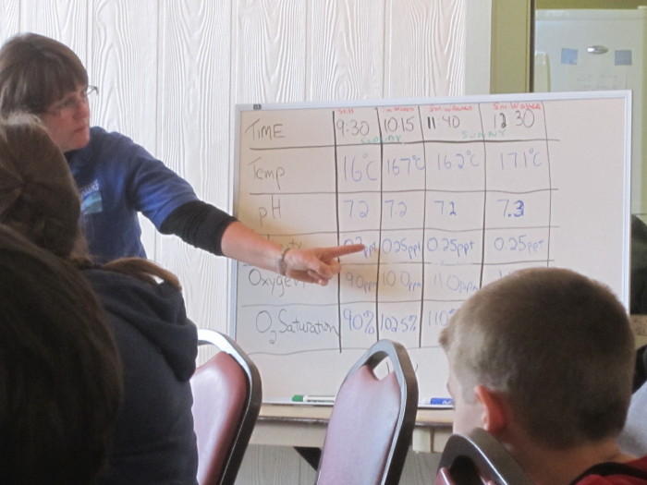
Location: Sandy beach at Kowawese, New Windsor, Orange County, Public Shore, Picnic Area
Area: Sandy beach bordered by forested area and parking lot. Used for picnic, fishing, kayaking
Surrounding Land Use: Forested 40%, beach 50%, Urban/residential 20%
Sampling Site: sandy beach (cove), rip rap in area of sampling site, debris in the area such as broken concrete, docking
Plants in area: Yes - < 10%of sampling area – 5% of plants Water Chestnut– 95% - other vegetation. (no water celery at all this year – more intact water chestnut than in prior years – perhaps storms and high water level dislodged plants that were washed downriver?)
Other trees in area – mostly wooded – oak, tulip, poplar and maple.
Water depth: <1 meter; Ebb tide early, followed by flood tide (low @ 10:14)
River Bottom –Mostly mud/sand with a few larger rocks.
ITEM | Time |  | Reading 1 | Reading 2 | Comments
Physical
Air Temperature | 10:30 AM |  | 11°C  52°F
Wind Speed | 0 – calm early in day |  | Increased to 2 later in day
Cloud Cover | Partly cloudy |  | No precipitation | Sky became more clear with sunny intervals by 11:30 AM
Weather today | Sunny 60s
Weather recently
Water Surface | calm
Water Temperature | 9:30 AM | 59.9 ° F  15.5 °C
 | 10:10 AM | 60.3° F  15.7°C
 | 11:45 AM | 64.6° F  18.1°C
 | 12:25 PM | 65.3° F  18.5°C
Water Calm | yes
Turbidity  Short sight tube | 9:30 AM | 50 JTU  60  60 |  |  |  | 56.7 JTU avg.
Chlorophyll | 8:50 AM | 3.0 |  | 100cc only*
Chemical
DO  (drop kit) | TIME | Temp |  | DO |  | % Sat
DO – drop count test kits | 9:30 AM | 15.5 °C |  | 9 |  | 90
DO – drop count test kits | 10:15 AM | 16.7 |  | 10 |  | 102.5
DO – drop count test kits | 11:40 AM | 16.2 |  | 11 |  | 110
DO – drop count test kits | 12:30 PM | 17.1 |  | 11 |  | 100
pH - meter | 9:30 AM  10:15 AM  11:40 AM  12:30 PM | 7.20  7.18  7.18  7.30
Salinity - Quantab | TIME | ppt |  | Cl- |  | Total Salinity
 | 9:30 AM | 1.0 |  | 23 ppm |  | 41.6 ppm
 | 12:30 PM | 1.2 |  | 29 ppm |  | 52.4 ppm
Fish Catch  35 ‘ X 3 ‘ with ¼ inch mesh | Time | Species |  | # |  | Size of largest (inches)
Water temp 12°C | 9:30 AM X 2 pulls | Alewives |  | 70 |  | 2
 |  | Spottail Shiner |  | 7 |  | 3
 |  | White Perch |  | 4 |  | 5.5
 |  | Gizzard Shad |  | 3 |  | 4
Water temp 12°C | 10:15 AM X 2 pulls | Alewives |  | 63 |  | 2
 |  | Spottail Shiner |  | 7 |  | 3
 |  | White Perch |  | 3 |  | 5
 |  | Gizzard Shad |  | 6 |  | 4
Water temp 18°C | 11:45 AM X 2 pull | Alewives |  | 45 |  | 2
 |  | Spottail Shiner |  | 4 |  | 3
 |  | Gizzard Shad |  | 1 |  | 4
 |  | Striped Bass (yoy) |  | 2 |  | 2
Water temp 18°C | 12:30 PM X 2 pulls | Alewives |  | 29 |  | 2
 |  | Spottail Shiner |  | 2 |  | 3
 |  | Striped Bass |  | 3 |  | 2.5
Tides -  (low tide in Newburgh 10:14 AM) | Time | Height in cm |  | Rate of change |  | Rising/falling
 | 9:30AM | 0 inch
 | 10:33 AM | -1 inch |  |  |  | Falling
 | 11:30 AM | 15 inch |  |  |  | Rising
 | 12:01 PM | 18 inch |  |  |  | Risinf
Currents | Very little | Water very quiet and still early in the day
Core | 4 inch | 1 inch top –  sandy/pebbly |  | 3 inch lower - clay-like – sulfur odor
Traffic
Other

