Snapshot Day 10/18/11 Data
(Salt Front RM 35.7)
RIVER MILE 61.1 E
Beacon Waterfront Train Station Park, City of Beacon, Dutchess County
Nancy Rypkema, Christine O’Shea, and 6 adult helpers/teachers - Valley Central Middle School, 7th & 8th graders (76 students )
Latitude 41°30’ 22” N - Longitude 73°59’ 07” W
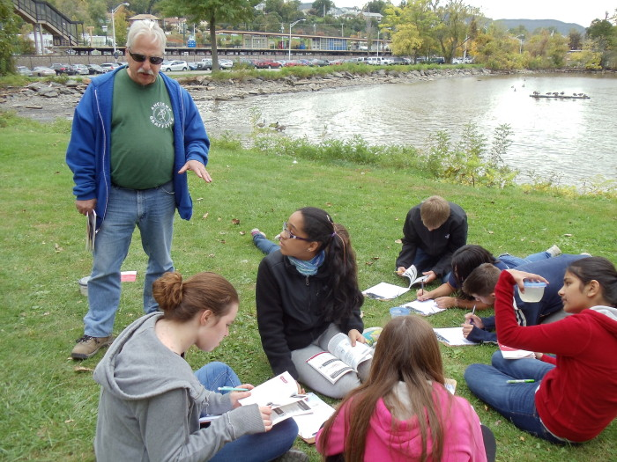
Location: Waterfront Park, Beacon, Dutchess County NY
Area: Park area near the Beacon train station - grassy lawns, forested around edges, parking lot to the side. Children’s play area
Surrounding Land Use: Park/grassy 60%, Urban/residential 10%; Forested 20%; shoreline/beach 10%
Student assessment: There is a bridge, transit station (train) and trees,
Sampling Site: beach, covered in vegetation, banks altered, rip rap
Plants in area of sampling: oak trees 10%; willow trees 10%; Grass 60%; maple trees 20%
Water depth:
Bottom Surface: sandy, rocky bottom

ITEM | Time |  | Reading 1 | Reading |  | Comments
Physical
Air Temperature | 11AM – 12:45 PM |  | 16.2°C  20.1  18.2 | 60°F  69  64.5
Wind Speed | 11 AM |  | Beaufort #2 | SW |  | 4-7 km/hr; 4-6 kts
Cloud Cover | Mostly cloudy
Weather today | Overcast
Weather recently | Dry for past 3 days – unusually wet fall
water calm | Choppy
Water Temperature | Time | Test one
Taken in 1 ft. of water | 11:00 - 12:45 PM | 15.8°C |  |  | 60 °F
 |  | 16.8°C |  |  | 62
 |  | 16.3°C |  |  | 61
Turbidity | Time | Secchi Disk |  |  | Turbidity Tube |  | Average
 | 10:40 AM | 27 cm |  |  | 16.8 cm |  | Secchi disc  27.3 cm
 | 10:46 AM | 35 cm |  |  | 17.2 cm |  | Turbidity Tube  18.25 cm
 | 11:48 AM | 20 cm |  |  | 21 cm
Secchi disk in inches | Noon | 13 inches |  |  | 2:00 PM |  | 13 inch
Short site tube | 11:25 AM | 60 JTU |  |  | Noon |  | 80 JTU
Chlorophyll | 10:22 AM  10:44 | 0.0  0.0 |  |  | 11:13 AM  11:36 AM  11:53 AM |  | 0.3  0.7  0.7
Chemical | Time | DO |  |  | Temp |  | % saturation
DO  (drop kit) | 10:43 AM  12:07 PM  1:00 PM | 9ppm  8  7 |  |  | 15C  15C  15C |  | 90%  80%  70%
pH –  meter | 10:35 AM  10:51 AM  11:23 AM  12:38 AM | 8:24/6.5  8.26  8:35/8:37  8:43 |  |  |  |  | *6.5 reading seems to be an error – huge variance from others & very low
Salinity – | Time | Quantab reading |  |  | Chloride reading |  | Total Salinity conversion
 | 10:42 AM  10:54 AM  11:03 AM  11:23 AM | 1.0 X 2  1.2 X 2  1.2 X 2  1.2 X 2 |  |  | ≤ 29 ppm Cl- |  | ≤ 52.39 ppm salinity
Fish Catch  seine 9X4feet | Number Caught | Species |  |  | CPUE |  | MACROs
noon | 8 | Shiner |  |  | 6 cm
 | 1 | White Perch |  |  | 25 cm
Tides | Time | Tide Stick |  |  | Flood/Ebb Still |  | Rate of change
 | 10:03AM | 20 cm
 | 10:30AM | 20 cm |  |  | Still
 | 10:45AM | 20 cm |  |  | Still |  | 0 cm/42 mins
 | 11:15AM | 35cm |  |  | Flood |  | 15 cm/30 mins
 | 11:41AM | 47 cm |  |  | Flood |  | 12 cm/26 mins
 | 12:53PM | 75 cm |  |  | Flood |  | 28 cm/72 mins
Currents | Time | Cm/60 secs |  |  | Cm/sec |  | knots
 | 10:13AM | 200 cm/60 |  |  | 3.3 cm/sec |  | 0.06 kts
 | 10:33AM | 100 cm/60 |  |  | 1.4 cm/sec |  | 0.03 kts
 | 10:53AM | 100 cm/60 |  |  | 1.4 cm/sec |  | 0.03 kts
 | 11:05AM | 100 cm/60 |  |  | 1.4 c/sec |  | 0.03 kts
Core | Length | Rare |  |  | Common |  | Abundant
 | 12 cm -  9 cm top  4 cm bottom |  |  |  |  |  | Large grain size  Plant material
Shipping | None noted
Observation: There is a blue heron sitting on a rock in the water. Canadian geese swimming, and seagulls flying. “The sky is cloudy and it may rain today. If it rained hard enough the water level would rise.” (anonymous) “On this field trip there have been many cool things that I’ve learned that I didn’t already know. I learned that seahorses can actually come from the Atlantic Ocean and live in the Hudson River. I also learned that moss always grows toward the north.” (Dominic)

